Riverbank Primary Literacy Grid First Level
Write a story with one of the following titles:  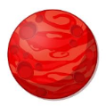  The Magical land, The Island, A Trip to MarsRemember to include character/setting descriptions | Choose a scene from the chapter or text you have read. Imagine you are peeping through a keyhole to catch a glimpse of the scene. Draw a sketch showing what you would see. | Choose 1 character from a book and act out something that s/he does in the story.  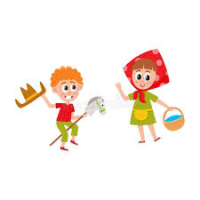 | Create your own comic strip and read it to someone at home.  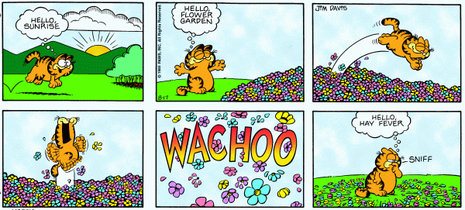
Choose a character from a book you have read and design a simple invitation, inviting him/her to your house. The invite should include a picture or sentence about what they will do during the visit  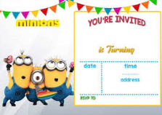 | List all the characters from a text you have read and rank them according to different criteria. These could include most to least powerful, kindest to meanest or bravest to most scared, for example. | Write 2 or 3 questions that you would like to ask a character from a book you have read. | Pick your favourite character from a book and use adjectives (describing words) to describe your character  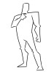
Write an acrostic poem about school  S ____________  C ____________  H ____________  O ____________  O ____________  L _________ | Be a story teller and read your favourite book to someone at home or retell the story in your own words. | Create a short and interesting fact file about an animal of your choice. (You could use the internet to do some research)  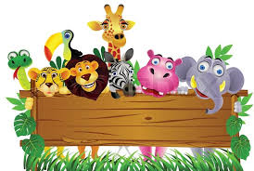 | Relax and watch your favourite TV programme at home.  Retell what it was about to someone at home

