Newsletter

**Riverbank Primary School**

**1 Sunnybank Street Twitter: @RiverbankPri**

**Glasgow Headteacher@riverbank-pri.glasgow.sch.uk**

**G40 4RX Pupil Absence Line: 0141 471 3710**

Issue 10

October 2020

Welcome to our October newsletter. We hope you have had a wonderful week off. We are ready for the new term ahead with lots of exciting learning opportunities planned.

**Covid-19 Advice**

Remember if you or someone in your household is displaying symptoms of Covid then you need to self-isolate until you get a test. Self-isolating ensures everyone’s safety. As a reminder, coronavirus symptoms are:

* A new and persistent cough
* A high temperature
* A change or loss of smell/taste

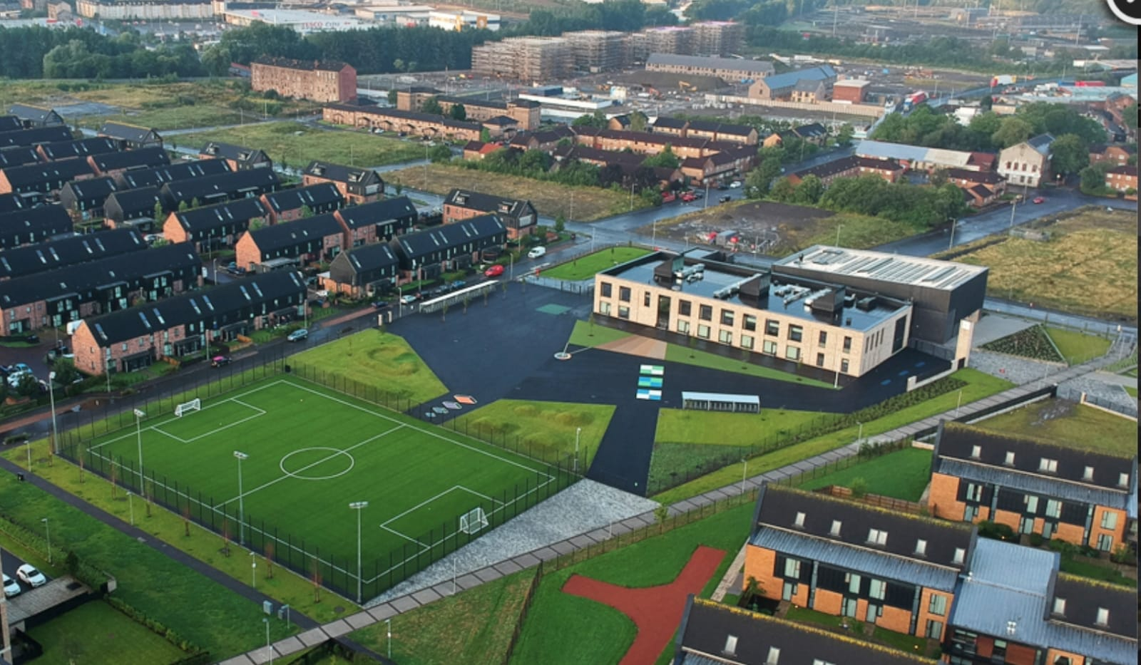

Further advice/information is available on the NHS Coronavirus website.



**P7 iPads**

As part of Glasgow City Council’s digital learning strategy all of our P7 pupils have received their iPads! We had a very exciting day on Monday trying them out. They are going to remain in school for the time being before being allowed to take them home. Watch out for some very cool digital learning taking place!

**Homework**

We now have Showbie and Sumdog up and running for

homework use. These apps were used during the lockdown period and are a useful tool for digital learning while adhering to restrictions around paper going to and from school. Everyone has been given login details for both platforms. Please let us know if you cannot get access and we will help. Mr Kenny is currently carrying out a survey of how well the apps are being used and how many pupils are engaging in homework. We will be in touch if you are not able to access this.

**Parent Council**

Our Parent Council has met twice since our return to school to look at ways in which to support the school community. We are very lucky to have a proactive Parent Council. If you would like to join please email [riverbankprimarypc@gmail.com](mailto:riverbankprimarypc@gmail.com) . The next meeting takes place on Tuesday 3rd November at 6pm. This will be done via Zoom.

C:\Program Files (x86)\Microsoft Office\MEDIA\CAGCAT10\j0234131.wmf

**Attendance/Late Coming**

We understand that there is anxiety surrounding symptoms of Covid and the wellbeing of children at this time. We ask that you continue to send your children to school as long as they are well and are not displaying any suspect symptoms. It is really important that children are here learning as often as possible, especially after being out of school for so long during lockdown. Also can you please ensure children come to school on time in the morning? We still have some children regularly coming in at 9:30 am. Added up that can be up to 2.5 hours per week of learning that is missed. It may also mean that you get a text saying your child is not at school as registers are taken before 9:30. Please try to ensure your child is at school on time each day. Thank you for your support with this.

**C:\Program Files (x86)\Microsoft Office\MEDIA\CAGCAT10\j0305493.wmf**

**Halloween**

After discussions with our Parent Council and our staff we have decided the following for Halloween celebrations:

* Every class will decorate a Halloween door in their class
* Every child will be asked to design a Halloween pumpkin and carve one at home if they can.
* P1-3 will design a Halloween costume and P4-7 will write a spooky story/poem. The best wins prizes!
* Suitable Halloween movies to be screened in school

On Friday 30th October we will have a dress down/up day! Children can wear costumes to school on this day if they wish to dress up, or just come in normal clothes to dress down. We are asking children to bring £1 to school on this day to raise money for school funds. If you have more than one child at school the max you will be asked to pay is £2. In class on the Friday school will provide juice and popcorn while the Parent Council will provide a treat bag with an activity.

Can I please ask not to send children to school with overly scary costumes, no props and no inappropriate costumes such as Fortnite characters or characters from movies that are not age appropriate? This ensures no one is scared and we can all celebrate and have a nice time.

**Reporting to Parents**

Due to Covid restrictions we are unable to have our traditional Parent’s Evening. We have instead developed an Interim Report which will allow the class teacher to inform you about your child’s strengths and next steps. We hope to have these to you by the end of November.

As always we are here if you need to speak to us. Please call the office to make an appointment to speak to a member of the management team.

Mr Hynes