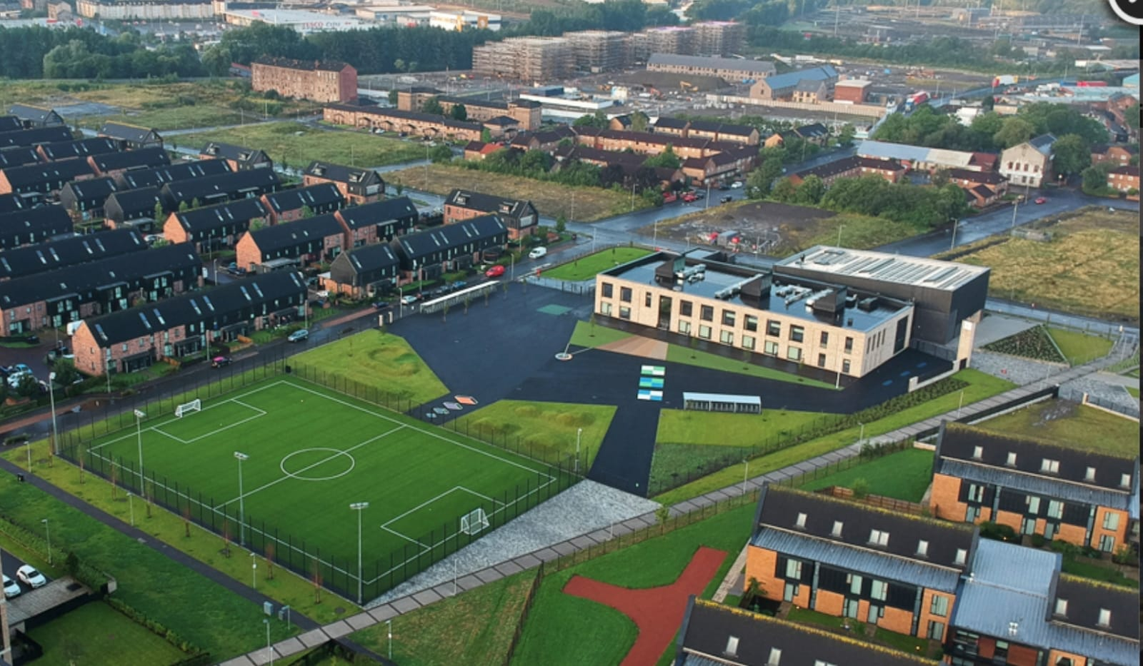Newsletter

Issue 11

November 2020

Welcome to our November newsletter. We can’t quite believe how quickly the time has passed and now we are preparing for Christmas, albeit a very different one. You will already have received a letter about our plans for Christmas and we look forward to enjoying some festive fun over the coming weeks.

**Covid 19 Advice**

Remember if you or someone in your household is displaying symptoms of Covid then you need to self-isolate until you get a test. Self-isolating ensures everyone’s safety. As a reminder, coronavirus symptoms are:

* A new and persistent cough

**Riverbank Primary School**

**1 Sunnybank Street Twitter: @RiverbankPri**

**Glasgow Headteacher@riverbank-pri.glasgow.sch.uk**

**G40 4RX Pupil Absence Line: 0141 471 3710**

* A high temperature
* A change or loss of smell/taste

Further advice/information is available on the NHS Coronavirus website.

Thank you for supporting us in our work over the past few weeks when we have had to work in partnership with Public Health. It has meant effective and efficient identification and ensured we are keeping everyone safe.



**Homework**

We now have 73% of our pupils who have signed up for Showbie for homework use. Most of these pupils

are using this on a regular basis. However we still have some children who are not. If you need any support with this please call the school and speak with Mr Kenny who will be more than happy to help. It has been a pleasure to read through children’s homework and share their learning with you too. We are looking forward to further developing our use of Showbie throughout the school and we will be looking for your feedback on this too.

**Parent Council**

Our Parent Council have been meeting monthly since our return to school to look at ways in which to support the school community. We are very lucky to have a proactive Parent Council. If you would like to join please email [riverbankprimarypc@gmail.com](mailto:riverbankprimarypc@gmail.com) . The next meeting takes place on Tuesday 19th January at 6:15pm. This will be done via Zoom.

If you would like to read their annual report, this is available on our school website under the Parent Council tab.

C:\Program Files (x86)\Microsoft Office\MEDIA\CAGCAT10\j0234131.wmf

**Attendance/Late Coming**

We understand that there is anxiety surrounding symptoms of Covid and the wellbeing of children at this time. We ask that you continue to send your children to school as long as they are well and are not displaying any suspect symptoms. It is really important that children are here learning as often as possible, especially after being out of school for so long during lockdown. Also can you please ensure children come to school on time in the morning? We have noticed a slight improvement in this but it is still something to work on. If you need support with anything please just contact the school. Thank you for your support with this.

**Staffing**

Friday 27th sees Miss Hosie finishing up to begin her maternity leave. We wish her all the luck in the world for this exciting new chapter and we look forward to hearing about the safe arrival of her baby.

I am delighted to announce that Miss McLaughlin has been appointed as our Acting Principal Teacher for one day per week in Miss Hosie’s absence. Congratulations to her.

Miss Mort will now support our children in The Den each day. We are currently awaiting a supply teacher to be appointed for half a day per week to help with Miss Hosie not being here. I will let you know when this happens.

**Christmas Cards**

We know that lots of our children like to write Christmas cards for their friends in class. This year, due to Covid restrictions we cannot have the same freedom as usual. We are asking that if children wish to bring in Christmas cards that they are deposited in our school post box. The cut-off date for this will be the 11th December. The cards will then be left for 72 hours before being delivered to classrooms. It is important that the child’s name and class is put on the envelopes. Thank you for your help with this.

**Keeping Warm in Glasgow**

Glasgow City Council are currently running an initiative to ensure all children are kept warm in our schools. This is due to windows being open more often to improve ventilation to reduce the risk of germs. If you have any unwanted jackets and jumpers you can drop them off to school for donation. Thank you.

**Christmas Holidays**

School closes on Tuesday 22nd Dec at 2:30pm for P1-P3/2 and 2:40pm for P4/3-P7/6. School reopens on Wednesday 6th January.

Thank you, as ever, for your continued support. This has been a challenging term for many reasons but we have managed through it as a community and for that I am very grateful and appreciative. On behalf of myself and all of the team at Riverbank I wish you all a very merry, safe and peaceful Christmas. Enjoy the holiday and please rest and relax. We look forward to what lies ahead in 2021.

Mr Hynes