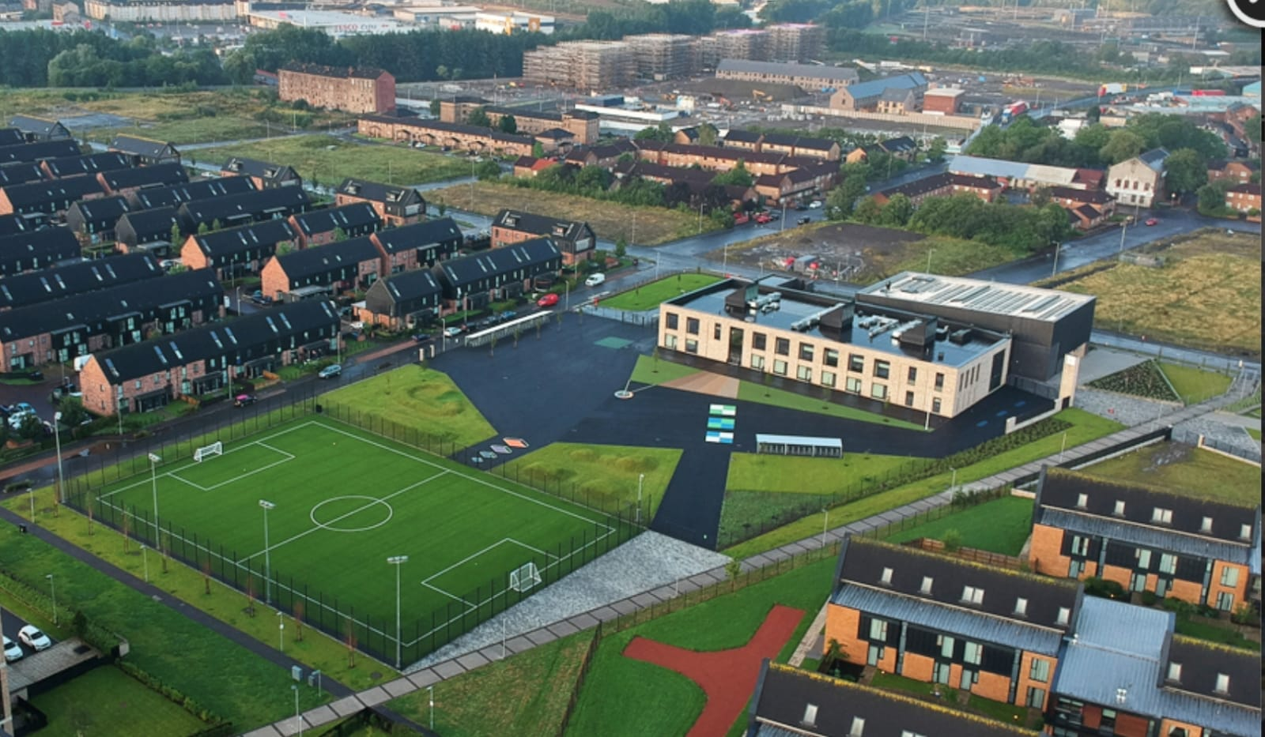Newsletter

Issue 12

March 2021

Welcome to our March newsletter and a somewhat return to normality! We are delighted to have our whole school back together after what has seemed like a very long term. We are incredibly proud of how quickly they have settled back into routine.



**Covid 19 Advice**

Remember if you or someone in your household is displaying symptoms of Covid then you need to self-isolate until you get a test. Self-isolating ensures everyone’s safety. As a reminder, coronavirus symptoms are:

* A new and persistent cough

**Riverbank Primary School**

**1 Sunnybank Street Twitter: @RiverbankPri**

**Glasgow Headteacher@riverbank-pri.glasgow.sch.uk**

**G40 4RX Pupil Absence Line: 0141 471 3710**

* A high temperature
* A change or loss of smell/taste

Further advice/information is available on the NHS Coronavirus website.

For any children who do need to self-isolate work will be provided through Showbie for them to complete.



**Homework**

During the lockdown period you as parents supported our children so well with their home learning. We can’t thank you enough for your efforts. As the children have returned to school we have ensured that we are supporting their progress within the classroom. As a

staff team we feel that homework is not necessary just now in order to give both pupils and parents a break. We plan to restart homework again after the Spring Holidays.

**Parent Council**

Our Parent Council have been meeting monthly since our return to school to look at ways in which to support the school community. We are very lucky to have a proactive Parent Council. If you would like to join please email [riverbankprimarypc@gmail.com](mailto:riverbankprimarypc@gmail.com) . The next meeting will take place after the Spring Holidays. This will be done via Zoom.

C:\Program Files (x86)\Microsoft Office\MEDIA\CAGCAT10\j0234131.wmf

**Attendance/Late Coming**

We understand that there is anxiety surrounding symptoms of Covid and the wellbeing of children at this time. We ask that you continue to send your children to school as long as they are well and are not displaying any suspect symptoms. It is really important that children are here learning as often as possible, especially after being out of school for so long during lockdown. Please remember the times for children starting or finishing:

P1a, P1b, P2/1, P2 and P3/2 – 9:00/3:00

P4/3, P5/4, P6/5 and P7/6 – 9:10-3:10

For families where there are children on different floors all children can be collected at 3:10. We will look after ground floor children between 3pm and 3:10.

**Staffing**

I am delighted to share with you all that Miss McGarrity has given birth to a beautiful baby boy named Oliver. We welcome him to the Riverbank family and wish them all the very best in the coming weeks and months.

Miss Morgan has joined us this term to cover Miss McGarrity’s maternity leave and will be with us until June. Welcome to her.

Since we last wrote to you Miss Hosie has welcomed a beautiful baby girl Grace. We wish them well too and look forward to having a cuddle when it is safe to do so.

**Safety Measures**

Since returning to school we have continued with the stringent safety measures we had in place since December. Some of these measures include

* Handwashing 6 times per day
* Class bubbles not mixing together
* Not sharing resources
* No bringing of toys/items from home
* PE outdoors

****We have also introduced separate playground zones for each class and named seating in our lunch hall for extra safety. We are trying to make life feel as normal as possible for our children. We hope that with the success of the vaccine roll out that these restrictions will begin to ease soon. Can I please remind everyone of the importance of wearing a face covering at pick up and drop off at the school gates and also maintaining a 2 meter distance from other households. This will ensure safety for everyone.

**Safe Parking**

With the onset of hopefully better weather we ask that families try to walk or cycle to school where possible. We have unfortunately had complaints from some of our neighbours on London Avenue where people are parking their cars and walking over flower beds and hedges. Please try to be mindful of others’ property when parking your car. Thank you.

**Reporting to Parents**

As previously sent out our staff will be calling parents for a short telephone catch up about your child. This is to be instead of a face to face parent’s night. Please note each call will only last for between 5 and 10 minutes. If you require a longer discussion then we can arrange an appointment at a different time.

**Online Catch-Up**

As we are not able to meet face to face at the moment we are organising a series of online catch ups over the next term. We held one this term on school values. Our next catch up will be on Zoom and this will be on the new Relationship, Sexual Health and Parenting resource being used in schools across the country. This will be on Wednesday 21st April at 6:30pm. If you are interested in joining us please email Mr Hynes on [headteacher@riverbank-pri.glasgow.sch.uk](mailto:headteacher@riverbank-pri.glasgow.sch.uk) for

**Dates for Diary**

**Thursday 1st April – School closes at 2:30pm for Spring Holidays**

**Monday 19th April – School reopens at 9am/9:10am**

**Wednesday 21st April – Online Meeting with Mr Hynes and Mrs Whyte for new Relationship and Sexual Health and Parenting resource at 6:30pm**

**Monday 3rd May – School closed for May Holiday**

**Thursday 6th May – Inservice Day to coincide with school being used as a polling station – no pupils to attend**

**Friday 28th and Monday 31st May – School closed for Bank Holiday Weekend**

**Thursday 24th June – School closes for summer holidays at 1pm**

the link. Before the meeting you can take a look at the resource online at [www.rshp.scot](http://www.rshp.scot)

**Breakfast Club/Lunch Payments**

Payments for lunch and breakfast are still cashless. If your child is not in receipt of a free school meal and wants lunch or breakfast then payments will need to be paid online. To do this you will need a unique code for our school. Please call the office where Karen or Ashleigh can help with this.



In our April newsletter we will give more detailed dates for class assemblies, achievement celebrations and transition information for new P1s and P7s. We will also share information on our report cards due out in June.

Once again my sincere thanks to all of you for your unwavering support during this very challenging term. I hope that better days are coming in light of the success of the vaccination programme and the relaxation of restrictions. I hope you and your family enjoy some rest and relaxation over the Spring Holiday.

Mr Hynes