Newsletter
Riverbank Primary School
1 Sunnybank Street @RiverbankPri
Glasgow Headteacher@riverbank-pri.glasgow.sch.uk
G40 4RX Pupil Absence Line: 0141 471 3710

Issue 9
August 2020
Welcome back to school everyone! We are beyond delighted to have all of our children back where they belong at Riverbank. This has been a strange time for all of us and we are incredibly grateful for all of the hard work you have put in at home over the last few months. Your children have returned to school looking very smart and full of joy at being reunited with their friends and school staff. Thank you for this.
This newsletter will hopefully give you a little bit more information about what life looks like at Riverbank and any other important points to note.

Parent Council
Our Parent Council have been working hard behind the scenes as always. They have been supporting families throughout lockdown and providing guidance too. They have a newly set up Parent Council Facebook page which offers advice and help if needed. Please have a look for this if you use Facebook. If you would like to help them or volunteer to join them please get in touch directly with them or with the school. We cannot thank them enough for their on-going support and we look forward to a continued partnership this session.
School Website
Mr Kenny has been busy updating the school website with lots of information and activities. All of our letters
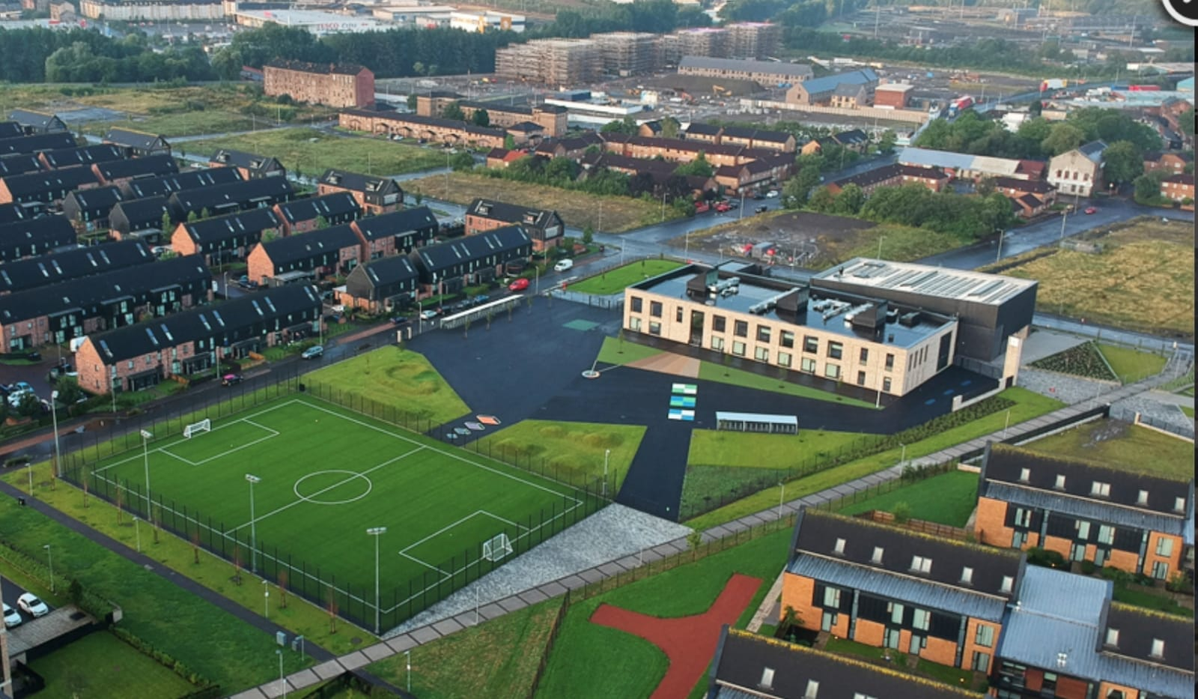

home and newsletters will be placed here so please check it regularly. We also have pictures of our new staff members here for you to familiarise yourself with.
COVID-19 Recovery
Coming back to school safely was and is our number one priority. Our staggered starts and finishes and different entry and exit points are helping with congestion of people in one place and safe passage for our children. We are very grateful to you all for supporting with this and adapting to changes so quickly and smoothly. If you are collecting or dropping of children can I remind you to keep a 2 metre distance from other adults at the gate? There should be only one adult per household at the gates which will greatly help. This is particularly important at the P1a/P1b gate at Cuningar Loop which can get busy. Please help us to keep everyone safe – thank you.
As previously stated children will be washing their hands a minimum of 6 times per day with soap and water to reduce the risk of spreading germs. They are also playing in zones in our playground to limit the mixing of class groups. We are reviewing this plan and will look at rotating zones in the coming weeks.
Use of water coolers is currently not allowed. Please send your child to school with a filled water bottle each day.
As per Scottish Government guidelines we aim to be outdoors as much as we can this year. We are lucky to have a very big playground space and so we intend to utilise this. Please ensure your child comes to school with a sensible jacket and shoes for outdoor learning. P.E. is only being delivered outdoors at the moment until further guidance is issued. Your child’s P.E. days are as follows:
P1a – Tues/Thurs
P1b – Mon/Weds
P2/1 – Tues/Thurs
P2 – Mon/Weds
P3/2 – Mon/Fri
P4/3 – Tues/Fri (until October week, then Weds/Fri)
P5/4 – Mon/Weds
P6/5 – Tues/Thurs
P7/6 – Tues/Thurs
On these days children can wear a polo shirt under their school jumper. If you are worried about school shoes being scuffed please send in appropriate shoes for outdoor P.E.
Recovery Curriculum
As part of our safe return to school we have a whole school focus on Health and Wellbeing. Your child will be learning outdoors, playing games, making rules for their class, learning about values, taking part in PE, discussing mental health and lots of other activities linked to reconnecting with their school environment. Our staff team will be monitoring everyone closely to see if anyone needs extra support. Additional support may be offered in a number of ways for example by Lou Butters, our school counsellor or from Miss Hosie who is delivering nurture and wellbeing support this year. From the beginning of September we will address our other curricular areas as appropriate. We will be in touch with you soon to discuss this further.
School Uniform
As stated previously the children have come back to school looking so smart in their uniforms. They are an absolute credit to you all – thank you for this. As a reminder, shirt and tie should be worn at all times except on the days when they have gym. They can then wear a white polo shirt. School trousers are grey and shirts are white. Please try to follow uniform policy as this ensures everyone looks the same and promotes our sense of belonging to our wonderful school community.
Primary 1
Our new Primary 1 children have settled incredibly well and we are delighted that they are now joining us for full days. Thank you to parents and carers for supporting us with starts and finishes – we know its emotional at times but we promise that we take very good care of them. I have seen so many smiling faces during the day and at 3pm so I hope that shows what a wonderful time they have had. Special thanks to our staff in P1 for supporting them so well.
Lunches
Glasgow City Council have been working hard to try and find a way to handle payments for lunches as we are not allowed to handle cash due to the pandemic. You will have received information about this already. It is hoped that this is a temporary measure so please bear with us while it is being worked through. If your child is in P1-P4 they are entitled to a Free School Meal automatically. In P5-P7 it costs £1.90 per day unless you have applied for Free School Meals. This can be paid weekly/monthly/yearly. If you need help with this please contact the school where we will be happy to explain the process involved. There is a limited menu now with two choices each day. The menus are on our school website and are shared on Twitter so please read through them with your child.
Allergies
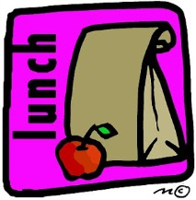
At Riverbank we have a strict no nut policy. This is due to allergic reaction that could be caused. All nut products are prohibited – this includes all Nutella products. Thank you for your support with this.

Communication
This year we hope to keep in touch through email and through a new app for your smartphone. We will be in touch about this soon so please ensure we have an up to date email address for you. Communication will be challenging with you all this year as we cannot have face to face meetings in the same way. If you need to speak to us please contact the school office where you can make an appointment to speak to a member of staff.
We will still aim to have all information on our website, Twitter and newsletters too.
During lockdown and the summer holidays I had a mobile phone in use for ease of contact. Now that we are back at school this phone will no longer be in use. Please contact the school through the normal channels.

Again, thank you for your continued support. We are extremely fortunate to work with understanding, helpful and supportive families. I am very much looking forward to continued partnership in our Riverbank family this year.
Mr Hynes

