Newsletter

**Riverbank Primary School**

**1 Sunnybank Street @RiverbankPri**

**Glasgow Headteacher@riverbank-pri.glasgow.sch.uk**

**G40 4RX Pupil Absence Line: 0141 471 3710**

Issue 10

September 2020

Welcome to our September newsletter. We have now been back at school for four weeks and I am delighted to say that the children have settled back into our new normal really well. There have been a lot of safety measures for children and staff to get used to but it seems that our planning and your preparation has helped them to feel safe back at school. Thank you for this. In this newsletter we hope to give you an update on a few issues and news about what is in the weeks ahead.

**Covid 19 Advice**

Remember if you or someone in your household is displaying symptoms of Covid then you need to self-isolate until you get a test. Self-isolating ensures

everyone’s safety. As a reminder, coronavirus symptoms are:

* A new and persistent cough
* A high temperature
* A change or loss of smell/taste

Further advice/information is available on the NHS Coronavirus website.

**Entry/Exits at Gates**

Thank you to the majority of our parents for staying socially distant at the gates in the morning and the afternoon. I have had to remind a few people about this as it is sometimes difficult for children to leave the building safely. This is particularly difficult at the gate at Auckland Wynd. To help with this from Monday 21st September we will ask P2/1

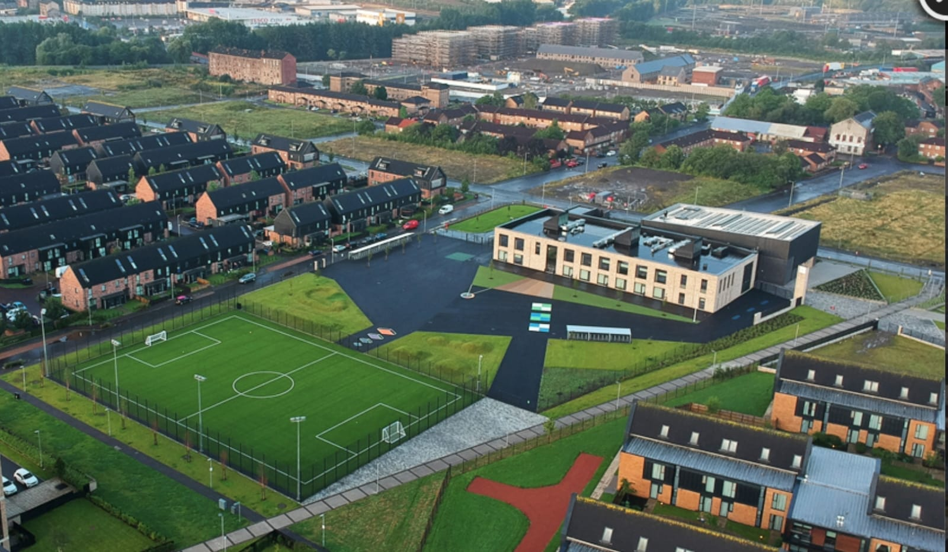

children to leave through the gate at the drop-off point. There is more space at this gate for social distancing to happen. Can I also ask that only one adult per household comes to collect children? This will help enormously with social distancing. Thank you for helping keep everyone safe.

**Parking**

We have had some concerns from residents who live on London Avenue about parking when collecting children at 3pm. We are very lucky in that most of our families live within a manageable walking/cycling distance and we encourage this way of transport. However when you need to take the car please be mindful of parking across other people’s driveways. Everyone’s safety is important. Thank you.

**P7 iPads**

As part of Glasgow City Council’s digital learning strategy all of our P7 pupils will receive an iPad that they can use at home and school to help with their learning. Mr Kenny will be in touch with their families to discuss this over the next few weeks. Later in the school year it is hoped that all pupils will have access to shared iPads across he school. We will inform you when this is going to happen. Digital Learning is part of our improvement plans this year and we aim to ensure that all pupils have access in some form. We have text you to ask you to get in touch if you do not have wifi access or a suitable device. We hope to be able to help you with this where we can.

**Homework**

We now have Showbie and Sumdog up and running for homework use. These apps were used during the lockdown period and are a useful tool for digital learning while adhering to restrictions around paper going to and from school. Everyone has been given login details for both platforms. Please let us know if you cannot get access and we will help.

**Parent Council**

Our Parent Council have met once since our return to school to look at ways in which to support the school community. We are very lucky to have a proactive Parent Council. If you would like to join please email [riverbankprimarypc@gmail.com](mailto:riverbankprimarypc@gmail.com) . The next meeting takes place on Tuesday 6th October at 6pm. This will be done via Zoom.

**Open Afternoon**

As part of our reporting to parents plans last year we had an open afternoon to allow parents to visit the classrooms while pupils were working. That is not possible this year due to restrictions. Instead our staff have recorded videos of what happens in their classrooms during the day. We hope these video clips gives you a taste of what learning is like in your child’s class. These videos can be found through the link on the main page of our school website from Monday 21st Sept. [www.riverbank-pri.glasgow.sch.uk](http://www.riverbank-pri.glasgow.sch.uk)

**Attendance/Late Coming**

We understand that there is anxiety surrounding symptoms of Covid and the wellbeing of children at this time. We ask that you continue to send your children to school as long as they are well and are not displaying any suspect symptoms. Our attendance figures show we still have some children off school for unexplained reasons. It is really important that children are here learning as often as possible, especially after being out of school for so long during lockdown. Also can you please ensure children come to school on time in the morning? We still have some children regularly coming in at 9:30 am. Added up that can be up to 2.5 hours per week of learning that is missed. It may also mean that you get a text saying your child is not at school as registers are taken before 9:30. Please try to ensure your child is at school on time each day. Thank you for your support with this.

C:\Program Files (x86)\Microsoft Office\MEDIA\CAGCAT10\j0234131.wmf



**Parent Feedback**

**You Said – We Did**

When we came back to school we asked you to complete a survey around our return to school. Here is a summary:

96% of you said you were happy with the safety measures we have put in place. One family asked about everyone wearing face masks. We are following national guidance on this and will continue to do so. If advice changes we will let you know.

Some of you asked about signs for social distancing at the gates which we have now displayed.

Some of you asked about meeting new staff and what our classrooms now look like. We are in the process of creating videos from each teacher to show you what happens in a school day at Riverbank.

We are also very grateful for the very kind and supportive comments we received about our communication during lockdown. Thank you for the very positive feedback.

**School Improvement Plan**

Every year we have a list of priorities we work on to improve our school. This coming year they consist of:

* Recovery after Lockdown (Outdoor Learning, Health and Wellbeing, Nurture)
* Literacy – development of reading and writing strategies
* Digital Learning
* Learning and Teaching (assessment, target setting, play)

We will soon have our improvement plan published onto our website and we will let you know when this happens.

**Pupil Equity Funding**

This year our school has been allocated £91845. This money is to be used to provide equity for all children in terms of educational experiences and outcomes. Our plan for this money so far is:

* Outdoor clothing to allow us to play and learn in all weathers
* Outdoor nurture group for senior children
* Nurture teacher (Miss Hosie) to provide nurturing support for pupils
* Develop literacy
* Develop play in P1 and P2
* School Counsellor (Lou Butters)

If you have any suggestions on how we spend the rest of our PEF please get in touch with the Head Teacher to discuss.

**Water bottles**

A gentle reminder that water bottles must only contain water and not juice. We have had instances where sticky liquids have spilt over expensive school resources and personal items. We also want to promote a healthy example across the school. If possible send a couple of water bottles to school with your child so they have enough for the day. Thank you for your support with this.

As always we are here if you need to speak to us. Please call the office to make an appointment to speak to a member of the management team.

Mr Hynes