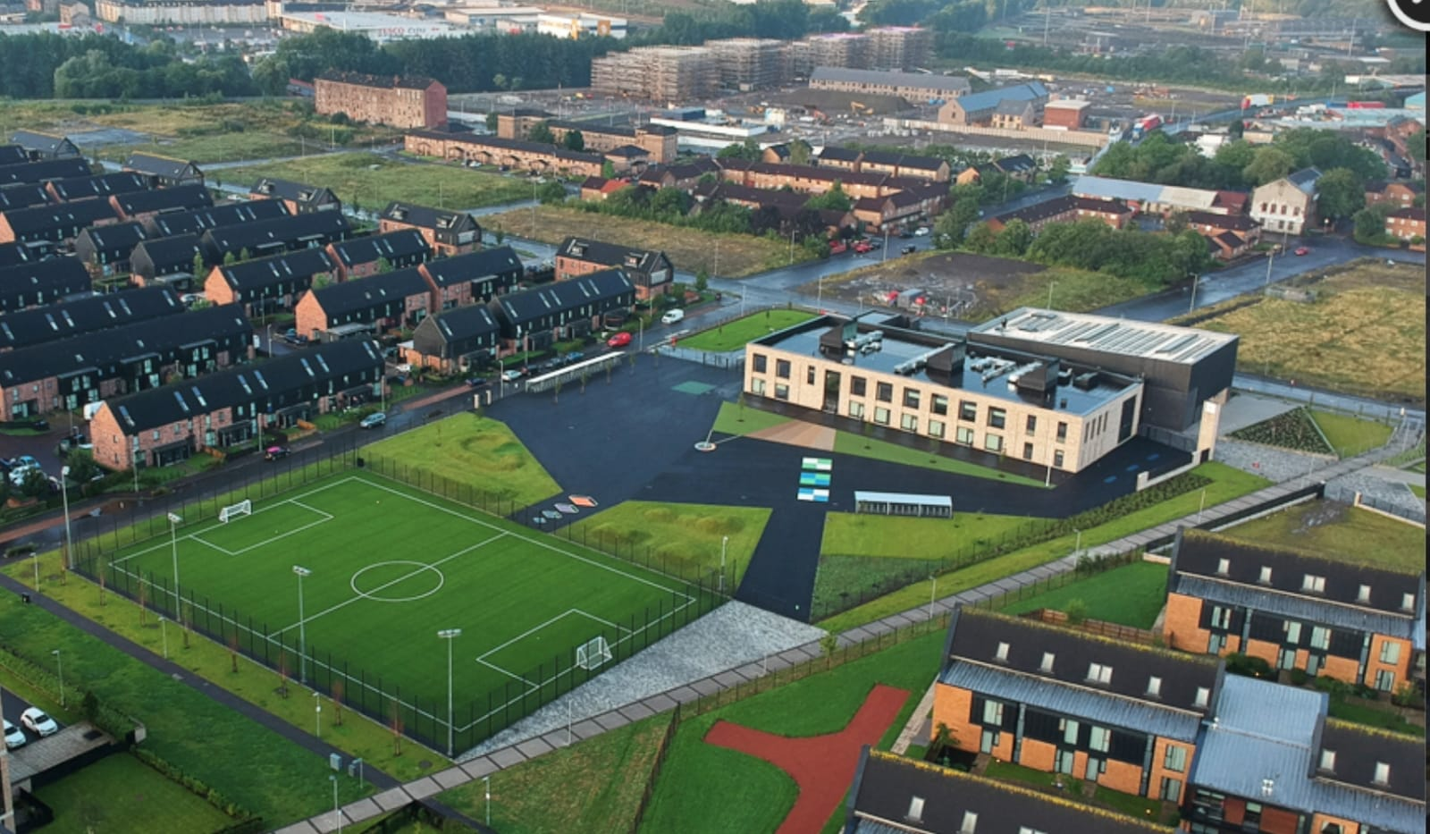
Newsletter

Issue 21
April 2022
Welcome to our April newsletter. We can’t believe we are already in Term 4. It is shaping up to be a busy and exciting term already and we hope this newsletter gives you a flavour of what is to come.
Covid 19 Advice
We are delighted that life is beginning to return to some normality. As of the beginning of Term 4 parents and carers are once again allowed to come into our school building for Parent’s Evenings. You will find a date for this at the back of the newsletter – we cannot wait to see you in person! We will still be encouraging hand washing and good hygiene practices within school to help stop the spread of germs.
When there are positive cases of Covid within a class we will not be sending letters home to inform each time. Instead these letters will be sent if there are a number of cases. We will continue to monitor the situation and risk assess as we go.
Homework
Please try to take part in homework activities that are available weekly on Showbie. If you need support with this you can check out our help-sheet on our website or call Mr Kenny. Homework will be given on a Monday and collected on a Friday.

Parent Council
Our Parent Council meet monthly to look at ways in which to support the school community. We are very lucky to have a proactive Parent Council. If you would like to join please email riverbankprimarypc@gmail.com . Please get in touch with us if you would like to join the next meeting.

Staffing
We are delighted to announce that Miss Hosie and her partner welcomed a beautiful baby boy last month. We wish them all the very best and are looking forward to a wee cuddle soon!
We welcome Mrs Davis to our school who will be teaching in P6 until the end of June. We also welcome Mrs Hashim who is our new Support for Learning Worker. She will be with us into next session too.
Huge congratulations to Miss Proctor who got married over the Spring break. She will remain known as Miss Proctor until the start of the new session when she will be Mrs Brooke.
Miss Cowden will be taking on the role of Learning Support Teacher for Term 4.
For next session we will have two new permanent teachers and two probationer teachers. We will also have a Pupil Equity funded teacher. Once names of staffing have been finalised I will let you know.
Uniform
A reminder that our uniform is navy blue jumper/cardigan, grey trousers/shorts/skirt, white shirt, school tie and black shoes. On gym days a white polo shirt may be worn. Tartan dresses, grey jumpers and white trainers are not part of the uniform and should not be worn to school. Please help us to uphold our uniform policy and show how proud we are to belong to the Riverbank family. Remember you can begin to order uniform for next year now through www.schoolwearmadeeasy.com All school ties will also be available to purchase from here too.
Can I also take this chance to remind you to please label everything your child brings to school? This will make it easier to find if misplaced. All of our previously lost property has been donated to clothing banks and charities and this is something we will continue to do.

Parent Pay
Huge thanks to the 82% of our families who have signed up to our new online payment system. All Glasgow schools will be using this from now on so please try to activate your account soon. If you need any support with this please get in touch with Karen or Ashleigh at the school office who will be more than happy to help.
Our meal selection feature is going very well so thank you for your support with this. Please continue to pre-select your child’s meal each night/morning for the day/week ahead. This will help reduce time spent in classes doing this. The new menus for meal selection are also available on our website.

Walk and Talk
Thanks to those of you who have come along to this – Mrs Whyte has loved chatting with you all. If you fancy having a walk in the park with some others, grabbing a coffee/tea/hot chocolate and having a chat then please just come along to the school on this date. Feel free to bring along a baby or a toddler if you need to – this is about having a wee bit of time to unwind and chat while having a healthy walk in the fresh air. The next date will be Friday 29th April at 2pm. We look forward to seeing some you then.

Community Litter Pick
We hope to have a community litter pick on Saturday 14th May at 12pm outside the school. This will focus on streets around the school. We would love if your family could come along to help out. Litter pickers and bin bags will be provided. If you need more information please call and speak to Mr Hynes.

Transitions
At this time of year we begin to think about our new P1 children starting. Mrs Whyte has been visiting nurseries in preparation for the children starting. Our transition visits are being planned and information will be sent to families in the next week or so! We can’t wait to meet them.
Our P7s are beginning to look towards high school. Eastbank Academy staff will be visiting again on Tuesday 3rd May at 9:30am. The P7s will visit Eastbank in June for a full day experience of life at high school. Exciting times! We will write to our P7 parents soon with an update on the Leavers’ Assembly and celebrations.

Health Week
This year our Health Week takes place week beginning 23rd May. We will have a range of activities planned for children over this week including a sponsored walk, sporting activities and mental health and wellbeing workshops.

Careers Week
Hot on the heels of Health week is our Careers Week where we will be thinking about Developing the Young Workforce. Miss Proctor will be in touch soon with more information on this exciting week!

Reporting to Parents
As mentioned above our Parent’s Night will be held on Tuesday 31st May. You will get a choice for an afternoon or evening appointment and we will do our best to accommodate these where possible.
End of Year report cards will be issued before these meetings. This gives you an opportunity to discuss them with your child before the face to face meeting.

Curriculum News
This term our P5/6 children will be getting to experience bowling at Belvidere Bowling Club.
Our P4 children will be getting expert football coaching until June.
For Numeracy Mrs Clark will be supporting pupils and staff in their understanding and development of numeracy and maths and will be compiling our end of year report on our achievements. This will be shared with you all as part of our Standards and Quality Report in September.
Each class will update their class section on our website with this term’s plans – we will send a text when this is completed.

Please see attached a note of all of the important diary dates for the term ahead.
Mr Hynes

