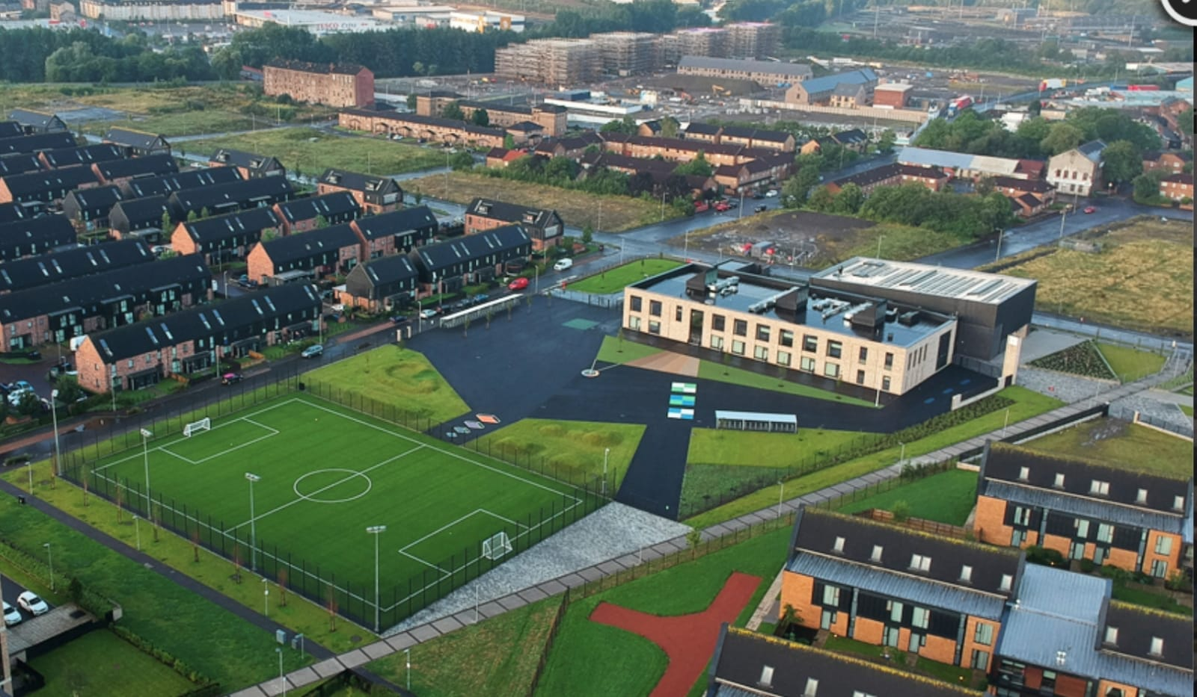
Newsletter

Issue 25
December 2022
Here we are at December already! We have been very busy here at Riverbank and have lots of exciting plans for the coming month.
Showbie
As usual all homework will be carried out via our online learning app Showbie. In response to a parent suggestion we will now also be sharing some of our learning through pictures and videos via Showbie. We hope you enjoy getting a glimpse into our daily learning.
Staffing
We will be saying farewell and good luck to Mrs McMillan-Currie on Thursday 22nd December as she starts her maternity leave. We wish her and her family all the very best at this exciting time. Mrs Gaw, who currently shares P1/2 with Mrs McMillan-Currie, will take on the class full time in her absence.
We are delighted to share that Ms Tan gave birth to a baby girl named Edith last month. We wish her and her family well and we hope to see her soon.

Uniform
A reminder that our uniform is navy blue jumper/cardigan, grey trousers/shorts/skirt, white shirt, school tie and black shoes. On gym days a white polo shirt may be worn. Tartan dresses, grey jumpers and white trainers are not part of the uniform and should not be worn to school. Please help us to uphold our uniform policy and show how proud we are to belong to the Riverbank family. Remember you can order uniform from www.schoolwearmadeeasy.com All school ties will also be available to purchase from here too.
Please ensure all school clothing have names on them. We already have a collection of un-named clothing built up in the school.

Parent Pay
Please continue to pre-select your child’s meal each night/morning for the day/week ahead. This will help reduce time spent in classes doing this. The new menus for meal selection are also available on our website.
Please ensure you have signed up to parent pay as all monies needed for school will be paid via here – as well as registration for after school clubs.

Pick Up/Drop Off
Our school roll is ever increasing and at the time of writing is at 305 children. This is a long way from the 160 we had when we opened 3 years ago. With this comes an increase in traffic and people at drop-off and pick-up times. Please follow these steps below to ensure safety for our pupils.
- If possible do not drive down Auckland Wynd. Park your car elsewhere and walk if you are picking up at this gate. If you must drive down it please drive at 5mph and be courteous to families.
- When standing at gates for pick up please stand well back so class teachers can see who children are going to. This is especially important for P1 families as we get to know you better.
- If you have more than one child please ensure they know which gate they are leaving from to alleviate any stress at the end of the day.
Thank you for your support with this.
We have had a number of complaints from local residents about parking on Sunnybank Street at pick up in particular. Please remember not to park up on the pavement as this makes accessibility difficult. We are liaising with Police Scotland and the Road Safety Team at GCC on ways to combat these issues.

Christmas Fair
It was so nice to be able to have an in-person fair again this year. We were overwhelmed with the donations for the stalls, raffle and tombola. We had a huge turnout of people on Thursday which although fantastic did give us food for thought in how we better organise the flow of traffic for next year.
The raffle prize winners were notified by telephone and the names were posted on Twitter and on the school door – well done to them. Huge thanks to Mr and Mrs Fairgrieve for their very generous donations from Scotrail for the raffle.
In total we raised an astonishing £2100!!! This money will be used to pay for trips, buses, learning materials and resources for our children. Huge thanks to all of you and our Parent Council for their efforts.

Children In Need
Huge thanks for your donations to our fundraising for Children in Need this year. We raised a total of £277 for the charity.
Christmas Fun
The month of December always brings festive cheer to our classrooms. Please see below for a list of things happening in our school to celebrate the festive season
1st Dec – Christmas Fair
9th Dec – Christmas Jumper Day
13th Dec – Christmas Lunch in dinner hall
14th Dec – Christmas Discos (P1-P3/4 6pm-6:50pm and P4-P7 7pm-8pm)
16th Dec – Pantomime in school (Goldilocks)
Week beg 19th Dec – class parties
20th and 21st Dec – Christmas Show for P1-P3/4 classes (tickets on sale now!)
22nd Dec – School closes at 2:30pm

May I take this opportunity to wish all of you a peaceful Christmas and I hope you enjoy the break. Thank you for your continued support with our school and we look forward to welcoming you all back on Wednesday 4th January.

Mr Hynes

