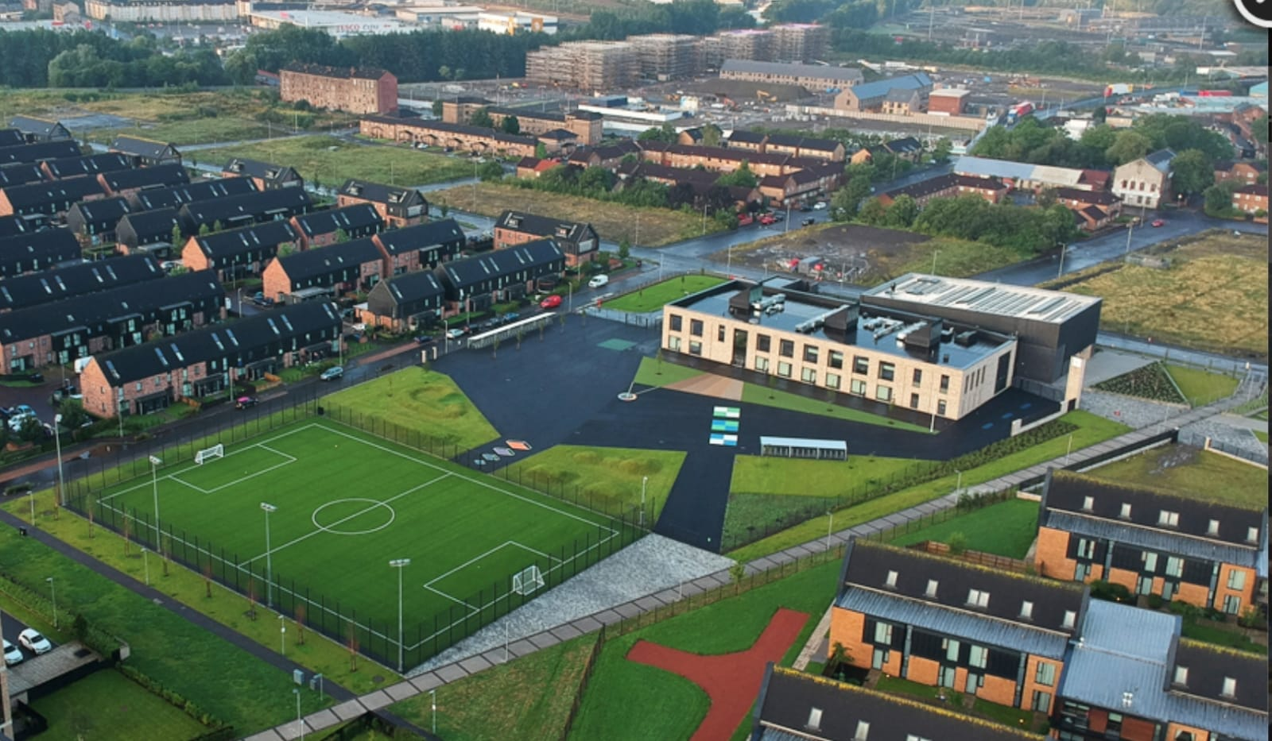
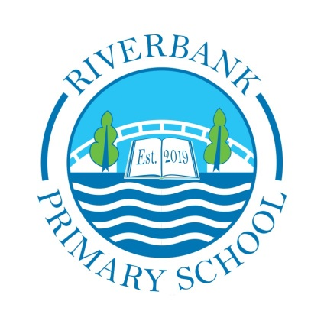
Newsletter

Issue 18
December 2021
We can’t believe it is December already! This term has flown by and we certainly have been very busy.
Covid 19 Advice
Guidelines and restrictions remain in place. Face coverings must be worn by adults at drop off and pick up. Parents are still not allowed into the playground or the building and social distancing still applies.
Remember if you or someone in your household is displaying symptoms of Covid then you need to self-isolate until you get a test.

Riverbank Primary School
1 Sunnybank Street Twitter: @RiverbankPri
Glasgow Headteacher@riverbank-pri.glasgow.sch.uk
G40 4RX Pupil Absence Line: 0141 471 3710

Self-isolating ensures everyone’s safety. As a reminder, coronavirus symptoms are:
- A new and persistent cough
- A high temperature
- A change or loss of smell/taste
Once a child receives a negative PCR test then they can return to school. Please remember – it must be a PCR test and not a lateral flow.
We will send a Warn and Inform letter when there has been a positive case of Covid-19 in your child’s
class. This is for you to read and to keep an eye for any symptoms with your child.
Further advice/information is available on the NHS Coronavirus website.
The new variant is of great concern and we want to ensure we are all playing our part to drive down rates of infection.
Homework
Please try to take part in homework activities that are available weekly on Showbie. If you need support with this you can check out our help-sheet on our website or call Mr Kenny. Homework will be given on a Monday and collected on a Friday.

Parent Council
Our Parent Council meet monthly to look at ways in which to support the school community. We are very lucky to have a proactive Parent Council. If you would like to join please email riverbankprimarypc@gmail.com . The next meeting takes place in January. This will be done via Zoom.
If you would like to read their annual report, this is available on our school website under the Parent Council tab.

Staffing
Mrs McHugh in P3a will finish up for maternity leave on 8th December. This is a very exciting time for her and her family and we wish her all the best for the weeks ahead. We can’t wait to hear her happy news. Miss Nicoll will now work with P3a Weds-Fri. We are awaiting the appointment of a teacher for Mon-Tues and will let families know as soon as we do.
Mr Ul- Hassan will be leaving us at Christmas. We thank him for supporting our learners and wish him well for his new school. Miss Hosie will return in January and we are delighted to have her back with us.
Uniform
A reminder that our uniform is navy blue jumper/cardigan, grey trousers/shorts/skirt, white shirt, school tie and black shoes. On gym days a white polo shirt may be worn. Tartan dresses, grey jumpers and white trainers are not part of the uniform and should not be worn to school. Please help us to uphold our uniform policy and show how proud we are to belong to the Riverbank family.
Can I also take this chance to remind you to please label everything your child brings to school? This will make it easier to find if misplaced. All of our previously lost property has been donated to clothing banks and charities and this is something we will continue to do.
TV and Film
Can I please ask that you keep a really close eye on the types of programmes children are watching? We have had a number of children discussing Squid Game and other inappropriate programmes for children. This can lead to upset and games that are not appropriate. We appreciate your support in this matter of safety.

Children In Need
Thanks to your incredibly generous donations we raised a phenomenal £570 for children In Need!! Thanks to all of you for your support and to staff for helping to organise activities.

Reporting to Parents
You recently received an interim report for your child in place of face to face meetings. We know this isn’t the same but we hope you found it useful. A short survey was sent out this week to gather your views on this. We will feed back results in the next newsletter and take forward any action points that are necessary.
Attendance
At recent tracking of attainment meetings with staff it has been noted that attendance at school is the single most common reason for some of our children not achieving. Please try to ensure your child is at school every day possible.
Remember if you need any support in relation to attendance then please do not hesitate to get in touch with the school.

Parent Pay
Huge thanks to the majority of our families who have signed up to our new online payment system. All Glasgow schools will be using this from now on so please try to activate your account soon. If you need any support with this please get in touch with Karen or Ashleigh at the school office who will be more than happy to help.
Free School Meals
As per Scottish Government guidelines Free School Meals will be rolled out to all P5s from 5th January. The kitchen staff are working hard to prepare for this. We will write to you all in January with details on how to pre-choose lunch choices via Parent Pay – this will be offered at the end of January.
Christmas
Christmas is just around the corner! Attached to this newsletter is a festive calendar to give you details of our upcoming events. Please read this carefully and take note of all important dates for your child’s class.
This year we would like to support our local foodbank with donations. Please, if you can, donate one of the items below at the school office or send it to school with your child. All support greatly appreciated.
- Christmas treats - selection boxes, chocolates etc
- Christmas Crackers
- Tinned meat such as ham
- Powdered Potato
- Gravy granules
- Mince pies
- Mixed veg

School Improvement Plan
In December each year we provide you with an update on our improvement plans. Please watch out for this coming before the Christmas break via email. We have been very busy!
Christmas Show
This year our show will be of a virtual nature again. We plan to release this via our Youtube channel in the last week of term. We will let you know when this happens so you can have your popcorn ready!

Thank you all, as ever, for your continued support this term. I think it is important to mention that we are still very much “mid-pandemic” with Covid still a present concern. We are doing everything we can to make a safe environment for everyone and I thank you for your support with this. Huge thanks must also go to our entire staff team for their never-ending hard work and care for our children. I hope that you all have a wonderful winter break when it comes and rest, relax, eat and be merry. School closes on Wednesday 22nd December at 2:30pm for P1-3 and 2:40pm for P4-7. We look forward to welcoming you all back on Wednesday 5th January at 9:00/9:10am.

Take care of each other
Mr Hynes

