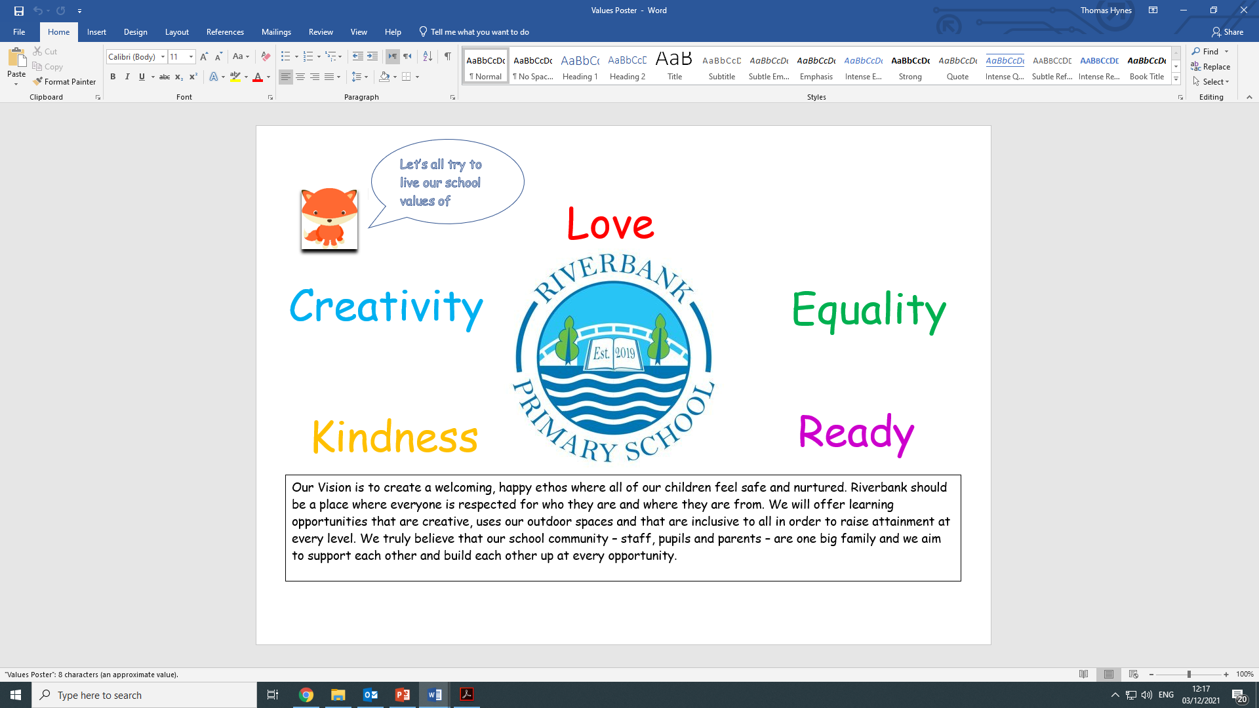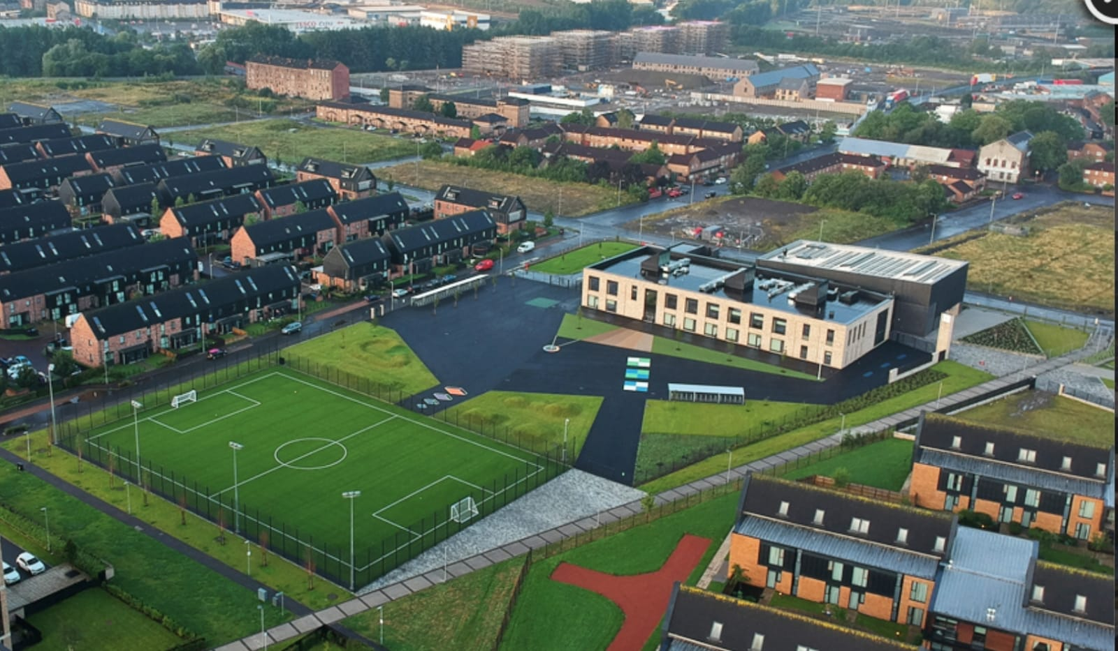Newsletter

Issue 19

January 2022

Happy New Year to all of our families. We hope you had a lovely holiday and that everyone is ready for a busy term ahead!

**Covid 19 Advice**

Face coverings must be worn by adults at drop off and pick up. Parents are still not allowed into the playground or the building and social distancing still applies.

Remember if you or someone in your household is displaying symptoms of Covid then you need to self-isolate until you get a test. If you test positive on a lateral flow device and have no symptoms then you don’t need to get a test but you do need to isolate for at least 7 days. If you test negative on Day 6 and 7 then you can return to normal life on the 8th day. Children will also need to isolate if they test positive. If your child is a close contact then they do not have to isolate – they can remain in school as long as you are testing them daily on a lateral flow device. This is extremely important for the safety of our staff and pupils.

Self-isolating ensures everyone’s safety. As a reminder, coronavirus symptoms are:

* A new and persistent cough
* A high temperature
* A change or loss of smell/taste

We will send a Warn and Inform letter when there has been a positive case of Covid-19 in your child’s class. This is for you to read and to keep an eye for any symptoms with your child.

Further advice/information is available on the NHS Coronavirus website.

The new variant is of great concern and we want to ensure we are all playing our part to drive down rates of infection.

**Homework**

Please try to take part in homework activities that are available weekly on Showbie. If you need support with this you can check out our help-sheet on our website or call Mr Kenny. Homework will be given on a Monday and collected on a Friday.

**Parent Council**

Our Parent Council meet monthly to look at ways in which to support the school community. We are very lucky to have a proactive Parent Council. If you would like to join please email [riverbankprimarypc@gmail.com](mailto:riverbankprimarypc@gmail.com) . Please get in touch with us if you would like to join the next meeting.

**Staffing**

We are delighted to announce that Mrs McHugh gave birth to a beautiful baby boy named Theo on Christmas Day. We hope the whole family are enjoying this precious time together.

We extend a very warm welcome back to Miss Hosie who has returned from her maternity leave. Miss Hosie will work in P5/6 for part of the week and will offer literacy support on her other days.

Welcome back also to Mr Ul Hassan who will be teaching in P3a on a Monday and Tuesday. He will work in a different school the rest of the week.

**Uniform**

A reminder that our uniform is navy blue jumper/cardigan, grey trousers/shorts/skirt, white shirt, school tie and black shoes. On gym days a white polo shirt may be worn. **Tartan dresses, grey jumpers and white trainers are not part of the uniform and should not be worn to school.** Please help us to uphold our uniform policy and show how proud we are to belong to the Riverbank family.

Can I also take this chance to remind you to please label everything your child brings to school? This will make it easier to find if misplaced. All of our previously lost property has been donated to clothing banks and charities and this is something we will continue to do.

**Reporting to Parents**

Before the holidays we asked for your feedback on our interim reports that were sent out in November. The results were as follows:

85% found the reports extremely/somewhat useful

81% felt they knew more about their child’s achievements

81% felt they knew what their child’s next steps are

73% said they preferred face-to-face reports

We also received a number of suggestions on how we could improve written reports which we will work on for our end of session reports.

We are still awaiting guidance from the Scottish Government on our next Parent Meetings in March – we will update you as soon as we know.

**Parent Pay**

Huge thanks to the majority of our families who have signed up to our new online payment system. All Glasgow schools will be using this from now on so please try to activate your account soon. If you need any support with this please get in touch with Karen or Ashleigh at the school office who will be more than happy to help.

From 7th February meal choices will be able to be made on Parent Pay meaning you and your child can choose their meals the night before. We will write to you soon with more information on this.

**Free School Meals**

As per Scottish Government guidelines all P5 children are now entitled to Free School Meals.

**Christmas**

Huge thank you to our families for supporting our local foodbank with their kind donations. They were very grateful.

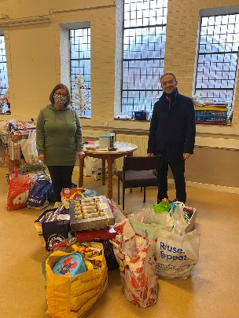

Thanks to your kind donations we raised £166.50 for school funds through sale of our Christmas crafts. This money will go towards paying for special visitors, trips and treats for our children.

For Christmas Jumper Day we were delighted to raise £192.50 for Save The Children. Thank you all for your generosity at what can be a difficult time of year for so many.

**Learning**

This term our school are focusing on Scotland as their learning theme. Classes will be working on many different aspects of our great country and you can find out more about this on our website in the next couple of weeks. We will be celebrating Burns’ Day on the 25th with some poetry and songs and then on January 28th we will have a day of Scottish Celebration. On this date we ask that our pupils wear something tartan along with their uniform. We will also be treated with some Irn-Bru and shortbread in classes. We hope to be able to share our celebration through YouTube shortly afterwards.

**Walk and Talk**

Mrs Whyte is organising a series of “Walk and Talk” sessions starting on Friday 4th February at 2pm. If you fancy having a walk in the park with some others, grabbing a coffee/tea/hot chocolate and having a chat then please just come along to the school on this date. Feel free to bring along a baby or a toddler if you need to – this is about having a wee bit of time to unwind and chat while having a healthy walk in the fresh air. We look forward to seeing some you then.

**RSHP**

We are continuing with our Relationship and Sexual Health Programme this term. To help your child understand the more sensitive topics please have a look at the website and its resources on [www.rshp.scot](http://www.rshp.scot) Here you will find all of the lessons being covered in classes.

As ever we are here in the playground each morning and afternoon, at the end of the phone or an email for anything that we can help with. Please continue to keep yourselves safe and well.

Mr Hynes