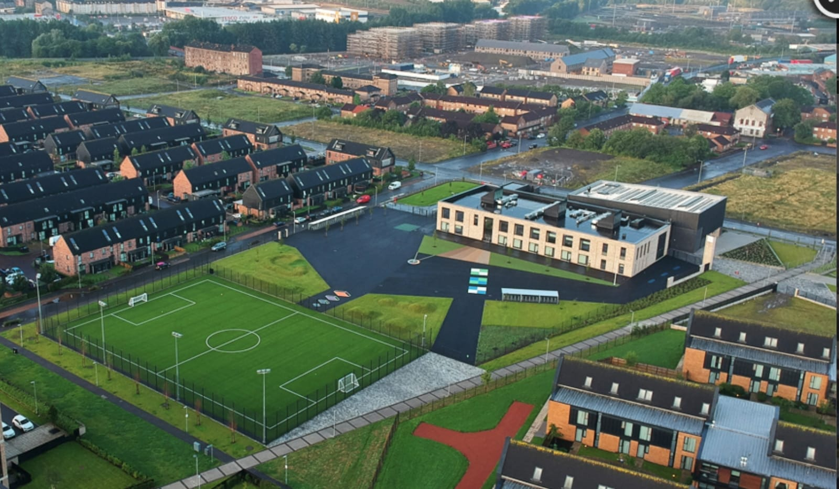
Newsletter

Issue 22
June 2022
Welcome to our June newsletter.
Homework
The final week of homework will be week beginning 4th June. After this class teachers will be focusing on gathering assessment information in preparation to pass on to the next class teacher.
Staffing
In August we will be welcoming some new staff to our team.
Ms Jarrett and Miss Logan will be joining us on a full-time permanent basis.
Mrs Tan will join us for a short while to cover Mrs McHugh’s maternity break.
Mrs Clark is expecting a baby and will be going on maternity leave in September. We are interviewing for an Acting Principal Teacher to cover her post next week and will let you know the outcome soon.
We are still awaiting names of three other staff members – once we know them we will let you know.

Classification
As we are still waiting for staff to be allocated we have not been able to fully work out classes for next session yet. We do know we will have a number of composite classes due to our numbers of pupils at certain stages. A composite class is when two classes are joined together. The benefit of this is that the class size is capped at 25 which means more teacher-pupil time. We will email all of the details out during the final week of term so please ensure your email details are up to date.
Uniform
A reminder that our uniform is navy blue jumper/cardigan, grey trousers/shorts/skirt, white shirt, school tie and black shoes. On gym days a white polo shirt may be worn. Tartan dresses, grey jumpers and white trainers are not part of the uniform and should not be worn to school. Please help us to uphold our uniform policy and show how proud we are to belong to the Riverbank family. Remember you can begin to order uniform for next year now through www.schoolwearmadeeasy.com All school ties will also be available to purchase from here too.

Parent Pay
Huge thanks to the 85% of our families who have signed up to our new online payment system. All Glasgow schools will be using this from now on so please try to activate your account soon. If you need any support with this please get in touch with Karen or Ashleigh at the school office who will be more than happy to help.
Our meal selection feature is going very well so thank you for your support with this. Please continue to pre-select your child’s meal each night/morning for the day/week ahead. This will help reduce time spent in classes doing this. The new menus for meal selection are also available on our website.

Walk and Talk
Thanks to those of you who have come along to this – Mrs Whyte has loved chatting with you all. If you fancy having a walk in the park with some others, grabbing a coffee/tea/hot chocolate and having a chat then please just come along to the school on this date. Feel free to bring along a baby or a toddler if you need to – this is about having a wee bit of time to unwind and chat while having a healthy walk in the fresh air. The last date for this session will be Thursday 16th June at 2pm. We look forward to seeing some you then.

Community Litter Pick
Huge thanks to those of you who were able to make it along to the community litter pick on the 14th May. We had over 60 people there and managed to collect more than 20 bags of rubbish. It was so nice to see so many people taking pride in our local community and also to chat and have a bit of fun. We will be doing this again when we return in August.
Transitions
It has been wonderful meeting all of our new P1s over the past few weeks. On Tuesday 31st May we met with our new (and some not so new!) families to discuss the big move.
Our P7s have begun their full day transition visits to their new high schools. An email has been sent to P7 parents with dates of these visits, Leaver’s Assembly, Leaver’s Treat etc for their information. On the last day of term we will have our annual special send off for P7s in the playground just before 1pm – please come along and help to cheer them on.
As part of our transition programme all children will “bump up” to their new classrooms and hopefully meet their new teachers on Monday 20th June at 2pm. This will give them a chance to meet new staff, see their new classroom and help to lay any worries at rest. We may not have all of our new staff on this date but we will do our best.

Health Week
Huge thanks to our staff team for their support in Health Week this year. We had lots of fun activities for children which everyone seemed to enjoy. It was nice to have so many parents and family members along to watch the sporting events too.

Communications
We understand that some of our recent communications could have been better timed. We take on all feedback and have ensured we learn from it for next time. This has been a very difficult year to manage in terms of Covid restrictions changing and we have tried incredibly hard to be responsive and measured in our approaches. We are grateful to our families for their support and understanding with this.
Reporting to Parents
On Tuesday 31st May we had our first Parent’s Evening in over two years. It was wonderful to be able to meet and greet you all in person and welcome you all back into our school. We had a huge turnout of 94%. It was great to be able to have some normality back.
All pupil report cards were sent home on Thursday 26th May. If you have not received it yet please let us know. We are very proud of our pupil’s achievements.

Feedback
At our Parent’s Evening we asked you for feedback of what we could do better. Communication timings were noted which we will act upon. You were also keen to have more in the way of coffee mornings and family engagement. We agree and will be organising more inclusive ways of ensuring we get to see more of you over the coming year. We can’t wait!

Fundraising
On Thursday 26th May we held a sponsored walk to tie in with Health Week in order to raise money for school funds. We were overwhelmed with your generosity as we raised over £500! Thank you so much.
Our Parent Council have also been busy and have donated over £1000 towards school funds. All money raised is being spent on:
- P7 Leaver’s Hoodies
- P7 Leaver’s Treat
- P1 ties (welcome gift)
- P1 Foxes (welcome gift)
- Ice lollies for all children
- Buses for trips
- Pantomime visit for end of term
- Fruit for smoothies
Huge thanks again to our Parent Council for their continued support.
School Disco
Our Parent Council are organising an end of term disco for the children now that we all can mix together. It will be on Wednesday 22nd June. Times are 6pm-6:50pm for P1-3 and 7pm-7:50pm for P4-7. It will be £1 per child and will take place in the school. We are looking forward to this fun event.
The Lion King
Pre-pandemic we had been allocated 50 tickets to see The Lion King in Edinburgh. Due to Covid-19 this was cancelled but we are delighted that we can now return. Due to numbers we are taking P5 and P6 to the theatre to see this spectacular show on 14th June. Parents of children in these classes have had information sent home about the trip. We believe it will be a very worthwhile and enjoyable experience – even if it will be a late night!

Diary Dates
Please see below some important dates for the term ahead:
Week beg 6th May – all classes will have fun sessions in Cuningar Loop
14th June – Teacher Swap afternoon (as suggested by our Junior Leadership Team!)
20th June – Bump Up Afternoon
21st June – P7 Leaver’s treat
22nd June @9:30 – P7 Leaver’s Assembly
22nd June 6pm-6:50 – School Disco for P1-3
22nd June 7pm-7:50 – School Disco for P4-7
23rd June – Treasure Island Pantomime for whole school
24th June @1pm – School closes for Summer Holidays

As mentioned previously we will write to you during the last week of term with details of classes and staff for next session. In the mean-time if you need any further information please just get in touch.

Mr Hynes

