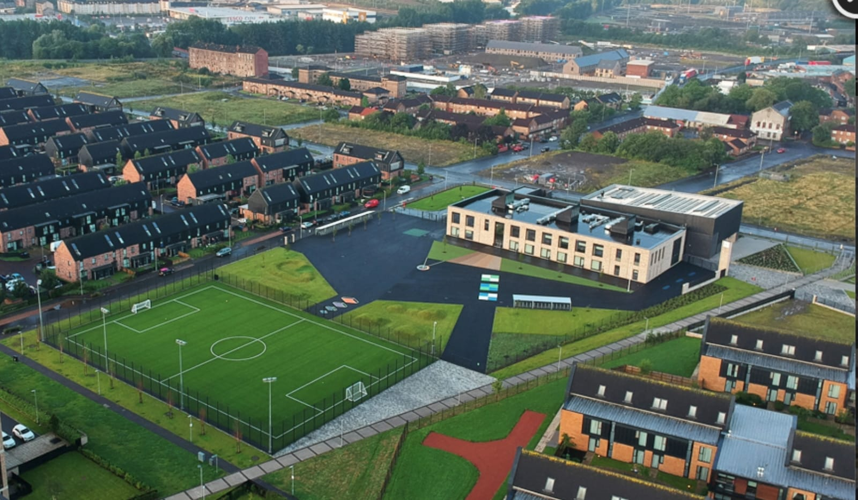Newsletter

Issue 14

May 2021

Welcome to our May newsletter. We can’t quite believe how quickly the time has passed and now we are in our final term of the year. This is our first Term 4 in our building and so we intend to make it a great one! I have attached a list of important dates at the back of this newsletter for your convenience. As always please get in touch if you need anything.

**Covid 19 Advice**

Remember if you or someone in your household is displaying symptoms of Covid then you need to self-isolate until you get a test. Self-isolating ensures everyone’s safety. As a reminder, coronavirus symptoms are:

**Riverbank Primary School**

**1 Sunnybank Street Twitter: @RiverbankPri**

**Glasgow Headteacher@riverbank-pri.glasgow.sch.uk**

**G40 4RX Pupil Absence Line: 0141 471 3710**

* A new and persistent cough
* A high temperature
* A change or loss of smell/taste

Further advice/information is available on the NHS Coronavirus website.



**Homework**

All classes will now be receiving homework again via Showbie. Please get in touch with us if you have forgotten your child’s login or if you have difficulties accessing a device.

**Fundraising**

Last term we raised an incredible £344.37 for Red

Nose Day! A total to be proud of! We also raised £154.62 for our dress down day at the end of March. This money goes towards our schools funds to help buy items for our children to enrich their learning. Huge thanks to everyone for their support.

**Parent Council**

Our Parent Council have been meeting monthly to look at ways in which to support the school community. We are very lucky to have a proactive Parent Council. If you would like to join please email [riverbankprimarypc@gmail.com](mailto:riverbankprimarypc@gmail.com) . The next meeting takes place on Tuesday 11th May at 6pm. This will be done via Zoom.

If you would like to read their annual report, this is available on our school website under the Parent Council tab.

C:\Program Files (x86)\Microsoft Office\MEDIA\CAGCAT10\j0234131.wmf

**Attendance/Late Coming**

Please ensure children attend school as often as possible. Even one day absences here and there can all add up. Now more than ever it is important to ensure maximum attendance so that we can support children in the recovery from the pandemic. Please also try to ensure children are on time in the morning.

If you need support with anything please just contact the school. Thank you for your support with this.

**Staffing**

Mrs MacMillan Currie will finish up for her maternity leave on Friday 14th May. It is a very exciting time for her and her family and we wish her well in the coming weeks. We are very much looking forward to hearing some lovely news soon. We are still awaiting confirmation of who will cover P1b – once I know who this is I will let parents know.

We are delighted to confirm that Mrs McGeouch has been made a permanent member of our staff team for next session. Miss Mort will also be staying with us in the short term to continue to cover Miss Hosie’s maternity leave. We will confirm our new staffing for August in our June newsletter.

**Snacks/Lunch**

Just a reminder that healthy options should be included in children’s snack and lunches. Fizzy juice or diluting juice is not allowed due to the sticky nature of the liquid when it spills. Water bottles should be brought from home as these cannot be refilled in school due to our water machines being out of use at the moment.

**Road Safety**

As you are aware Sunnybank Street and Auckland Wynd are very busy roads. Please remember that children and adults are crossing these roads in the mornings and afternoons when dropping off or collecting their children. If you are driving please do so slowly to ensure everyone is kept safe. If you are walking please cross at a quiet and open space so you can see clearly. Thank you.

**Reports**

As usual you will receive a progress report for your child towards the end of this session. The date is on the list attached. This will provide you with a further update on how your child is progressing and will look at next steps for learning also. There will be a feedback sheet attached to this and we welcome your comments in order for us to further improve for next session. Thank you.

**Pupil Equity and Covid Recovery Funding**

Each year we receive Pupil Equity Funding to help with teaching and learning and closing the poverty related attainment gap. For this year we have been allocated £111510. We have also been allocated £29807 in Covid Recovery funding. We will be discussing this spend with our staff team and pupils in the coming weeks. We will also be emailing a questionnaire to you shortly to find out your views on what we should do with this. Everyone’s views are important and we look forward to hearing them.

**Transitions**

|  |  |
| --- | --- |
| **Date** | **Activity** |
| Monday 3rd May | School closed for Bank Holiday |
| Thursday 6th May | School closed to pupils due to General Election |
| Week beginning 24th May | Health Week at Riverbank |
| Thursday 27th May | Sports Day – more info to follow |
| Friday 28th and Monday 31st May | School closed for May Holiday Weekend |
| Monday 7th and Tuesday 8th June | P7s to Blairvadach for two day visits (letters to follow) |
| Week beginning 14th June | P7 Leavers assembly/celebration (date TBC) |
| Week beginning 21st June | Class Treats |
| Thursday 24th June | School closes at 1pm |

**Important Dates for your Diary**

Our new P1s for August will be getting excited about what lies ahead. We will be contacting their families soon with information about a pre-visit to the school.

Our current P7s will be thinking ahead to S1. I know some of you have applied to other schools through Placing Requests. Please get in touch with me if you have any questions regarding this. We are waiting on guidance from Eastbank Academy on another visit for our P7s this term.

**Class Treats**

We are working with our Parent Council to provide a treat for all classes for the end of term. As soon as we have a plan we will let everyone know.

As ever if you need anything from us here at Riverbank please just let us know. Thank you for your ongoing support in ensuring our children are ready, respectful and safe.

Mr Hynes