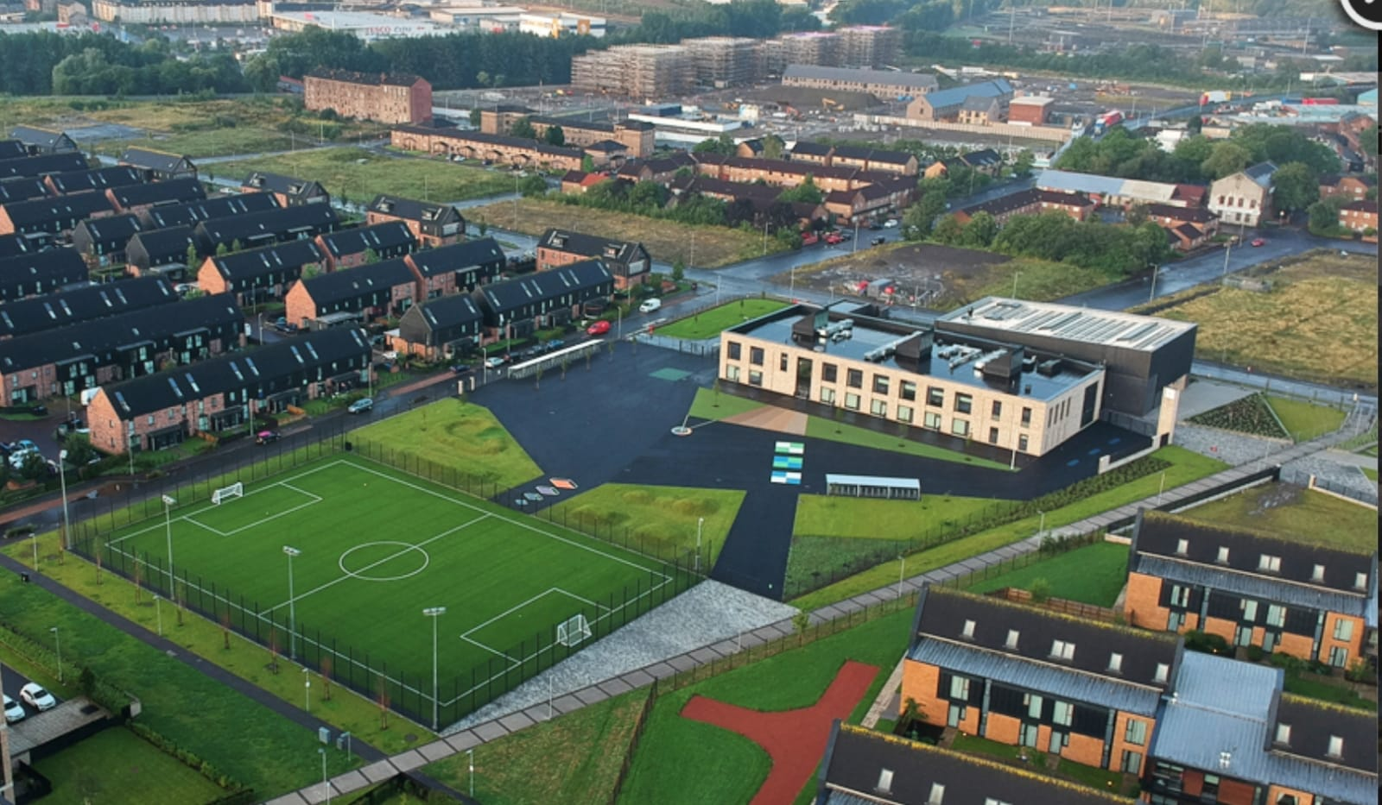
Newsletter

Issue 30
Nov/Dec 2023
Term 2 is well and truly underway at Riverbank. We have been busy with beginning new topics of learning and welcoming lots of new families to our school community. In this newsletter you will find some information regarding our plans for Christmas too.
Homework
Recently we carried out a survey of homework and its suitability. Thank you for your responses. Mr Kenny is now liaising with staff and children and we hope to share the results of this with you early next term. For now, homework will continue on Showbie.

Staffing
Congratulations to Miss Hosie who welcomed a beautiful baby girl last month. We wish her and her family well in this exciting time and we look forward to meeting her soon.
Congratulations also go to Miss Nicoll who got married at the October break and is now known as Mrs Bennett. We wish her and her husband the very best in this new chapter.
We have been lucky enough to be joined by three teaching students over the past few weeks. Miss Low in P7/6, Miss Carmichael in P2b and Miss Hanna in P4a. We thank them for their hard work and enthusiasm and we wish them all the best in their future careers.
Due to our increasing school roll we have been allocated the role of a new Principal Teacher. Following interviews on Monday 13th we are delighted to share that Mrs Clark was the successful candidate. We are thrilled for her and our school. We will let you know when her official start date will be and what her remit will entail.

Uniform
A reminder that our uniform is navy blue jumper/cardigan, grey trousers/shorts/skirt, white shirt, school tie and black shoes. On gym days a white polo shirt may be worn. Tartan dresses, grey jumpers and white trainers are not part of the uniform and should not be worn to school. Please help us to uphold our uniform policy and show how proud we are to belong to the Riverbank family. Remember you can order uniform from www.schoolwearmadeeasy.com All school ties will also be available to purchase from here too.
Please ensure all school clothing have names on them. We already have a collection of un-named clothing built up in the school.
Please remember that branded uniform is not compulsory. Uniform items bought in supermarkets is perfectly acceptable as long as it is school colours.

Parent Pay
Please continue to pre-select your child’s meal each night/morning for the day/week ahead. This will help reduce time spent in classes doing this. The new menus for meal selection are also available on our website.
Please ensure you have signed up to parent pay as all monies needed for school will be paid via here – as well as registration for after school clubs.
Parent Portal
Please ensure you have signed up for Parent Portal. If you need help with this please contact the school office.
Parent Portal now contains our school calendar for the year ahead for your convenience.
You can also use this to apply for your child’s free bus pass.

Online Safety
A reminder that we will run a Parent/Carer information session around online safety on Tuesday 28th November at 6:30pm. Please prioritise this meeting and send one adult per household. It is essential to our children’s safety and wellbeing that we all have the same information. A sign-up option is available on Parent Pay. Thank you.

P.E.
As per Scottish Government guidelines each child will receive 2 hours of P.E. each week. Please note that for P.E. children should bring appropriate kit for that day. No jewellery is permitted to be worn during P.E. as per Glasgow City Council guidelines. All earrings must be removed. If you child has had their ears pierced within the last 6 weeks then they will not be permitted to take part.
Child Protection and Safeguarding
For all Child Protection concerns Mr Hynes remains the Child Protection Coordinator so please contact him if you have a concern. In his absence please contact Mrs Whyte.
Drop Off Point
Please consider safety when dropping off your child at the school gate in the car. The drop off point is not a car park. You should drive your car in, allow your child to exit and drive off. If you need to park and walk your child to the gate then please park on one of the side streets and walk over. Thank you for your support with this.

Cost of the School Day
As a school we are looking at ways in which to address the cost of the school day. We try our best not to ask for too much money at once and look to support families when necessary. We have recently emailed a survey out to parents about this. Thank you to those who responded. The feedback is being analysed and an email will be sent to everyone soon with our next steps. Please remember if you are struggling financially to get in touch with us and we will try to help.
As mentioned previously, staff have kindly asked for no gifts at Christmas this year. We understand the pressures on families and while we greatly appreciate the kind gestures we really don’t need anything. Instead a card or email of thanks will be wonderful. Thank you.
Attendance
At Riverbank we try to ensure we support families with attending school. We monitor attendance closely and keep in contact to see if there is anything we can do to help. Coming to school is very important. The routine and structure is vital for their progress and development. Next week we will be sending letters home to anyone whose attendance has fallen under 90%. We will do this every 6 weeks to ensure we keep good communication with those who may find this difficult.
We are also going to publish the attendance statistics each month for everyone to see. Every day matters. Please see below for our current attendance statistics for each class.
 | Oct | Nov
P1a | 97% | 97%
P1b | 95% | 89%
P2a | 95% | 92%
P2b | 96% | 98%
P3a | 95% | 94%
P3b | 96% | 94%
P4a | 97% | 96%
P4b | 94% | 95%
P5a | 96% | 95%
P5b | 95% | 93%
P6 | 94% | 96%
P7/6 | 95% | 92%

As you can see the majority of classes have seen a decrease in attendance over the past few weeks. This is something we are monitoring closely and we will work to support families to improve on this.
As always if there is anything we can help with please let us know.
Christmas Fayre
This year our Christmas Fayre takes place on Thursday 7th December from 3:15-4:45 in our hall. We hope to have the usual stalls featuring our class creations, local vendors, toys/books, hot chocolate and many more. We also hope to have our famous raffle! If you are interested in holding a stall please contact our Parent Council who can help.
If you have any old toys, books, games etc that you want to clear out then please bring it into the school so we can sell it on. The fayre is our main source of funds for the school year and so we hope to raise a lot of money.
Please note – we are no longer allowed to have alcohol as part of our raffle prizes or donations. This is a Glasgow City Council policy.
This year we are organising our raffle slightly differently. We are going to have class hampers based on colour themes as follows.
P1 – Red
P2 – Blue
P3 – Yellow
P4 – Pink
P5 – Green
P6 – Orange
P7 – Purple
On Friday 1st December we ae going to ask children to dress in the colour of their hamper and bring a donation from home of something with that colour. It can be anything from chocolate to a beach towel. We will then raffle these hampers at the fayre.
Christmas Show
Our P1-3 classes will put on a Christmas show for families on 13th Dec at 1:30pm and 14th Dec at 9:30am. Our P1 children will perform in their version of the nativity “It’s a Census, Get Me Out of Here!”. Our P2 and P3 classes will perform some Christmas songs to get us in the festive mood. There will also be a performance from our school choir.
Tickets for performances will cost £2 each and can be bought on Parent Pay now.

Christmas Dates
Please see below our diary dates for the Christmas season.

1st Dec – Choir performing at St Enoch’s Centre at 12pm for Prince and Princess of Wales Hospice
1st Dec – each class dressing down in hamper colours – bring donation of that colour to school
Week beg 4th Dec – Christmas Tree lights switch on in front of school (date TBC)
5th Dec – P7/6 attending panto at Kings Theatre
7th Dec – Christmas Fayre (3:15-4:45 in hall – all welcome)
8th Dec – Christmas Jumper Day - donation on Parent Pay
12th Dec – Panto performance in school for P1-P6 classes
13th Dec – P1-3 Christmas Show @1:30pm
14th Dec – P1-3 Christmas Show @9:30am
14th Dec – Christmas Lunch in lunch hall (menu to follow)
21st Dec – Christmas Discos (P1-3 6pm-6:45pm; P4-7 7pm-8pm, £2 per child)
22nd Dec – school closes at 2:30pm for Christmas holidays

