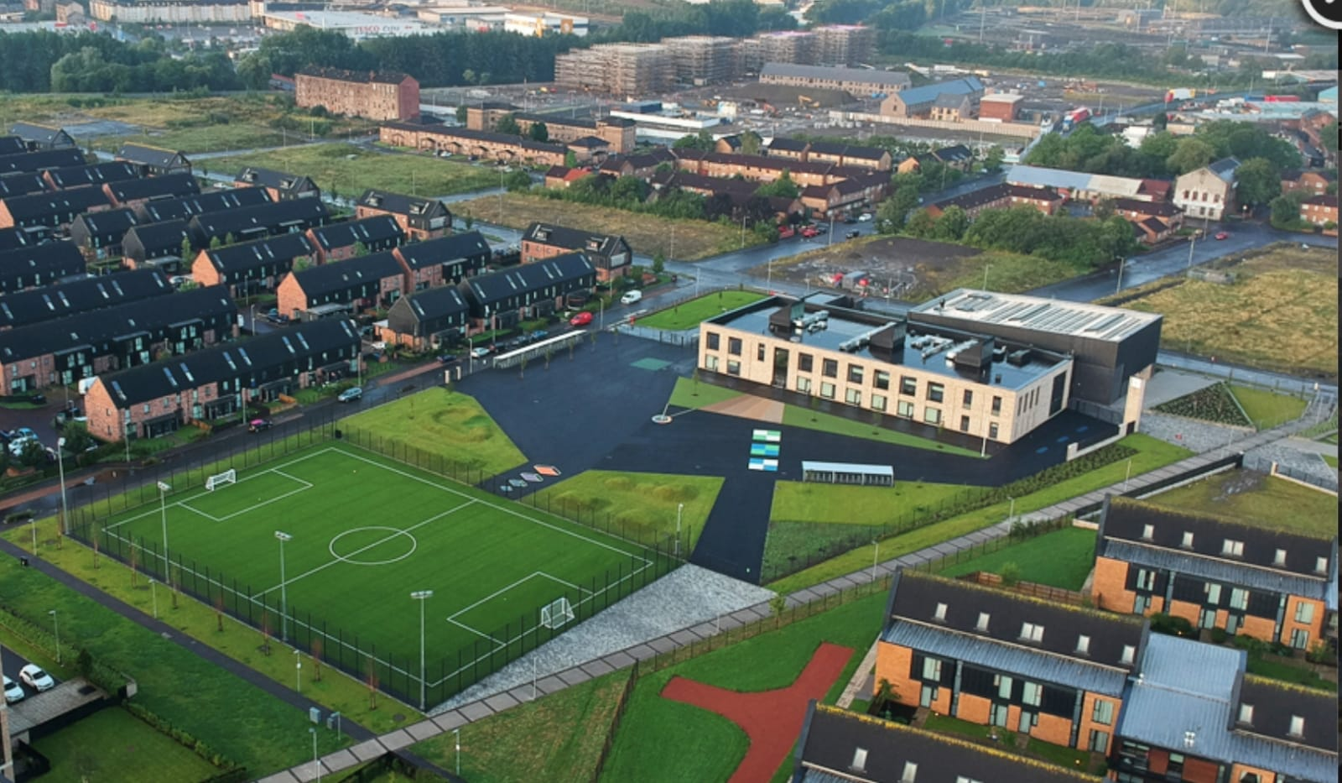
Newsletter

Issue 24
October 2022
Welcome to the start of another term here at Riverbank. We have lots of information to share with you – hopefully you will find it helpful.
Showbie
As usual all homework will be carried out via our online learning app Showbie. In response to a parent suggestion we will now also be sharing some of our learning through pictures and videos via Showbie. We hope you enjoy getting a glimpse into our daily learning.
Staffing
We are delighted to welcome some new staff members to our team.
Mrs Gaw will teach P1/2 Mon-Weds to cover Mrs Tan.
Miss Berwick will teach P2/3 until Miss Hosie returns from maternity leave.
We know you will make them feel welcome in our school community.
At the end of last term we said farewell to Mrs Tan who started her maternity leave. We hope to share good news with you all soon.
Speaking of good news I am delighted to share that Mrs Clark gave birth to a beautiful baby boy last month! Both are doing well and we look forward to giving him a cuddle very soon.
Uniform
A reminder that our uniform is navy blue jumper/cardigan, grey trousers/shorts/skirt, white shirt, school tie and black shoes. On gym days a white polo shirt may be worn. Tartan dresses, grey jumpers and white trainers are not part of the uniform and should not be worn to school. Please help us to uphold our uniform policy and show how proud we are to belong to the Riverbank family. Remember you can order uniform from www.schoolwearmadeeasy.com All school ties will also be available to purchase from here too.
Please ensure all school clothing have names on them. We already have a collection of un-named clothing built up in the school.

Parent Pay
Please continue to pre-select your child’s meal each night/morning for the day/week ahead. This will help reduce time spent in classes doing this. The new menus for meal selection are also available on our website.
Please ensure you have signed up to parent pay as all monies needed for school will be paid via here – as well as registration for after school clubs.

Online Safety
Huge thank you to those parents and cares who attended our Online Safety event with Police Scotland last month. We hope you found it helpful. For those of you who couldn’t make it along we have put the presentation on to our school website for your information.

Pick Up/Drop Off
Our school roll is ever increasing and at the time of writing is at 305 children. This is a long way from the 160 we had when we opened 3 years ago. With this comes an increase in traffic and people at drop-off and pick-up times. Please follow these steps below to ensure safety for our pupils.
- If possible do not drive down Auckland Wynd. Park your car elsewhere and walk if you are picking up at this gate. If you must drive down it please drive at 5mph and be courteous to families.
- When standing at gates for pick up please stand well back so class teachers can see who children are going to. This is especially important for P1 families as we get to know you better.
- If you have more than one child please ensure they know which gate they are leaving from to alleviate any stress at the end of the day.
Thank you for your support with this.
It will be Road Safety Week beginning 14th November. Our Junior Road Safety Officers will be launching a competition for our children and sending home information for families around road safety.

Parent/Carer Feedback
It was wonderful to be able to welcome families back into our building again this session. Our Meet the Teacher and Open Afternoon sessions were well attended and we had lots of positive feedback on them. Some of the things you said we were doing well were:
- Good communication
- Nice learning environments
- Friendly staff
- Welcoming ethos
- School is well organised and run

As part of the feedback we asked about thing we could better. Some of you said:
- More opportunities for learning with children in classes/school
- More parental involvement
- Information about what children are learning
- More after school clubs
- Reading books being sent home
- More trips

We listen to your feedback and are implementing a Family Learning and Engagement programme. I have attached details of this to this newsletter. I trust you will find this helpful and we look forward to increased family engagement over this session. My thanks to Miss McMillan and Mr Kenny for their lead on this.
We are also using Showbie as a tool to share what is happening in classes as well as a termly overview of what will be learned.
Reading books were not being sent home due to Covid restrictions. We are discussing the sending home of books again with staff and will update you soon on this.

Christmas Fair
We are delighted to reinstate our Christmas Fair again. This year it will be held on Thursday 1st December from 3:15-5pm. This will be held in our assembly hall. Our Parent Council are helping to organise this but if you would like to help too then please get in touch. We hope to have a tombola, raffle, bric-a-brac, toys, gifts, uniform, home baking and handmade crafts on sale. Remember all profits go back into the school to pay for resources, trips etc.
If you have any old toys, games, books, gifts or household items you want to clear out please send them into us over the next few weeks. All donations welcome!

Parent’s Evening
Our fist reporting event of the session will take place on Tuesday 8th November. Your appointment slip will be with you this week. Please try to stick to this time so that the appointments run smoothly. We are looking forward to sharing your child’s progress with you.

Children In Need
Fundraising for Children in Need will take place on Friday November 18th this year. The theme is “Be Spotacular”. On this day it will be non-uniform and we encourage our school community to be spotty in their clothing! A letter with further information on the day will follow soon.

Christmas Show
This year we will return to an in-person Christmas Show! Our P1s will take on lead roles in our nativity called Wriggly Nativity. Our P2s and P3s will support this with beautiful Christmas songs. These shows will take place at the following times:
20th December @ 9:30am
21st December @ 1:45pm
We are looking forward to seeing you all there!
Our P4-7 children will take part in a Summer Show later in the school year.

As always if there is anything we can help with please get in touch at the office.

Mr Hynes

