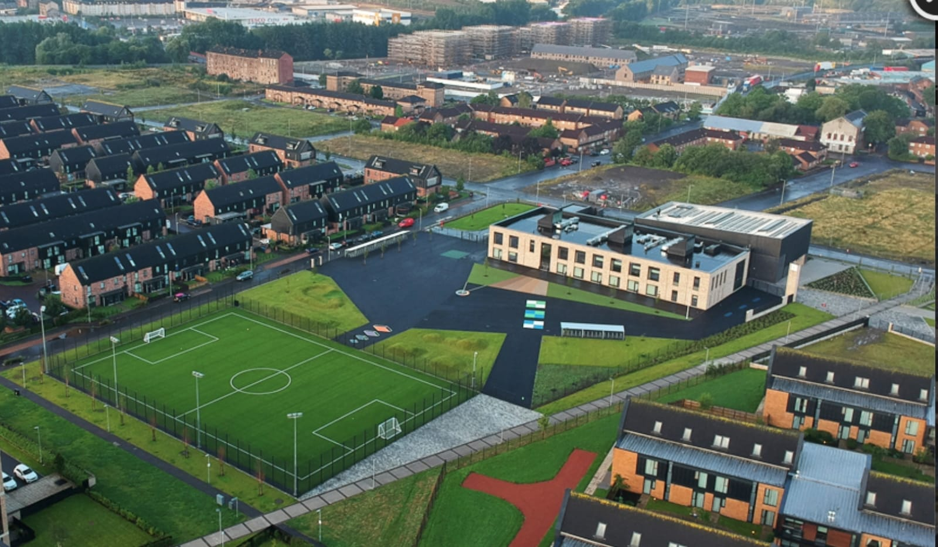
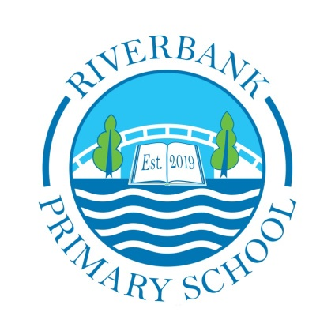
Newsletter

Issue 16
September 2021
Welcome back everyone. We are delighted to be back into routine here at Riverbank and we are looking forward to a hopefully more normal school year.
Covid 19 Advice
For the next few weeks there are still guidelines and restrictions in place. Face coverings must be worn by adults at drop off and pick up. Parents are still not allowed into the playground or the building and social distancing still applies.
Remember if you or someone in your household is displaying symptoms of Covid then you need to self-isolate until you get a test.

Riverbank Primary School
1 Sunnybank Street Twitter: @RiverbankPri
Glasgow Headteacher@riverbank-pri.glasgow.sch.uk
G40 4RX Pupil Absence Line: 0141 471 3710

Self-isolating ensures everyone’s safety. As a reminder, coronavirus symptoms are:
- A new and persistent cough
- A high temperature
- A change or loss of smell/taste
Rules have changed for schools and now all contact tracing will be carried out by Test and Protect. Once a child receives a negative PCR test then they can return to school. Please remember – it must be a PCR test and not a lateral flow.
We will send a Warn and Inform letter when there has been a positive case of Covid-19 in your child’s

class. This is for you to read and to keep an eye for any symptoms with your child.
Further advice/information is available on the NHS Coronavirus website.
This virus is still very much with us so please remember to keep following all of the safety rules: for you and for everyone else.
Homework
Showbie codes have now been sent out to everyone. All homework will be given through this platform. If you need support with this you can check out our help-sheet on our website or call Mr Kenny. Homework will be given on a Monday and collected on a Friday.

Parent Council
Our Parent Council meet monthly to look at ways in which to support the school community. We are very lucky to have a proactive Parent Council. If you would like to join please email riverbankprimarypc@gmail.com . The next meeting takes place on Tuesday 26th October at 6pm. This will be done via Zoom.
If you would like to read their annual report, this is available on our school website under the Parent Council tab.

Staffing
We are delighted to welcome so many new staff members to our school this term.
Miss Gamble – P2b
Miss McKenzie – P3b
Mr Keenan – P3b
Miss Reilly – P4
Miss Barr – P5/6
Mr Ul Hassan – P5/6
Miss Cowden – P6
Mrs Dempsey – Support for Learning Worker
As part of our Pupil Equity Funding we have appointed a new Principal Teacher who will help to raise attainment across our school. Mrs Clark (formerly Miss McLaughlin) has taken up this post. Congratulations to her on this and also on her recent celebration of marriage.
We have also used our PEF to appoint one additional member of support staff. We are awaiting their start date. This is to provide additional support for our children.
With the updated Covid advice around testing and isolating we are experiencing periods where we do not have a full staff team. This is especially true in our office. Please bear with us and allow for extra time when calling or visiting in person. Thank you.

Uniform
Now that we are beginning to return to a sort of normality the rules on school uniform will be followed again. Uniform is navy blue jumper/cardigan, grey trousers/shorts/skirt, white shirt, school tie and black shoes. On gym days a white polo shirt may be worn. Tartan dresses, grey jumpers and white trainers are not part of the uniform and should not be worn to school. Please help us to uphold our uniform policy and show how proud we are to belong to the Riverbank family.
Can I also take this chance to remind you to please label everything your child brings to school? This will make it easier to find if misplaced. We have an enormous amount of lost property already. We will place this outside the main entrance (with the support of our Parent Council) over the coming weeks for you to look through and claim.

School Improvement Plan
Each year, following self-evaluation and consultation with parents and pupils, we identify areas to improve on for the coming session. This year we have identified the following areas:
- Improving our numeracy approaches to ensure consistency in teaching and learning across the school
- Making our school more inclusive through communication and language, ensuring rights-based education is at the forefront of learning and ensuring equality for all
- Ensuring a whole school focus on Developing the Young Workforce to begin discussions around the world of work.
We will update you on our progress within these areas in December and again in June.
Our Standards and Quality Report from last session will be shared with you all in the coming weeks. This will provide a brief summary of our achievements and successes.

Face Coverings
National guidance remains in place for the need to wear face coverings at drop-off and pick up at the school. This means wherever you are standing around the building. Please ensure you have a face covering. If you are exempt then please show appropriate exemption lanyards or cards.

Road Safety
You may have heard that last week Archie, our school Lollipop Man was knocked down while helping people across the road. He was injured but will make a full recovery. The police have been notified and are investigating. Please help us to keep our school community safe by following local speed restrictions and parking safely around our school. We send Archie all of our best wishes for a speedy recovery.
Diary Dates
I have included a list of important dates. We hope there will be additions to these depending on restrictions being lifted. We hope to have a full year in our beautiful building this session. Let’s all keep being safe to ensure this happens.

Thank you for your continued support
Mr Hynes

Friday 24th and Monday 27th September | School closed for September Weekend
Week of 28th September | Maths Week
7th October | Flu Vaccinations
8th October | School closed for Inservice Day training for staff
11th – 15th October | School closed for October Week
21st October | P6 Assembly (hopefully in person in the hall)
1st November | Sustainability Fortnight
4th November | Outdoor Classroom Day
12th November | Children in Need Day (more info to follow)
15th November | Anti-Bullying Week  Parent’s Evenings (to be confirmed)
Week of 13th December | Christmas Show (more info to follow)
22nd December | School closes at 2:30pm for Christmas Holidays
Riverbank Primary School Diary Dates 2021

