 | Mathematics Second Level  Remote Learning Activities | WEEK 1

Day 1 | Combinations of 1,000 (Source: mathlearningcenter.org)  Fill in the missing numbers to make a total of 1,000 in each box.  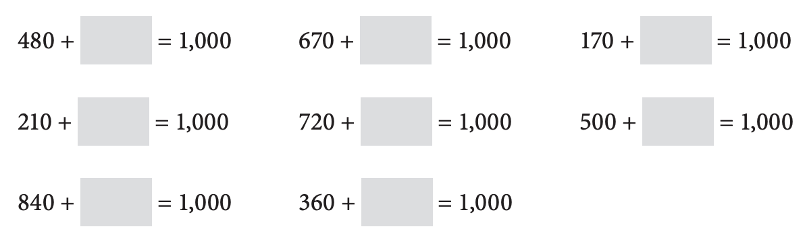  Measuring in Centimetres (Source: mathlearningcenter.org)  Please measure the following objects in centimetres and record the results.  Object to be Measured Measurement in Centimetres  - Width of your bed  - Width of a door  - Height from the floor to the seat of your favourite chair  - Length of a telephone or mobile phone  - Dimensions of your favourite book  Alligators  Ten alligators went down to the river. Three of them laid eggs. They laid 5 eggs each. A snake ate 8 eggs. How many eggs are left?  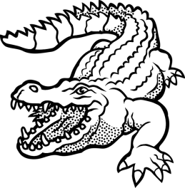
Day 2 | Noticing (Source: https://samedifferentimages.wordpress.com/)  On a piece of paper, make two columns. In one column, list the things that are the same in this picture, and in the other column, list the things that are different.  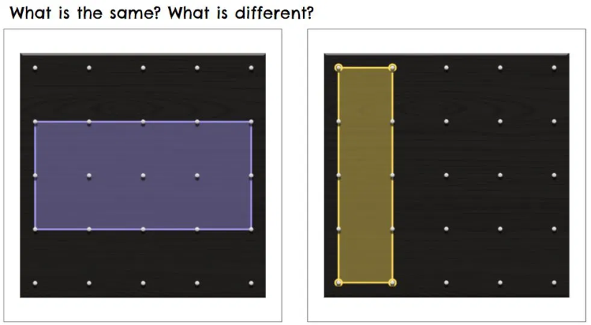  same different  Stacking Shapes  You have a sphere, a cube, a cylinder, a cone, a rectangular prism and a pyramid. Which shapes will stack? Which shapes will roll? Explain your reasons for each answer.  Pig Game (Source: mathforlove.org)  Materials: dice, pencil and paper.  Pig is a game for 2 or more players. Players take turns rolling the die as many times as they like. If a roll is a 2, 3, 4, 5, or 6, the player adds that many points to their score for the turn. A player may choose to end their turn at any time and “bank” their points. If a player rolls a 1, they lose all their unbanked points and their turn is over. Play to 50.
Day 3 | Number Line Puzzle (Source: mathlearningcenter.org)  Use what you know about multiplication to fill in the blanks.  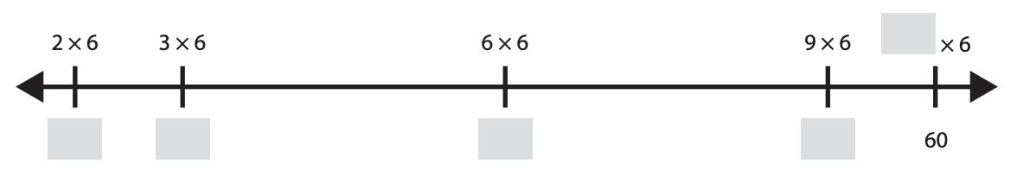  Which One Doesn’t Belong? (Source: talkingmathwithyourkids.com)  Choose one item in this picture that you don’t think it belongs with the rest. Explain why. Can you pick another item and give a different reason?  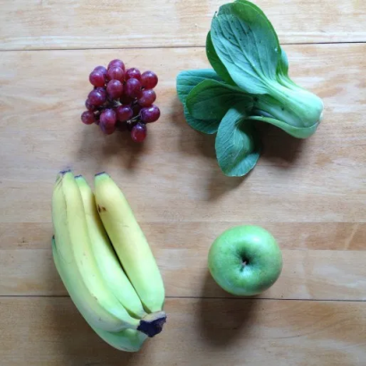  same different  Identify a Fraction on a Number Line (Source: https://www.openmiddle.com/)  Label the point where 2/3 belongs on the number line. Be as precise as possible.
Day 4 | Number Puzzles. (Source: mathlearningcenter.org)  Find the missing numbers in the equations below.  Revision  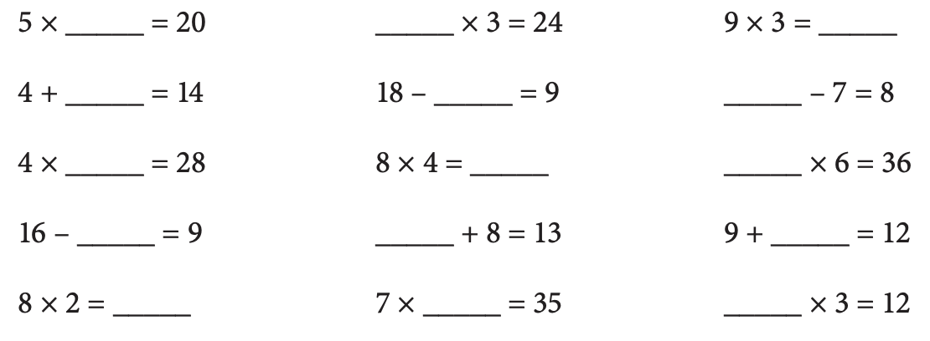  Visual Pattern (Source: visualpatterns.org)  Below is a pattern of stars in stages 1-3 below. Draw what you think the next pattern might look like. Label how many stars are in each stage.  Story Problem (Source: mathlearningcenter.org)  LaToya had a large collection of basketball cards. She decided to give half of them to her friend, Erin, and a quarter of them to her brother. She still has 75 cards left. How many cards did she start with?  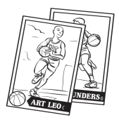
Day 5 | Noticing (Source: https://samedifferentimages.wordpress.com/)  On a piece of paper, make two columns. In one column, list the things that are the same in this picture, and in the other column, list the things that are different.  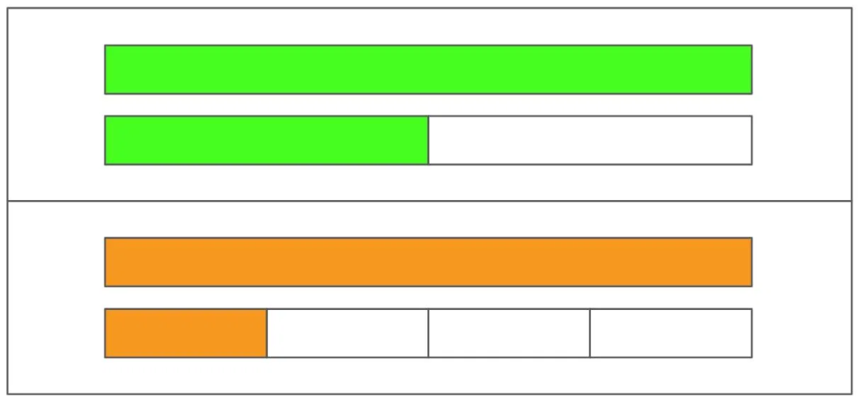  same different  Multiplying by Multiples of Ten (Source: mathlearningcenter.org)  Solve each problem below:  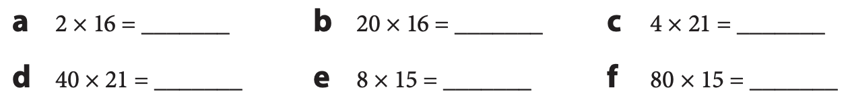  Elapsed Time (Source: mathlearningcenter.org)  Solve these worded time problems. You may want to use an open number line to model the problem.  - Anna started a race at 9:30 am. She ran for 3 hours and 47 minutes. What time did she finish her race?  - Michael and Tyler both ran a half marathon. Michael finished in 1 hour 42 minutes and 13 seconds. Tyler finished in 97 minutes and 49 seconds.  - Who was faster?  - How much faster was he?  - Takumi ran the first mile of his race in 450 seconds. How many minutes was his first mile?

 | Mathematics Second Level  Remote Learning Activities | WEEK 2

Day 1 | Operations with Time (Source: https://www.openmiddle.com/)  Use the digits 1 to 9, only once each, to fill in the boxes to make the latest possible time.  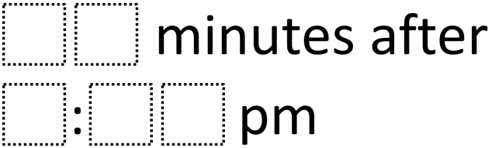  Fraction Talk (Source: http://fractiontalks.com/)  What fraction of the big square is represented by each region?  (Do all your fractions add up to one whole?)  Noticing (Source: https://samedifferentimages.wordpress.com/)  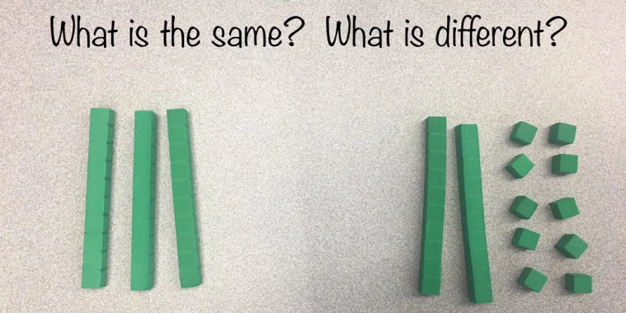  same different
Day 2 | Multiplication Strategies (Source: mathlearningcenter.org)  Solve these problems in your head. Fill in the blanks.  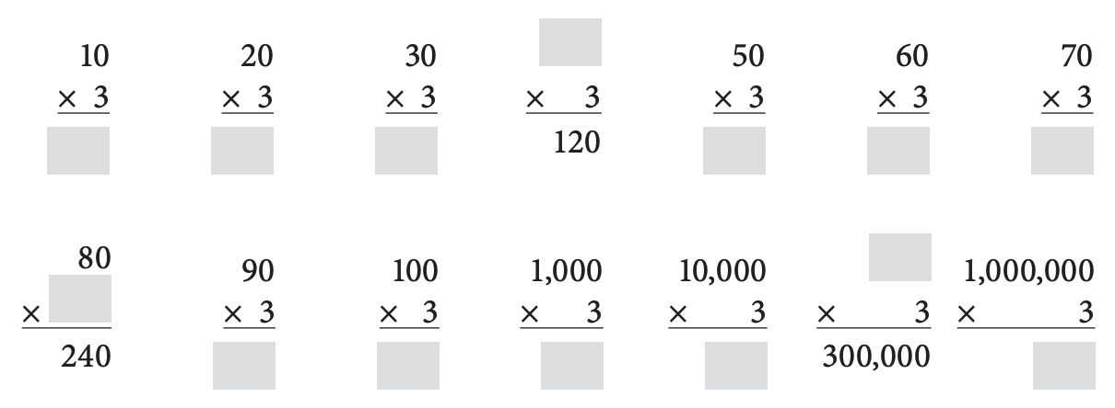  Puzzle (Source: https://www.solvemoji.com/)  What is the value of the last row?  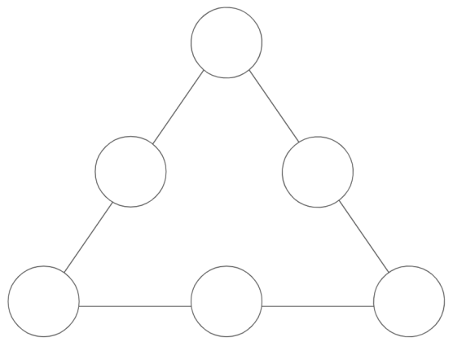  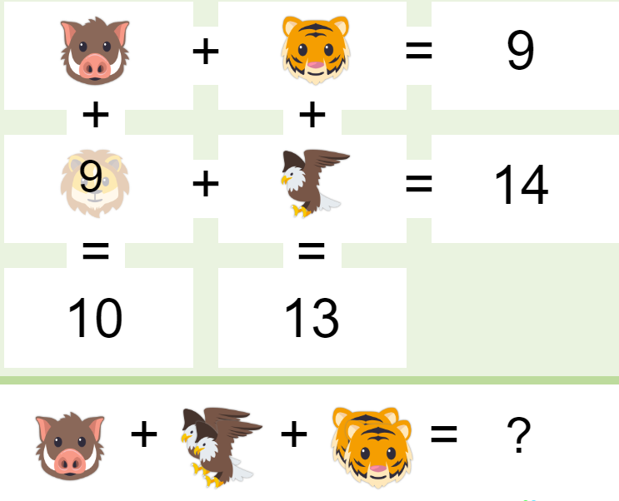  Magic Pyramid (Source: Critical Thinking Puzzles, Michael A. DiSpezio, 1996)  For this pyramid, can you place the numbers 1, 2, 3, 4, 5, and 6 in the circles shown below? Only one number may be placed in a circle and all numbers must be used. When the final arrangement is complete, the sum of each side’s three numbers must all be the same.
Day 3 | Finding Sums (Source: mathlearningcenter.org)  Fill in the missing digits.  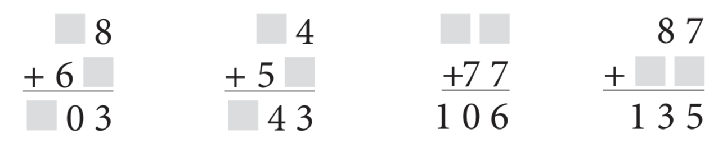  Baking Cookies (Source: https://www.openmiddle.com/)  Daniel was making chocolate cookies. He had ▢▢ cookies in each row and ▢▢ many rows. There were a total of 84 cookies. How many cookies were there in each row and how many rows of cookies were there? Draw a model to support your answer.  NOTE: You may use the digits 0-9 once in any of the blank boxes. (The answer of 84 does not eliminate the 8 or the 4.)  Which One Doesn’t Belong? (Source: wodb.ca)  Choose one sum in this picture that you don’t think it belongs with the rest. Explain why. Can you pick another sum and give a different reason?  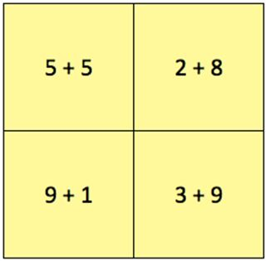
Day 4 | Telling Time (Source: mathlearningcenter.org)  Write the time shown on each clock.  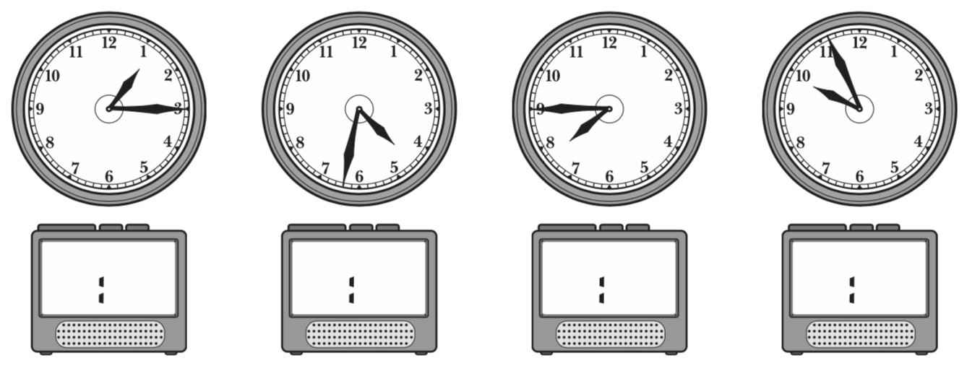  Visual Pattern (Source: visualpatterns.org)  Below is a pattern of squares in steps 1-3 below. Draw what you think step 4 might look like. Label how many squares are in each stage.  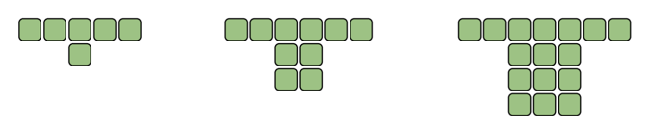  Fraction Talk (Source: http://fractiontalks.com/)  What fraction of the big square is shaded? Show your work.  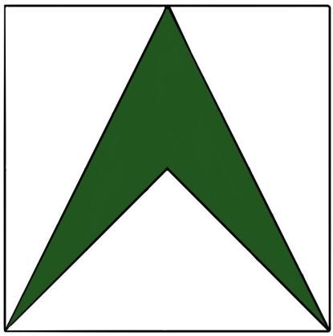
Day 5 | Baking Brownies (Source: mathlearningcenter.org)  Brad likes to bake brownies. It takes him 15 minutes to mix up all the ingredients. Then the brownies need to bake for 25 minutes. After that they have to cool off for 7 minutes. How long does it take Brad to have brownies ready to eat? Show your work.  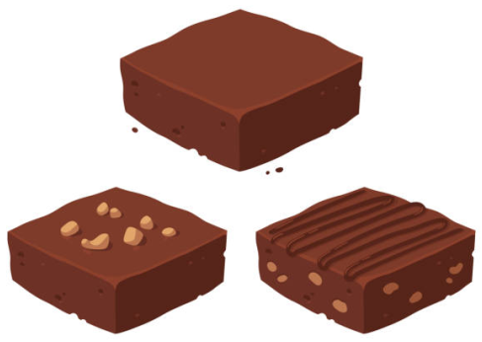  Symmetry (Source: mathlearningcenter.org)  Figures a–c show only half of the designs, on the left side of their lines of symmetry.  Complete each design on the right side of the line of symmetry.  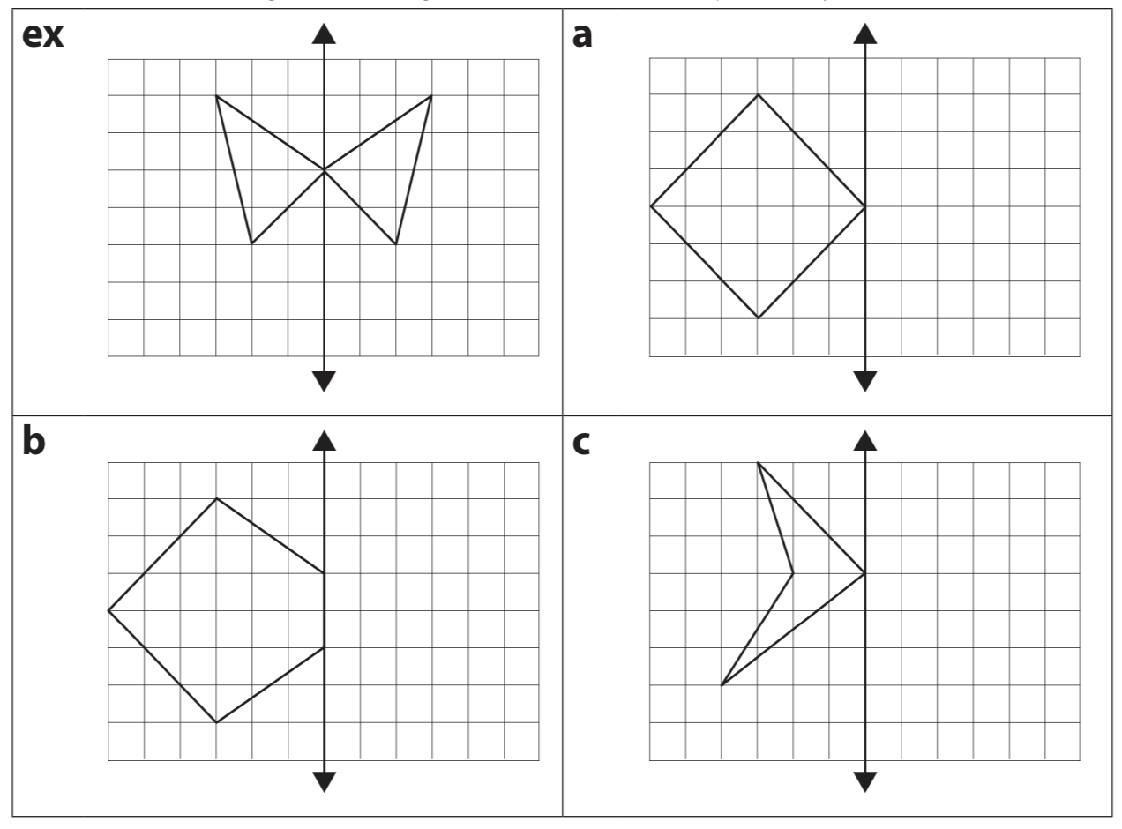  What did you do to make sure that the other half of each design you drew was accurate?  Counting (Source: visualpatterns.org)  How many squares do you see? How did you count them?

 | Mathematics Second Level  Remote Learning Activities | WEEK 3

Day 1 | Fractions (Source: https://www.openmiddle.com/)  On each square, fill in a fraction of the square that is less than 1/2. Then use the symbols >, =, or < to compare your fraction to 1/2.  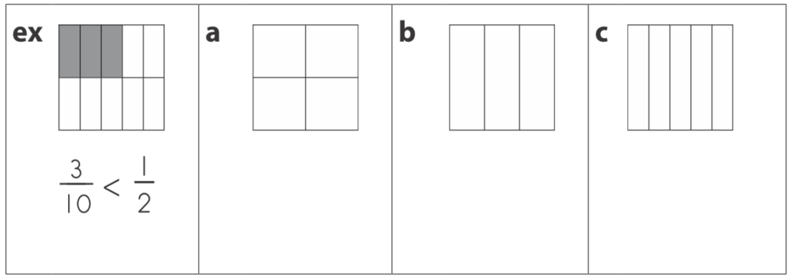  On each square, fill in a fraction of the square that is greater than 1/2 . Then use the symbols >, =, or < to compare your fraction to 1/2 .  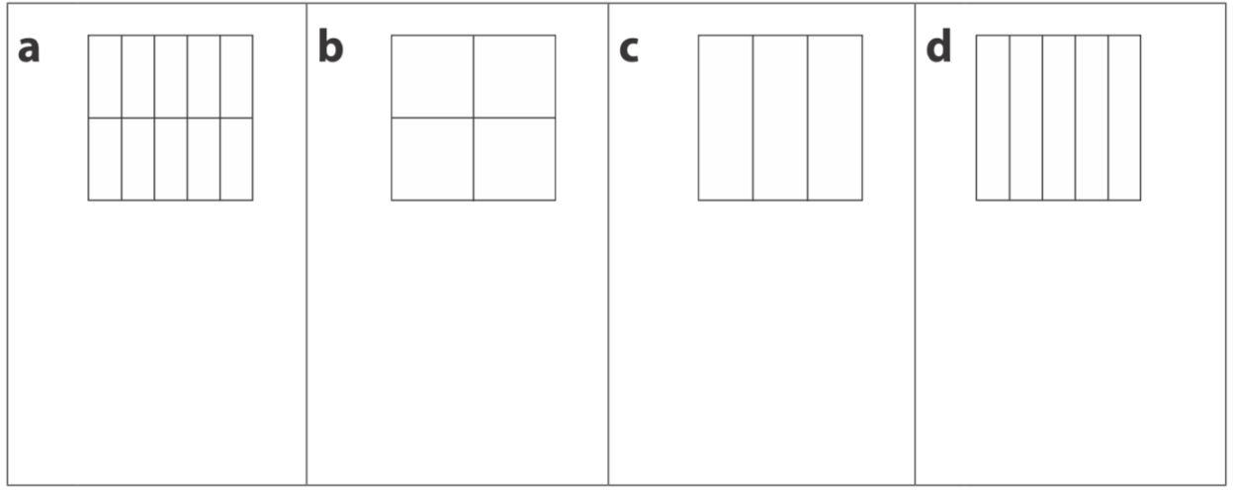  Number Line (Source: mathlearningcenter.org)  Write each of the following fractions where they belong on the number line below.  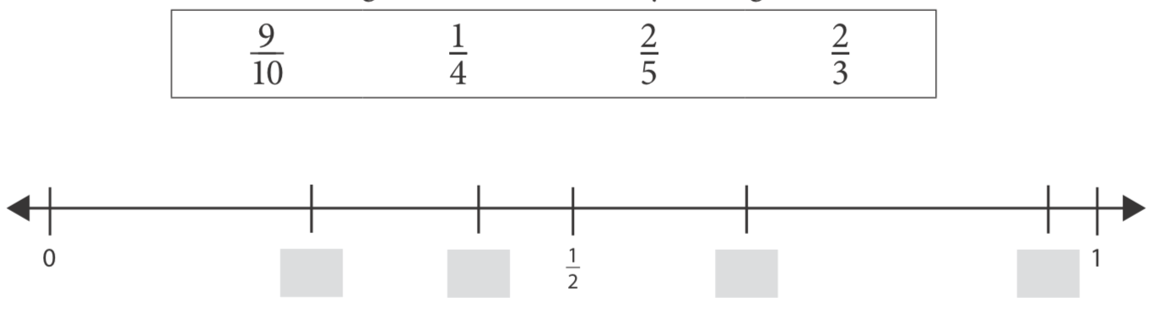  Round and Round (Source: https://brilliant.org/)  In a circle puzzle like the one below, dashed arrows mean to add and solid arrows mean to multiply. For example, the solution to the puzzle is a number whose sum is, 5 + 9, which is 14. The solution on the right is a number that, when multiplied by 6, gives us 12. By working backwards, we get a solution of 2.  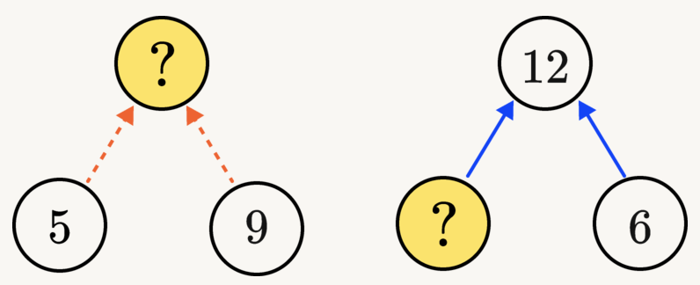  Solve the puzzle below.  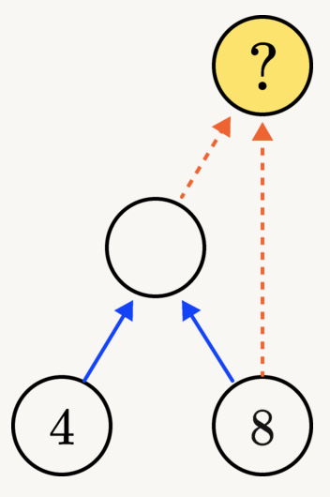

Day 2 | Pyramid Puzzle #1 (Source: mathforlove.org)  Each number in the Pyramid is the sum of the two numbers below it. Fill in the missing numbers in the Pyramid. Numbers may repeat.  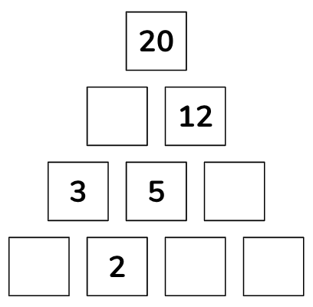  Would You Rather (Source: https://www.wouldyourathermath.com/)  Whichever option you choose, justify your reasoning with mathematics.  Would you rather?  Sell a batch of 30 cookies for 50 p each with a cost to make of £8? OR Sell a batch of 30 cookies for £15 with a cost to make of £6?  Comparing Fractions (Source: https://www.openmiddle.com/)  Use the digits 1 to 9, at most one time each, to fill in the boxes to create two different fractions: one that is less than one half and one that is more than one half.  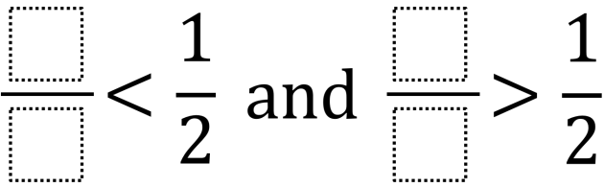
Day 3 | Practice (Source: mathlearningcenter.org)  Fill in the blanks.  - 48 × 25 = 24 × ____  - 48 × 29 = (48 × 30) – (48 × ____)  - 48 × 29 = (48 × 20) + (48 × ____)  - 50 × 29 = ½ of ____ × 29  True or False?  - 16 × 17 = 34 × 8  - 39 × 8 = (40 × 8) – 1  - 64 × 20 = 32 × 40  - 50 × 89 = 100 × 89  Visual Pattern (Source: visualpatterns.org  Below is a pattern of apples in stages 1-3 below. Draw what you think stage 4 might look like. Label how many apples are in each stage.  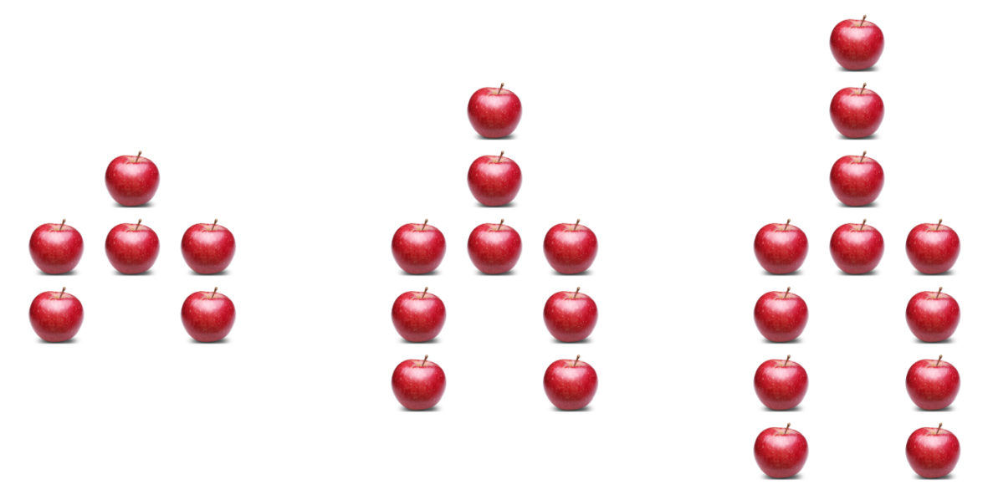  Puzzle (Source: https://www.solvemoji.com/)  What is the value of the last row?  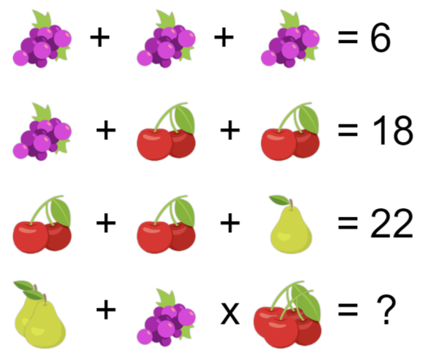

Day 4 | Telling Time to the Minute (Source: mathlearningcenter.org)  Fill in the circle next to the time shown on each block.  Write the time shown on each clock.  Fraction Talk (Source: https://www.wouldyourathermath.com/)  What fraction of the big square is represented by each region? (Do all your fractions add up to one whole?)  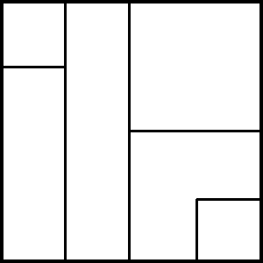  Conrad’s Room (Source: mathlearningcenter.org)  Think about the most efficient strategy for each problem. Then show your work using numbers, labeled sketches, or words.  - Conrad is cleaning his room. His bookcase has 7 shelves. He put 18 books on each shelf. How many books did Conrad put away?  - Conrad’s dresser has 6 drawers. He put 13 pieces of clothing in each drawer. How many pieces of clothing did he put away?  - Conrad has 11 containers for his toys. He put 17 toys in each container. How many toys did he put away?

Day 5 | Division Practice (Source: mathlearningcenter.org)  Fill in the blanks.  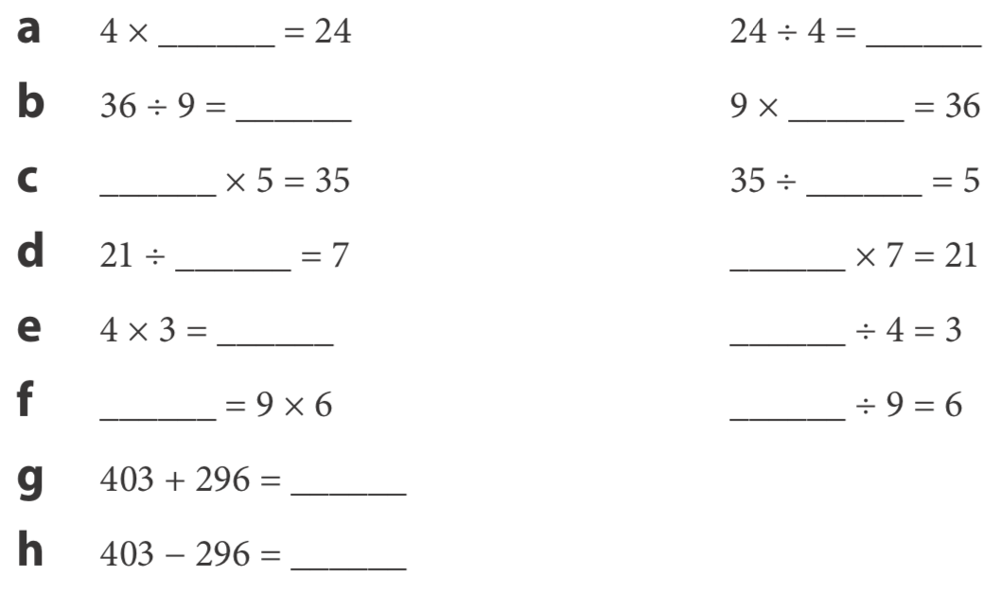  Puzzle (Source: https://www.solvemoji.com/)  What is the value of the last row?  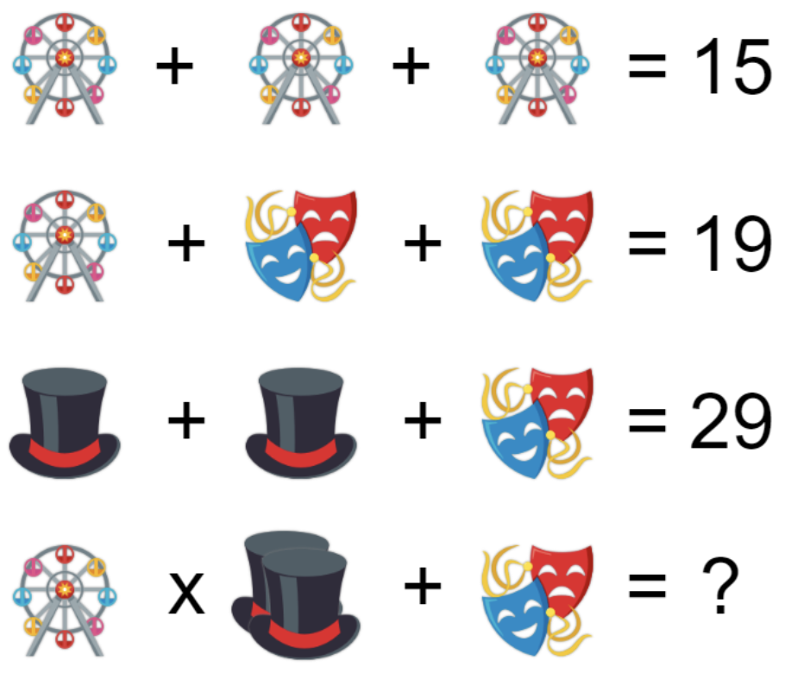  Multiplication Challenge (Source: mathlearningcenter.org)  Use the digits 0–9 each just one time. Write them in the boxes below. Make each multiplication problem correct.  