These are the things I like :

These are the things I don’t like :

I am excited about going to school because

My Name is

I am excited to start Primary 1 at Riverbank Primary

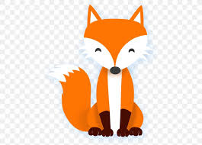
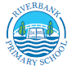

A little bit about you and your family
I am _____ years old.
I live with ______________________
Draw a picture of the people who live in your house. Maybe an adult could help you to write their names.

My friends are ________________________________
Draw a picture of you and your friends playing your favourite game.

My favourite animal is a _______________
Draw your favourite animal.

My favourite colour is __________________
Draw something using your favourite colour.

My favourite food is ___________________
Draw a picture of your favourite food.

My favourite colour is ___________
Draw something that is your favourite colour

