**Uniform**

All uniforms will now need to be ordered online at: [www.schoolwearmadeeasy.com](http://www.schoolwearmadeeasy.com) Please remember, only navy-blue jumper and white polo shirt (for gym) are essential. Blazer, bags and jackets are optional. Uniform is as follows:

* Navy blue v neck jumper/cardigan
* White shirt
* Tie
* Grey trousers/skirt/pinafore/shorts
* White polo shirt (for gym days)

Please ensure your child has indoor shoes (black plimsolls are ideal) as we want to try and keep our carpeted areas clean. These shoes will also be used for gym time. For shoes please try to ensure their shoes have Velcro if they can’t tie laces.

**Snacks/Lunches**

At Riverbank Primary we promote healthy eating at all times. For snacks, we would encourage our pupils to bring one or two healthy options in to school, including fruit, vegetables and water. For lunch, pupils in P1-P5 can have a school lunch for free each day or bring their own lunch. Pupils in P5-P7 can buy lunch for £1.90. The lunch hall operates a cash less system and all lunches must be chosen and paid for through our **Parent Pay** app. There is adult supervision in the lunch hall. We kindly ask our families not to send large amounts of sugary snacks into school. Fizzy drinks are not allowed for health reasons but also in case of spillage causing stickiness. Thank you for supporting us to improve the health and wellbeing of our young people.

**A Normal Day at Riverbank Primary**

8am – Breakfast Club will be open for pupils. This costs £2 per day unless you are in receipt of a Free School Meal.

8:50am – School staff will be in playground to welcome children and children can go directly to their classrooms.

9am – Teachers will be in classes

9:05 – playground gates will be shut and locked for safety (9am on a Friday)

10:30 Break – 15mins

12.15pm-1pm - Lunchtime

3pm – Children will exit out a specific gate where parents can collect them

**Health and Safety -** It is hoped that most pupils will either walk/cycle to school. We have around 100 spaces for bikes in the playground. If you are dropping off/collecting children by car, please use drop off point at Sunnybank Street. Please park sensibly in the surrounding streets as we need to consider both safety of pupils and our neighbours.

**Playground -** Support for Learning Workers and a member of SMT will be present in the playground at all breaks. They will be supported by our P7 PATHS PALS. Pupils will also have access to the pitch on a rotational basis.

**Wednesday 17th August 2023**

All P1 pupils are due to start at 10am and finish at 2pm. These will be the times for the first 3 days. The P1 children will enter and exit through their own classroom doors. On day 1 you will be able to accompany your child into their classroom and on days 2/3 we ask that you try and leave your child at the classroom door. The following week we will encourage the children to come into the playground by themselves and go directly to their class, staff will be there to support you with this.

We ask that the adults who are collecting the children stand well back at the school gates. This allows staff to hand over children individually to parents/carers until we get to know faces. For the first 3 days children can be collected from their classroom door.

**Classification**

At the moment we have classified for 12 classes. There will be two P1 classes. In Riverbank Primary we have a play-based curriculum in Primary 1 which means the children in all the classes will come together throughout the school day for teaching and learning.

**Contact Information**

At the beginning of the session we ask that you complete Annual Data Checks to ensure we have the correct and up to date information for you and your children. This will also include photographic permission slips. This is now all done online via Parents Portal and we ask that you complete these as soon as possible after your child starting school.

If you require to speak to a member of staff at the school about your child please contact the main office to arrange an appointment.

**School Phone Number:** 0141 550 3679

**Mr Hynes e-mail:** [headteacher@riverbank-pri.glasgow.sch.uk](mailto:headteacher@riverbank-pri.glasgow.sch.uk)

**Mrs Whyte e-mail:** [lwhyte@riverbank-pri.glasgow.sch.uk](mailto:lwhyte@riverbank-pri.glasgow.sch.uk)

**School Website:** www.riverbank-pri.glasgow.sch.uk

I feel that the staff in the office are amazing whenever I have approached or phoned the office they have been so approachable, kind and always keen to help.

**Twitter:** @RiverbankPri

Every staff member is approachable and I really like that when I drop my daughter off she can go straight to class.



**Some quotes from our Primary 1 parents just now!**

My son has grown in confidence and socially the school experience has been excellent for him. Being physically active is really important to him and this is a big part of his P1 experience which is great!

My child has improved in all aspects of learning with big steps in writing and counting

My child is very happy and comfortable in school with his new friends and teacher. He has developed into a confident and capable child.

Information for Primary 1

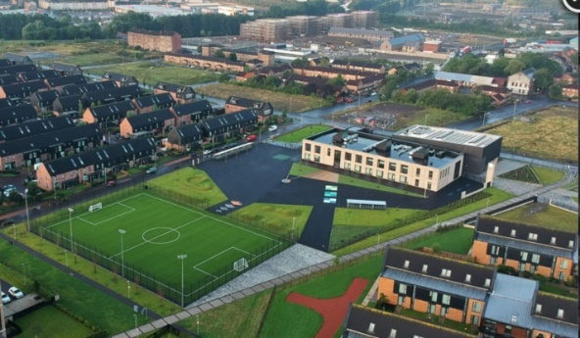Parents and Carers

The school has a really warm and welcoming atmosphere

