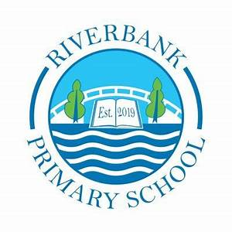
P1/2 Term 1 2026

Numeracy and Maths

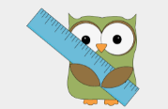
You can support this at home by:
- Counting objects at home and when out and about, for example counting cars on the road, toys in the toy box, etc.
- Looking for numbers when in our environment, for example numbers on a bus, numbers on a TV remote, numbers on doors etc.
- Topmarks.co.uk has some great number recognition and counting games, including Teddy Numbers, Underwater Counting and Ladybird Spots games.
- Regular practice writing accurate formation of numbers to 10.
- Discussing the order of things; first, second, third etc.

Numeracy
P1
- Numbers to 10 – counting amounts and formation • Number ordering, sequences and patterns • Number facts and number bonds to 10
P2
- Estimating
- Number order to 100 and place value
- Counting in 2s, 5s, 10s.
- Ordinal numbers
Maths
- We will focus on Pattern, 2D Shape and Symmetry.

I look forward to seeing your home learning on Showbie!
If you need a paper copy, please contact the school office.



You can support this at home by:
- Please see Showbie for the weekly letter sounds and common words.
- Look out for words in your environment – Do you recognise any of the letter sounds?
- Read stories at home and discuss it together – Who is your favourite character? What was your favourite part of the story?
- Work on writing your name – what letter sounds are in your name?
- Have ideas for what you will write for news time.
- Practice spelling sounds and words with active spelling strategies.
Literacy
P1
Rhyme and nursery rhymes • Initial sounds – a t s p i n m o • Begin to blend and read 3 letter words using the above sounds (cvc words e.g., sat, map) • Recognise and read your name.
P2
- Revise alphabet sounds for confident use.
- Begin to learn digraphs – ch/sh/th etc.
- Practice writing sentences independently.

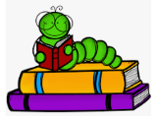

Other Curricular Areas
In IDL we will be learning about each other through the topic All About Me and Our Senses during Science activities. We will also be learning about People Who Help Us in our community. The children will learn about the value of a community.
In R.M.E. we will be listening to some Bible stories.
In Music we will have a specialist who will visit fortnightly. We will enjoy singing and playing along to music of different styles. In French we will have our French word of the week…Greetings, please and thank you!
In Art we will begin to recognise colour, line and shape. We will begin mark making, making lines that can have different qualities, for example, thick, thin, broken, wavy, diagonal, zig zag. We will look at the artists Paul Klee and Piet Mondrian and be inspired to create our own pictures with colour and shapes. Ww will learn to draw people and add pattern to a snail shell and a chameleon!
We learn through play-based learning where learning takes place through role play, exploring, building and creating together. We have different areas in our class and the open area to facilitate this; Library, Lego, House, Construction, Sand, Water, Junk Modelling, Painting and Writing/Drawing area.

Health and Wellbeing
We have PE on a Wednesday with Mrs Tan and a Thursday with Miss Stewart.
In P.E. we will be developing movement skills; running, jumping, and balancing. We will also focus on ball skills; throwing and catching. We will be working in individuals, pairs and team-based activities. Please ensure your child has their full P.E. kit, including footwear, on these days. Some of the sessions will be on the pitch.
All jewellery must be removed for PE lessons. Staff are not allowed to remove earrings so if your child cannot take these out then please take them out before coming to school.
We use our daily emotions check-in to express our feelings throughout the day. We will continue to explore feelings through PATHS lessons each week. We will be choosing a PATHS Pupil of the Day who will receive compliments from their classmates. We will be looking at our similarities and differences and how we are all unique through exploring different stories and having class discussions.
Outdoor Learning
On a Tuesday, Thursday and Friday, we will be going to the school garden to explore, build and play with loose parts. We will also be planting and taking care of plants! We have puddle suits the children can wear but we do ask that suitable footwear is worn on these days!

Top Tips!
- Please ensure that your child’s name is on all their property.
- Dress sensibly for outdoor learning as we will be going outside in almost all conditions.
- Check Showbie for weekly information and your child’s work.
- Follow us on X @RiverbankPri I am looking forward to working with all the children and meeting you all during the Open Afternoon on Wednesday 7th October! Thank you! Miss Stewart

