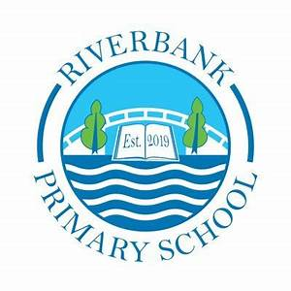
Riverbank T3 Overview

P1 2024

Literacy
This term in Literacy we will be exploring:
- sounds h, w, j, v, y, z, q(u), sh, ch, th and ng.
- common words was, went, his, have, just, to, your, by, only, are, dad, she, come, from, this, that, then, with, us, so, much, of and or.
- We will be sending reading books via Showbie to practise.
- Please do ask your child to practise their sounds at home.

-

Numeracy and Maths
In Term 3, we will continue to revise learned strategies to ensure we are confident in numbers to 20 and beyond.
We will also be focussing on time and positional language. Some key phrases we will be using are:
add, plus, subtract, take away, more than, less than
o’clock
before, after, forward, backwards, left, right

Health and Wellbeing
P_1_ have PE on a Wednesday and a Friday.
In PE, we will be focussing on:
- dance
We use our daily emotional check in to express our feelings throughout the day. We will continue to explore these through 2 x PATHs lessons. All jewellery should be removed on PE days.

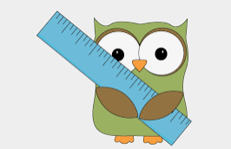

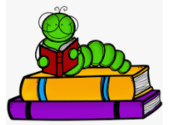



Social Studies/ IDL
In Term 3, we are going to be exploring Polar Regions. This will include researching and learning about different polar animals and their habitats. We will be tying this in with our STEM focus which is to look at solids, liquids and gases and will use ice, water and steam to support this.

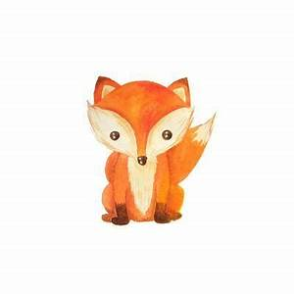


- Please ensure that your child’s name is on all their property.
- Dress sensibly for outdoor learning as we will be going outside in almost all conditions.
- Check Showbie for weekly homework sheets and information.
- Follow us on @RiverbankPri

Top Tips!

