
P 4 Term 4 2026 Overview

Numeracy and Maths

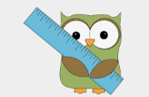
In Term 4, we will continue to revise learned strategies to ensure we are confident in addition, subtraction, multiplication and division. We will complete our work on fractions and explore different number systems. We will apply our knowledge of the four operators to solving 1 and 2 step problems and explore probability. Another topic we will explore is measure. We will learn about measuring shapes in centimetres and metres, as well as measuring weight and volume. Some vocabulary relating to our measure topic is: length, height, width, area, centimetre squared, grams, kilograms, millilitres and litres.
We will also be focussing on tiling patterns through art and IDL.

You can support this at home by:
- Accessing online games to support learning (links in homework).
- Accessing Magma Maths with the QR code to complete outstanding tasks or specific homework tasks.
- Testing your child on multiplication and division.
- Involve your child in any practical activities involving maths- e.g. baking, measuring, budgeting, party planning (quantities) etc.



Number Strategies

Partition
Repeated Addition and Arrays
Bridging
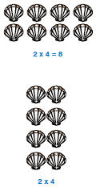

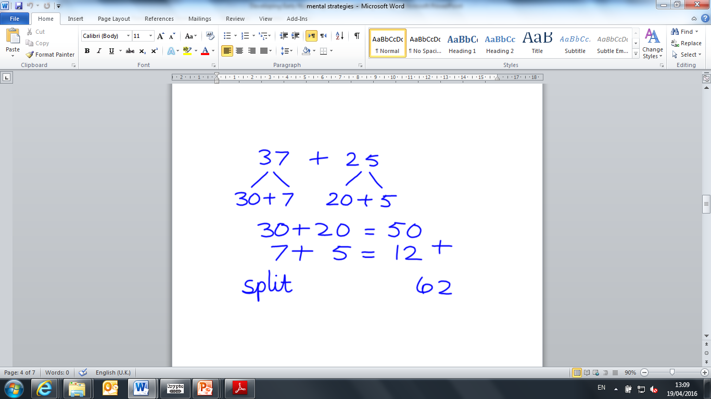
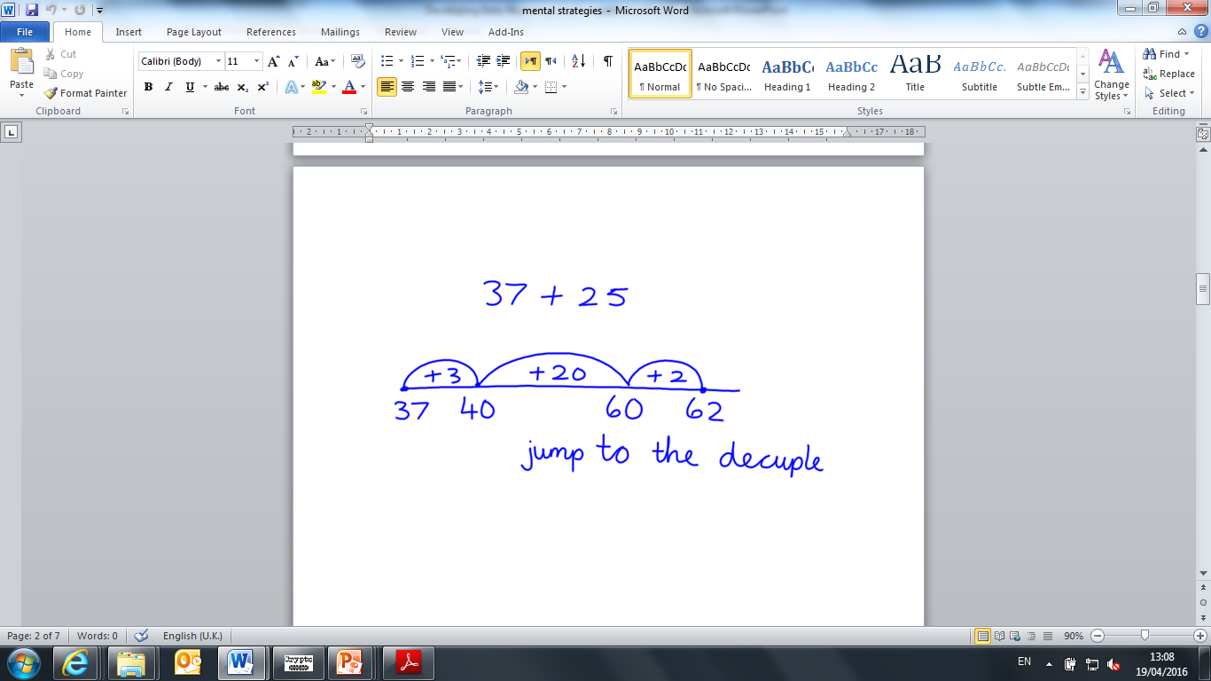
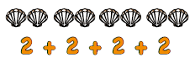


Literacy
This term in Literacy we will be exploring:
- A Class novel- The Firework Maker’s daughter.
- Reading for understanding.
- Persuasive writing
- Grammar and tools for writing
- Talking and listening: revising group discussions and presentations

You can support this at home by:
- Reading daily. Newspaper, magazine, comic, fiction or non-fiction book.
- Reading/Talking and listening- support with learning lines for the school show.
- Discussing how adverts make products/services sound appealing through language (e.g. flattery, bargains, describing words)
- Picking up brochures for tourist destinations and reading the language/techniques used which could be useful for persuasive writing in class

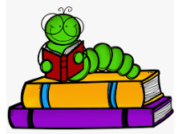

Other Curricular Areas
In IDL, the children chose to learn about Ancient Greece with Mrs. Tan. The children picked some key questions they want to investigate and will be using a variety of sources to answer these questions and think about how to present their findings. Mrs. Perakis will focus on modern Greece, the physical features, climate and its impact on life in Greece. We will have an open afternoon to undertake some activities based on our IDL on Wednesday 20th May.
P4 love the garden! We are growing potatoes and looking after our planter with strawberries. We will be weeding and watering the planters and trees each week and taking care of our community garden.
We will be taking part in our P4-7 school show in Term 4. More information to follow! In Art we are critically examining different artists, designers and testing out some of their techniques and artistic styles.
In health and wellbeing there will be a focus on RSHP. The children will learn about body parts, keeping parts of the body private, personal hygiene, pregnancy and birth, taking care of babies and pets as well as life cycles.

Health and Wellbeing
P4 have PE on a Wednesday (Mrs. Tan) and a Friday (Mrs. Perakis).
In P.E. we will be focussing on skills for football and will be participating in athletics (running, long jump, javelin and shot put). We are practising safe and responsible use of sports equipment and developing our skills in positive communication, through team work and competitive play. You can support your child at home by playing any sports or games together, that encourage movement and listening to/following instructions.
Please ensure your child has their full P.E. kit, including footwear, on these days. We will be outside as much as possible, so please ensure children are dressed for the weather.. All jewellery must be removed for PE lessons. Staff are not allowed to remove earrings so if your child cannot take these out then please take them out before coming to school.
We use our daily emotions check-in to express our feelings throughout the day. We will continue to explore these through two PATHS lessons each week. Our PATHS lessons this term will focus on topics such as change and transitions. You can support your child at home by encouraging them to talk about their feelings and help them to find positive strategies to manage them.

Top Tips!
- Please ensure that your child’s name is on all their property.
- Dress sensibly for outdoor learning as we will be going outside in almost all conditions.
- Check Showbie for weekly information and your child’s work.
- Follow us on X @RiverbankPri


