Riverbank Primary School
Handbook
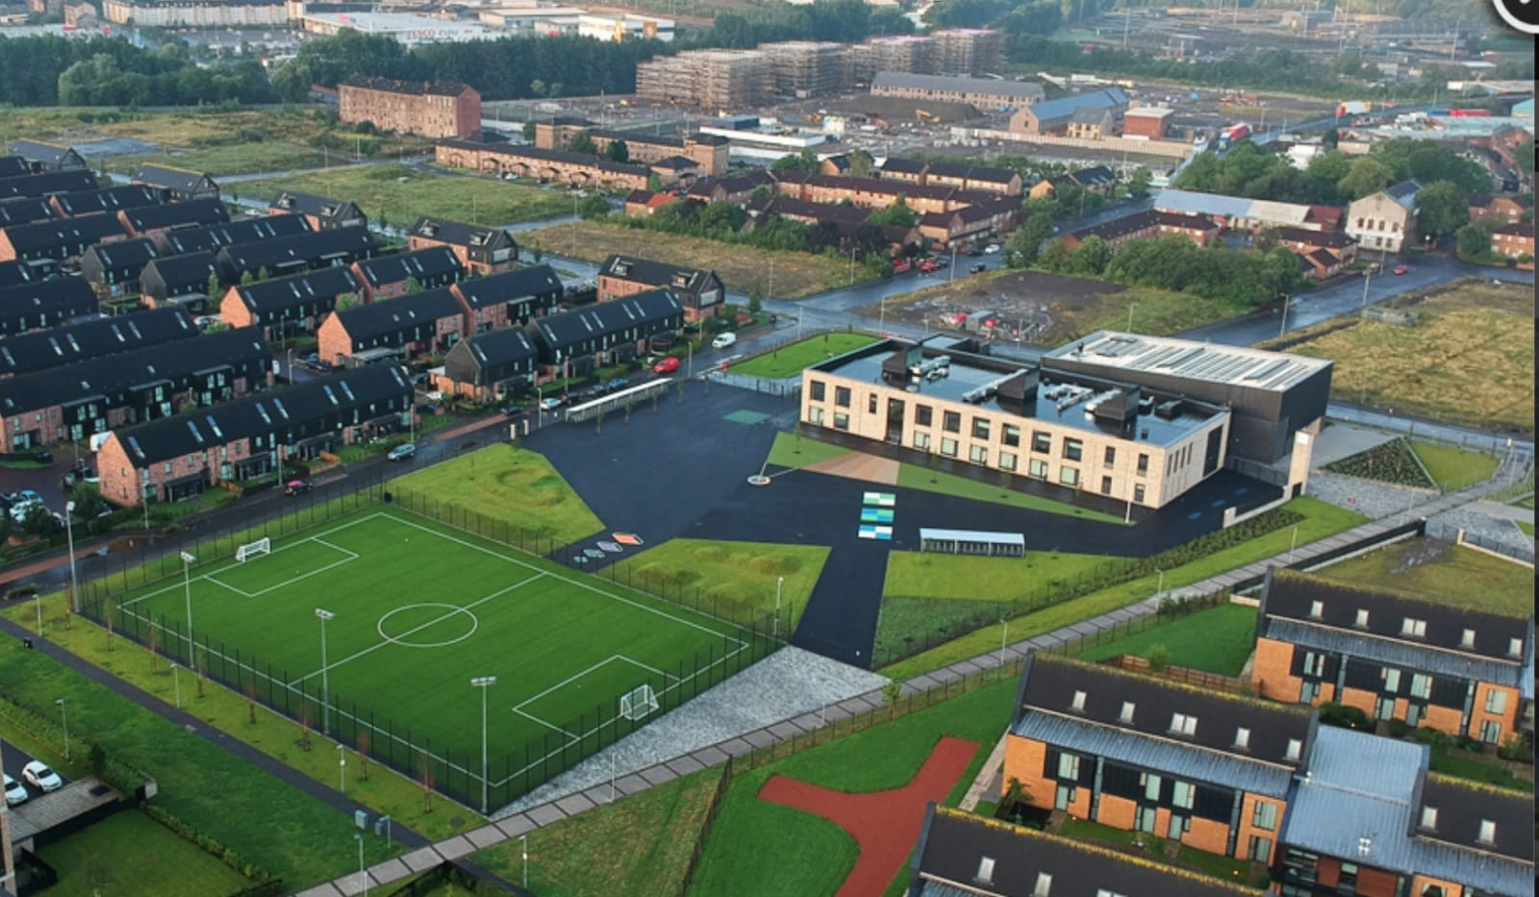

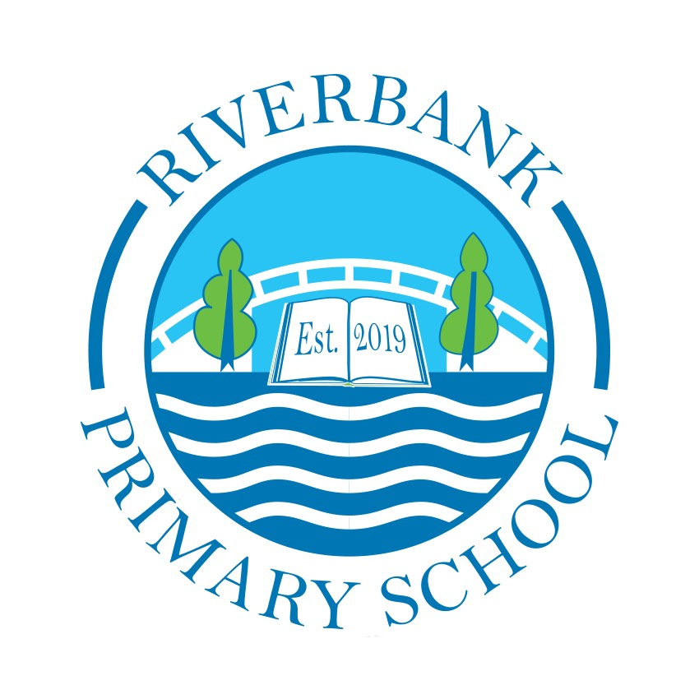

Riverbank Primary
School Handbook

Welcome to Riverbank Primary School

I would like to welcome you and your child to Riverbank Primary School. We are a new school in the Dalmarnock area of Glasgow. We have quickly established ourselves as an important part of the local community and aim to provide your child with a safe, welcoming and nurturing environment where they will thrive.

This handbook contains a range of information that you might find helpful. Please do not hesitate to contact the school if you need more information.

I hope that this handbook gives you a glimpse of life at Riverbank Primary School. We look forward to having you and your child work with us and hope that this will be the start of a strong partnership.

Tommy Hynes
Headteacher

Last updated on 25th October 2022

School Vision & Values

In Riverbank Primary School we will provide a welcoming and friendly environment, which celebrates the diversity of our community.
We are a nurturing school where everyone feels safe, happy and valued and all children are supported to reach their full potential. This is achieved through working together with children, their families and the community, based on a shared sense of direction.

Values:

- Ready – being ready for our learning everyday
- Love – caring for others
- Kindness – being kind to those we meet
- Equality – ensuring everyone is treated the same
- Creativity – ensuring we sue our skills and talents for good

School Information

You can cut out the following information and have it on your fridge, purse or work desk etc. for ease of finding the numbers required.

Contact Details:

1 Sunnybank Street
Glasgow
G40 4RX
Phone: 0141 550 3679
Email: headteacher@riverbank-pri.glasgow.sch.uk
Twitter: @RiverbankPri
Website: www.riverbank-pri.glasgow.sch.uk

Background information:

- Co-educational school
- Non-denominational
- Stages taught: P1-P7
- Current Roll: 304
- Capacity: 315

School staff

The leadership team is as follows:

Headteacher: Mr Hynes
Depute Head Mrs Whyte
Principal Teacher Mr Kenny
Principal Teacher (PEF) Miss McMillan (Acting)

Class Teachers:
P1a – Mrs Fisher
P1b – Mrs Logan
P1/2 – Mrs Gaw (Mon-Weds) and Mrs MacMillan Currie (Thurs-Fri)
P2 – Mrs McGeough (Mon-Tues) and Miss Nicoll (Weds-Fri)
P2/3 – Miss Berwick
P3 – Miss McStay/Ms Stewart
P3/4 – Mrs Brook (Mon-Tues) and Miss McMillan (Weds-Fri)
P4 – Miss McGarrity
P4/5– Miss Mort
P5/6 – Mr Sly/Miss Cowden
P6/7 – Mrs Jarrett
P7 – Mrs Lovick

The Den Teacher – Miss Gamble
Challenge Leader of Learning (3 days) – Mrs Brook
NCCT Teacher – Miss Cowden

Support Staff
Miss Hanlon
Miss Bulloch
Miss Cartwright
Miss McCue
Mrs Hashim
Miss Dempsey

Clerical Staff
Miss Williamson
Miss Wilson

Janitor
Mr Cooper

Enrolment

Registration of Primary 1 children takes place in November and is advertised widely in local press etc. Prospective parents are welcome to visit the school and should contact the school office. Enrolment is now conducted online – see the link below.

Families living outwith the catchment area are welcome to make a placing request to attend Riverbank Primary School but must enrol their child online as a first step. Further information is available using the following
https://www.glasgow.gov.uk/index.aspx?articleid=18426

Organisation of Classes

The following guidelines set by Scottish Government apply.
P1 maximum 25
P2&3 maximum 30
P4-7 maximum 33
Composite classes maximum 25

Composite classes have pupils from more than one stage. This year, we have composite classes due to the number of pupils at each stage.

The School Day
Morning 09.00 -10.30
Interval 10.30 - 10.45
10.45 - 12.15
Lunch 12.15 - 13.00
Afternoon 13.00 - 15.00

School Term Dates

Details of school term dates are available on the Glasgow City Council website: https://www.glasgow.gov.uk/index.aspx?articleid=17024

Pupil Absence

Within Glasgow Primary School good attendance is encouraged at all times and children rewarded accordingly. Parents are asked to advise if their son or daughter is going to be absent. This should be done as early as possible on the first day of absence. If the young person is going to be absent for some time, it would be helpful to know at the earliest opportunity. The school uses daily text messaging to inform parents and carers of absence if no contact is made. All unexplained absences are investigated by the school and appropriate action taken. All calls must be made to the Pupil Absence Reporting Line on 0141 287 0039. The line is open between 08.00-15.30 Monday to Friday. Alternatively you can use the online form on the Glasgow City Council website: https://www.glasgow.gov.uk/index.aspx?articleid=18832

Medical & Healthcare

The school nurse visits at various times during the year for routine health checks, vaccinations and medical examinations. Parents are kept informed by letter.

If a child becomes ill during the course of the school day, he/she may require to be sent home. Please ensure that you keep the school informed of all contact details.

Parents should inform the school of any medical requirements relating to their child. If a child requires medication during the school day, parents must complete the appropriate medical form. This is available on request from the school office.

Emergencies

We make every effort to maintain a full educational service, but on some occasions circumstances arise which lead to disruption. Schools may be affected by, for example, severe weather, temporary interruption of transport, power failures or difficulties of fuel supply.

In such cases, we shall do all we can to let you know about the details of our closure or re-opening by using letters, texts and the local media etc.

School Uniform

The school uniform is:
- White shirt
- School tie
- Grey trousers
- Grey skirt/pinafore
- Navy blue cardigan/v-neck jumper
- Black shoes
- Indoor shoes (black sandshoes)

Sweatshirts, cardigans, polo shirts and ties with the school logo are available for purchase at www.schoolwearmadeeasy.com and search for Riverbank Primary. Cost of the School Day is important to us at Riverbank, and so a plain navy blue jumper/cardigan, available to purchase at local supermarkets, is acceptable for uniform too.
Our uniform was agreed in consultation with pupils and parents. It is expected that all children attending Riverbank Primary School will adhere to this dress code.

PE Kit

It is important that pupils come prepared to learn and for PE this requires appropriate clothing. All jewellery should be removed. Pupils who are not participating in PE must have a note or a medical certificate. Pupils who are unable to participate in practical PE should still bring their kit to allow them to assist in the lesson by refereeing, keeping scores or assisting with the distribution of equipment. This ensures that they are still able to take part in some way in the work of the class and do not miss out on the knowledge and understanding of the course.

There are forms of dress that are unacceptable in school, such as items of clothing which:

- Potentially encourage factions (such as football colours)
- Could cause offence (such as anti-religious symbolism or political slogans)
- Could cause health and safety difficulties (such as loose fitting clothing, jewellery)
- Could cause damage to flooring
- Carry advertising particularly for alcohol or tobacco
- Could be used to inflict damage on other pupils

This session PE will take place outdoors due to Covid-19 restrictions. Please ensure your child wears appropriate outdoor clothing on their PE days.

Clothing & Footwear Grants

Parents/Carers receiving Income Support, Job Seekers Allowance (Income Based), Working Tax Credit (check link below for thresholds), Housing Benefit, Council Tax Benefit or Universal Credit (check link below for thresholds) will normally be entitled to monetary grants for footwear and clothing for their children. Information and application forms may be obtained from schools and at
https://www.glasgow.gov.uk/index.aspx?articleid=17885

School meals

Our school provides a lunch service which offers a variety of meals and snacks. Medical diets for children can be provided. Further information can be found here: http://www.fuelzoneprimary.co.uk/UserFiles/files/Medical_Diet_Leaflet%20-%20June%202017%20WEB.pdf. Please inform the Headteacher.

Children who prefer to bring packed lunches will be accommodated in a suitable area.

All children in P1-5 are entitled to a free school meal.

If you plan to send your child/children to breakfast club, you should inform the staff of any medical dietary requirements.

Children and young people of parents/carers receiving Income Support, income-based Job Seekers Allowance, Working Tax Credit (check link below for thresholds), Child Tax Credit only (check link below for thresholds), Universal Credit (check link below for thresholds) and income-related Employment and Support Allowance are entitled to a free midday meal. Information and application forms for free school meals may be obtained at
https://www.glasgow.gov.uk/index.aspx?articleid=17885
This session school meals are being paid for using BACS payments. Please contact the school office to find out more information about this.

Transport

The education authority has a policy of providing free transport to all pupils who live outwith a certain radius from their local school by the recognised shortest walking route. This means that the provision of transport could be reviewed at any time. Parents/Carers who consider they are eligible can apply online at
https://www.glasgow.gov.uk/index.aspx?articleid=17882

Transfer from Primary to Secondary School

Children and young people normally transfer between the ages of 11 ½ and 12 ½, so that they will have the opportunity to complete at least 4 years of secondary education. Parents and carers will be informed of the school arrangements no later than December of P7. Children from our school normally transfer to:

Eastbank Academy
26 Academy Street
Glasgow
G32 9AA
Phone: 0141 582 0080
Email: headteacher@eastbankacademy.glasgow.sch.uk
Website: http://www.eastbankacademy.glasgow.sch.uk/

Eastbank Academy staff work with our pupils from Primary 6 onward to prepare them for the transfer to secondary school.

Communication with Parents

At Riverbank Primary School we use a variety of ways to keep in touch.

Open Door Policy – the senior leadership team are available for all parents and carers at any time providing they are not teaching or in another meeting. Please phone for an appointment.

Newsletters – will be sent out on a monthly basis to keep parents informed about the work of the school.

Letters – further information which requires a response may be sent out in letter form.

Twitter – will contain a great deal of information about the school. It is a good idea to check this regularly.

Text messaging – You may also receive text reminders about events/school closures etc.

Meetings –parents and carers are welcome in the school to discuss any aspect of their child’s development and progress. This is usually in the form of reporting to parents evenings which are held twice per year

Class Assemblies – each class will hold a display of learning assembly for their parents and carers. You will be informed of these dates closer to the time.

Open Afternoons – where parents/carers are invited into school to share in their child’s learning

Emergency Contact Information

At the start of each school session, parents will be issued with the annual data check form. Please ensure that this is completed and returned to the school. It is also important that you let us know if there are changes to your telephone number(s) or to those of your emergency contacts throughout the year. Annual Data Checks can now be completed online via Parents Portal. Please ensure you have downloaded this app and speak to our office staff for any more information.

Data Protection – use of information about children and parents/carers

We collect information about children attending school (and also about parents/carers, emergency contacts etc. provided in the annual data check) to allow us to carry out the Council’s functions as the education authority for the City of Glasgow. This may sometimes involve releasing personal information to other agencies and other parts of the Council, particularly in relation to child protection issues or criminal investigations, and it may also be used for research purposes (see the link below for more details regarding this).

Information held by the school is, in legal terms, processed by Glasgow City Council. The Council is registered as a data controller under the Data Protection Act 2018 and all personal data is treated as confidential and used only in accordance with the Data Protection Act, the General Data Protection Regulations, and the Information Use and Privacy Policy approved by the City Council. For more information on how we use personal information, or to see a copy of the Information Use and Privacy Policy, see https://www.glasgow.gov.uk/index.aspx?articleid=18010 .

Education specific privacy statements can be accessed at https://www.glasgow.gov.uk/index.aspx?articleid=22069 .

Appointments during school hours

If your child has an unavoidable appointment, please give them a letter for their class teacher and then collect them from the school office at the specified time.

Comments & Complaints

In Riverbank Primary School we aim to have positive relationships across our school community. However, if you have a comment or complaint about any aspect of school life, please contact the Headteacher in the first instance.

Glasgow City Council complaints procedures are available : https://www.glasgow.gov.uk/index.aspx?articleid=16133

Customer Care Team
Customer & Business Services
Glasgow City Council
City Chambers
Glasgow G2 1DU

Tel: 0141 287 0900
e-mail: customercare@glasgow.gov.uk or education.customercare@glasgow.gov.uk

The above website also includes information on data protection and freedom of information.

Curriculum

Curriculum for Excellence 3-18

Curriculum for Excellence has been introduced to raise standards of learning and teaching for all 3 to 18 year olds. It aims to help prepare children and young people with the knowledge and skills they need in a fast changing world. As part of Curriculum for Excellence all children from pre-school to the end of S3 will receive a rounded education known as a Broad General Education(BGE). Curriculum for Excellence is all about bringing real life into the classroom and taking lessons beyond it.

Through the experiences we provide at Riverbank Primary School we want our children to become Successful Learners, Confident Individuals, Responsible Citizens and Effective Contributors. We are committed to providing children with a broad general education and focus on eight curriculum areas.

Expressive Arts | Health & Wellbeing | Languages | Mathematics
Religious & Moral | Sciences | Social Studies | Technologies

Progress in learning is indicated through curriculum levels as detailed below.

Level | Stage
Early | The pre-school years and P1 or later
First | To the end of P4, but earlier or later for some
Second | To the end of P7, but earlier or later for some
Third & Fourth | S1-S3, but earlier for some

Expressive arts: The inspiration and power of the arts play a vital role in enabling our children and young people to enhance their creative talent and develop their artistic skills.

Health and wellbeing: Learning in health and wellbeing ensures that children and young people develop the knowledge, understanding and skills which they need now and in the future to help them with their physical, emotional and social wellbeing.

Science: Science and its practical application in healthcare and industry is central to our economic future, for our health and wellbeing as individuals and as a society.

Social Studies: Through social studies, children and young people develop their understanding of the world by learning about other people and places both past and present, societies, their beliefs and values.

Religious and moral education: Religious and moral education includes learning about Christianity, Islam and other world religions, and supports the development of beliefs and values.

Languages: Knowing other languages and understanding other cultures is a 21st century skill set for students as they prepare to live and work in a global society.

Mathematics: Mathematics equips us with the skills we need to interpret and analyse information, simplify and solve problems, assess risk and make informed decisions.

Technologies: The range of subjects in technical education has changed significantly over the last two decades and now includes craft, design, engineering and graphics.

There will be opportunities throughout the year for parents and carers to learn more about aspects of the curriculum and to be consulted about significant changes if appropriate.

Useful websites

Education Scotland www.education.gov.scot
National Parent Forum of Scotland www.npfs.org.uk

Religious Observance

Our school is fortunate to have a close link with the local church. The minister and school chaplain, Mr Peter Davidge, assists with the Christianity element of Religious and Moral Education and provides opportunities for religious observance. Parents have the right to withdraw their child from religious observance and should inform the school in writing.

In addition, parents and carers from religions other than Christianity may request that their children may be permitted to be absent from school in order to celebrate recognised religious events. Only written requests detailing the proposed arrangements will be considered. Appropriate requests will be granted on up to 3 occasions in any 1 school session.

Assessment & Reporting

All children are assessed both formally and informally throughout the year. This allows children and their teachers to identify their strengths and areas for improvement. A variety of assessment methods are used to enable staff to pass on information to parents about the progress of their child. Assessment records are kept by the class teacher and form the basis of discussion at Parents’ Evenings in November and March. An annual report is sent to parents towards the end of each school year.

If you have any concerns about your child’s progress do not hesitate to contact the school.

Support for Pupils

The school has a duty to ensure that all pupils have equal access to the curriculum, with appropriate support for their needs if required. This applies to the content of lessons, teaching strategies and minor adaptations to the school environment. There are a wide range of factors which may act as a barrier to learning. We are committed to working closely with parents and carers to ensure that they are fully involved in any decisions about support for their children’s needs.

Any parent or carer seeking further advice regarding this policy should contact the Headteacher in the first instance.

Further information relating to additional support needs is available on the Glasgow City Council website at https://www.glasgow.gov.uk/index.aspx?articleid=18941

Information on the Glasgow City Councils’ Parental Involvement Strategy can also be found at https://www.glasgow.gov.uk/index.aspx?articleid=17870

Nurturing City

The Glasgow City Council vision ‘towards the nurturing city’, puts building positive, trusting relationships at the core of our work. We ensure children, young people and families feel they belong, they are listened to and they are valued by embedding the principles of nurture across our early years, primary and secondary establishments. Staff are trained in attachment and nurture which deepens understanding of child development and enhances effective practice by responding to the needs of all children and young people in a consistent and caring way. Nurture is a universal approach which builds resilience, helping to reduce the impact of adversity. Effective communication and collaboration with parents and carers builds an ethos of partnership working putting the child at the centre, fostering high quality learning contexts.
Each of our nurturing establishments contribute to the development of Glasgow as a nurturing city, creating safe environments which allow our children and young people to flourish by raising attainment and promoting positive mental health and wellbeing.

School Improvement

On an annual basis, you will receive a copy of our Standards and Quality report. The Standards and Quality report highlights progress in key curricular areas such as literacy, numeracy and health & wellbeing. Our priorities for improvement are detailed in our School Improvement Plan which is discussed with our Parent Council. Any parent or carer seeking a copy of the plan can contact the school office.

Promoting Positive Relationships

Children’s Rights as outlined in the UNCRC (United Nations Convention on the Rights of the Child) are fundamental to a good school ethos. Adults in our school will work with children to ensure they are aware of their rights and fully respect the rights of others. Therefore, the approach within Riverbank Primary School is to build a positive ethos that demonstrates care and respect for all. Positive behaviour is recognised and celebrated. Our school operates a system of class charters to set out expected behaviour. This is celebrated through treats, awards at assemblies and certificates sent home to parents etc. As staff we model nurturing relationships and encourage our pupils to do this too through our school values.

The highest standards of behaviour are expected of pupils at all times. Where this is not the case, a variety of sanctions are used. Parents are asked to co-operate with the school in encouraging a sense of responsibility and good behaviour in their children.

Home Learning

Continuing to learn at home helps children to achieve more and is a vital part of our partnership with parents. Please check your child’s schoolbag for communication about home learning and specific tasks. Most of our homework is offered out on our online platform Showbie. You can contact the school to gain access to this.

Parent Council

We have an active Parent Council that represents the views of all parents. All parents are welcome to attend Parent Council meetings and can become members at the AGM in September. Parent Council minutes are available on request from the school office. If you would like to join the Parent Council please speak to the Head Teacher.

Junior Leadership Team

Our Junior Leadership Team is made up of representatives from across the school. This is an important group which ensures that the views of pupils are heard.

Extra Curricular Activities

We have a wide range of activities that run between Monday – Thursday to extend the learning experience. These currently include music, dance, athletics and football. Please check your child’s schoolbag for information as places are popular and usually limited.

Good links with community organisations and our Active Schools Co-ordinator, Ms Maureen McCormick are vital for the success of these programmes.
We also have a good working partnership with Riverside Care Home where we visit residents and work together on different projects. Research has shown that Intergenerational relationships can have a very positive effect on all parties.

Useful Contacts

Parentzone Scotland is a unique website for parents and carers in Scotland, from early years to beyond school. The website provides up-to-date information about learning in Scotland, and practical advice and ideas to support children’s learning at home in literacy, numeracy, health and wellbeing and science. Information is also available on Parentzone Scotland regarding additional support needs, how parents can get involved in their child’s school and education. Furthermore, the website has details about schools including performance data for school leavers from S4-S6; and links to the national, and local authority and school level data on the achievement of Curriculum for Excellence levels. Parentzone Scotland can be accessed at https://education.gov.scot/parentzone.

Connect

Connect is a national organisation that provides advice and resources for parents and carers. www.connect.scot

Connect 2

Connect 2 are the Out of School Care service that currently operate from Riverbank Primary. To find out more, please contact Linda Liddel on 0141 550 4999
Enquire Scotland

Enquire is a national advice service for families with additional support needs. www.enquire.org.uk

Glasgow City Council

Education Services
City Chambers East
40 John Street
Glasgow G1 1JL

Tel: 0141 287 2000

www.glasgow.gov.uk

Add local information as required.

