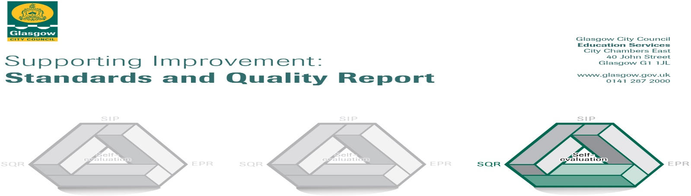

The summary report is provided for parents/careers and partners to outline our achievements this session and our priorities for next session. Throughout this session we have taken forward our priorities as detailed in our school improvement plan. Through our processes of self-evaluation, we have identified how we can improve outcomes for our children and young people.

Our achievements and improvements this year.
We would like to highlight the following improvements/achievements:

Over the session 2021-22 we have worked hard to ensure a safe and stable learning environment for our children. This has been a priority given the challenges of the past couple of years.
One of the ways in which we have ensured this is the provision of our wellbeing worker. Lou has worked with 37 children over the course of the year to support general wellbeing. She has also supported parents and families with concerns and helped to increase attendance at school for some children. We also employed a counsellor during Term 3 to support 6 pupils with health and wellbeing concerns. This allowed them a safe space to talk and helped to increase attainment in some cases.
This year our Challenge Leader of Learning had a focus on improving numeracy across our school. Our CLOL supported staff members through training events and in class modelling of lessons as well as working with small groups of children. This intervention of appropriate support ensured equity where necessary and enabled pupils o begin to close the gap in knowledge and skills in numeracy. Over the course of the year attainment in numeracy rose from 76.3% to 85.1% (of all P1, P4 and P7 pupils). We are incredibly proud of our children and staff for this achievement and we are keen to build on this success.
Our Primary 1 children continued to learn through play. Class teachers have attended training from the Glasgow Improvement Challenge team and we have received supportive visits from the staff there. These visits have seen our school receiving praise for our innovative ways of engaging children in their learning during a difficult time with respect of covid procedures.
Our PATHS programme entered its third and final year of rollout this session. Our PATHS coach has seen the good work that takes place in our school and has recommended we move towards being a “Model School” in our next year. This will mean we are seen as a place of excellent practice for PATHS delivery.
All of our P6 children experienced participation in the John Muir Award training this year and were successful in certification for this. All of our P7 children took part in a semi-residential experience at Blairvadach in August. This was paid for using PEF funding to ensure equity of experience for all.
Our P7 children completed a two year long project this session in collaboration with the Glasgow Boathouse Preservation Trust and Doors Open Festival. This was a look at Dalmarnock and involved old footage found of the local area. Children were involved in filming, writing and producing. WE were invited to the official launch of the film in May 2022 and this will be on display again during the Open Doors Festival in September 2022.
As part of our Improvement Plan this session we launched a whole school focus on Developing the Young Workforce. We had a termly skill to work towards and had two successful skills master afternoons. During our Careers Week we had over 15 stalls of professions/carers in our hall for our upper school children to visit to experience different jobs. Most of these jobs came from within the school family. Our younger children enjoyed visits from Police Scotland detailing their role in the community.
In light of the conflict in Ukraine our school decided to raise funds to help them. We raised £500 and donated it to the DEC Humanitarian Appeal.
Some of our upper school children took part in the Go Yellow Walk in aid of The Prince and Princess of Wales Hospice in June 2022. We raised £440 and this was presented to them in June.

Here is what we plan to improve next year.
To raise attainment in literacy and to ensure a shared understanding of attainment and achievement across all levels of the curriculum. (Creativity and Equality)

To ensure inclusivity and wellbeing for all pupils by embarking on a Language and Communication Friendly journey for our establishment. (Ready, Love and Kindness)

To ensure Riverbank Primary have a context specific curriculum based around the needs of our school community. (Ready, Creativity and Love)

To offer bespoke family learning programmes and to utilise local and national partners to achieve this. This will increase engagement for families who are difficult to reach and provide support for all. (Ready and Creativity)

How can you find out more information about our school?
Please contact us directly if you require further information or if you wish to comment on the report.

The contact e-mail address is: headteacher@riverbank-pri.glasgow.sch.uk

Our telephone number is: 01415503679

Our school address is: 1 Sunnybank Street, Glasgow G40 4RX

Further information is available in: newsletters, the school website, and the school handbook

