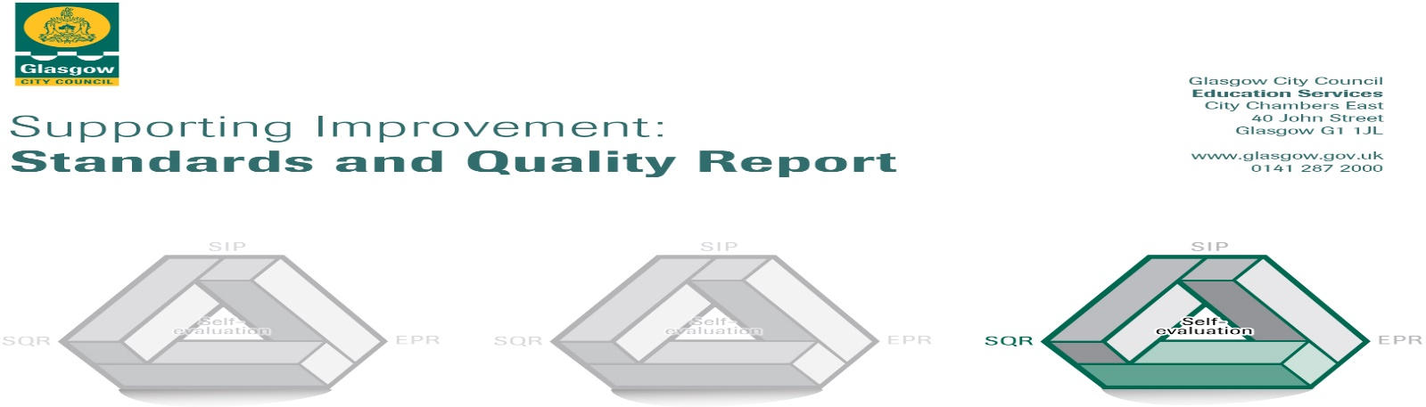

The summary report is provided for parents/careers and partners to outline our achievements this session and our priorities for next session. Throughout this session we have taken forward our priorities as detailed in our school improvement plan. Through our processes of self-evaluation, we have identified how we can improve outcomes for our children and young people.

Our achievements and improvements this year.
We would like to highlight the following improvements/achievements:

Over the session 2022-23 we have worked hard to ensure a safe and stable learning environment for our children. This has been a priority given the challenges of the past couple of years.
One of the ways in which we have ensured this is the provision of our wellbeing worker. Lou has worked with 42 children over the course of the year to support general wellbeing. She has also supported parents and families with concerns and helped to increase attendance at school for some children. We also employed a counsellor from Impact Arts to support a group of 5 pupils with health and wellbeing concerns. This allowed them a safe space to talk and helped to increase attainment in some cases.
This year our Challenge Leader of Learning had a focus on improving writing across our school. Our CLOL supported staff members through training events and in class modelling of lessons as well as working with small groups of children. Our staff working group created and implemented a Tools for Writing programme for all classes and this is being rolled out across the school for session 2023-24. This intervention of appropriate support ensured equity where necessary and enabled pupils to begin to close the gap in knowledge and skills in writing. Over the course of the year attainment in writing increased in P4 by 10% and in P7 by 20%. We are incredibly proud of our children and staff for this achievement and we are keen to build on this success.

Our journey to becoming a Language and Communication Friendly Establishment continued this year. We introduced weekly Makaton signs to our pupils at assemblies and have seen these in use daily around the school.
Our Curriculum Rationale was developed over the year, Our working group consulted with staff, parents and pupils to create this overview of learning for our school. A link to this is on our school website.
Our Primary 1 children continued to learn through play. Class teachers have attended training from the Glasgow Improvement Challenge team and we have received supportive visits from the staff there.
All of our P6 children experienced participation in the John Muir Award training this year and were successful in certification for this. All of our P7 children took part in a residential experience at Lockerbie Manor in February. This was paid for using PEF funding to ensure equity of experience for all.
Engaging with our families was a priority for us this session due to the restrictions during Covid. We created a calendar of family events and shared it with families at the start of the session to ensure clarity. At our Parent’s Evening we had an overall 86% turnout. We ran an adult exercise class that 10 parents joined with. We ran an Autism workshop for families and 7 parents attended. We ran Play Along Maths classes for P1 classes and had to run 3 blocks due to demand. We held a bingo evening for fun where over 25 families attended. We also ran family quiz night, sports day, Christmas and Summer shows and lots of other parental activities. Our Open Afternoons proved to be very successful and parents reported our learning environment to be excellent.
Our school was successful in achieving our first Green Flag for our environmental work from Keep Scotland Beautiful and Eco Schools Scotland. This flag is a representation of the commitment of our school community to being more environmentally friendly.

Our P7 pupils took part in Mock Court at the High Court in Glasgow. They were recognised for their efforts through two awards for Best Journalism and Best Artist.

Here is what we plan to improve next year.
- Improve learner’s experiences in listening and talking
- Improve teacher understanding and confidence of listening and talking
- increase practitioner knowledge and confidence in taking learning outdoors and to increase engagement with outdoors
- Embed talk practices across the school
- ensure all staff are creating learning intentions and success criteria correctly and using them consistently
- continue to offer opportunities for family learning

How can you find out more information about our school?
Please contact us directly if you require further information or if you wish to comment on the report.

The contact e-mail address is: headteacher@riverbank-pri.glasgow.sch.uk

Our telephone number is: 01415503679

Our school address is: 1 Sunnybank Street, Glasgow G40 4RX

Further information is available in: newsletters, the school website, and the school handbook

