 | Monday | Tuesday | Wednesday | Thursday | Friday
Week 1 | Combinations of 1000 Challenge: Create your own combinations using exchange.  Measuring in Centimetres Challenge: Convert the measurements into metres and millimetres.  Alligators Challenge: Double each number and calculate.  Triple them. | Noticing Challenge: Create two of your own shapes and complete a new table.  Stacking Shapes Challenge: Think of or find out about other 3D shapes and categorise them.  Pig Game | Number Line Puzzle Challenge: Extend the number line to the left and the right and add other multiplication stories. Create a division number line.  Which One Doesn’t Belong? Challenge: Pick four other items from your kitchen and do the same. Try different items from different rooms.  Identify a Fraction on a Number Line | Number Puzzles Challenge: Create your own equations using larger numbers.  Visual Pattern Challenge: Can you explain the pattern? What will the fifth pattern look like? The tenth? Twentieth?  Story Problem | Noticing Challenge: Create a third set and add an Odd One Out column.  Multiplying by Multiples of Ten Challenge: Add an extra digit to one (or both) of the numbers in each problem and solve them.  Elapsed Time
Week 2 | Operations With Time Challenge: Make the earliest possible time. How many different times can you make? Can you order them?  Fraction Talk Challenge: Draw some additional lines and work out the fractions of the new shapes.  Noticing | Multiplication Strategies Challenge: Change the 3s for other numbers and solve.  Puzzle  Magic Pyramid Challenge: Use a different sequence of numbers, e.g. 7, 8, 9, 10, 11 and 12 and see if you can complete it in the same way. Do any other sequences work? | Finding Sums Challenge: Create another set of sums for you to solve. Make the totals four or five digits long.  Baking Cookies Challenge: Can you find more than one solution?  Which Doesn’t Belong? Challenge: Do this for four subtraction, multiplication and/or division stories. | Telling Time Challenge: write some digital times down and draw analogue clock faces to match.  Visual Pattern Challenge: Can you explain the pattern? What will the fifth pattern look like? The tenth? Twentieth? How many squares will be in the hundredth pattern?  Fraction Talk | Baking Brownies  Symmetry Challenge: Can you draw one of the shapes in this format? 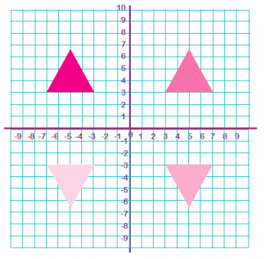  Counting Challenge: Add a block of squares area 7 x 3 and count the number of squares in the new shape
Week 3 | Fractions Challenge: Make the shapes and draw diagonals through each section then complete the task.  Number Line Challenge: Extend the line and add more fractions, for example 1 3/10  Round and Round Challenge: Create others using three and four-digit numbers. | Pyramid Puzzle Challenge: Extend the size of the pyramid by one, two or three boxes on each row and complete.  Would You Rather? Challenge: Create your own problem for someone else to solve. Make the answers close together if you can.  Comparing Fractions Challenge: Can you find more than one solution? | Practice Challenge: Create more True or False equations.  Visual Pattern Challenge: How many apples in stages 5, 10 and 12? Can you find a way of working it out without drawing them all?  Puzzle Challenge: Draw other combinations using all four operations and calculate. | Telling Time to the Minute Challenge: write some digital times down and draw analogue clock faces to match.  Fraction Talk Challenge: Create another shape with different fractions and work out the fraction each section has.  Conrad’s Room Challenge: Make other word problems | Four Operations Practice Challenge: Create your own and leave them to complete next week.  Puzzle Challenge: Create your own using different values for each object.  Multiplication Challenge Challenge: Is there more than one solution?

