Riverbank Primary Literacy Grid Second Level

Write a story with one of the following titles:  A Whole New World, The Tribe, Stranded! A New Species, The Island.  Remember to include character/setting descriptions, an event or problem and a solution. | Write a thought bubble for a character at a chosen point in a book when s/he is not actually speaking. Describe feelings relating to events and other characters at that point in the story. | Choose a non-fiction book about a subject you are interested in.  Or look it up on the internet.  List 5 facts that you have learned | Create your own comic strip and read it to someone at home.  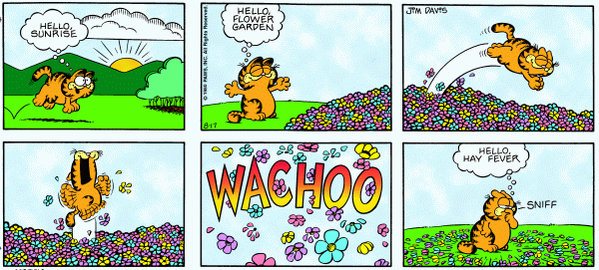
Read together with someone at home. It could be a book, newspaper, article on the internet, comic etc. Take turns when reading it and discuss what you like about it.  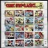 | Roll a dice 3 times and complete the activities to help you understand a new word from a book  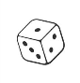  1 – Write a synonym for your word 2 – Write an antonym for your word 3 – Illustrate your word 4 – Use the word in a sentence of your own 5 – Act out your word to a friend | Write 4 or 5 questions that you would like to ask a character from a book you have read. | Pick your favourite character from a book and use adjectives (describing words) to describe your character  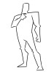
Look at examples of theatre, restaurant or book reviews from magazines and newspapers to explore the style and language used. Write your own column about the text which has been read, giving opinions about the book and justify these.  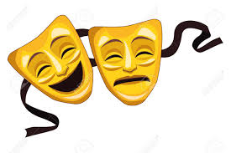 | Be a story teller and read your favourite book to someone at home or retell the story in your own words. | Create a short and interesting fact file about an author or poet of your choice. You could use the internet to do some research | Relax and watch your favourite TV programme at home.  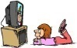  Put the subtitles on and read them as you are watching.

