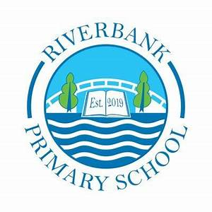
P3 Term 4 2026 Overview

Numeracy and Maths

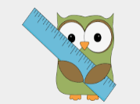
You can support this at home by:
- Forming numbers correctly and neatly to improve presentation – use paper, white boards etc.
- Give your child small simple numeracy problems to solve to encourage mental maths counting and thinking.
- Encourage your child to skip count in 4s, 3s, 5s, 2s, 10s.
- Look for examples of symmetry in your home or when out and about.
- Use the language of ‘left and right’ during everyday tasks.

In Term 4 we will be focussing on fractions, we will be looking at fractions through shape and amounts. A key learning point will be identifying and understanding the difference between the numerator and denominator.
We will continue to revise learned strategies to ensure we are confident in addition, subtraction, multiplication and division problems. We will be challenged by solving word problems.
Term 4 we will explore directions and angles both within the classroom and in outdoor environments. We will also be learning how to identify symmetry and create our own symmetrical designs.

Part Part Whole
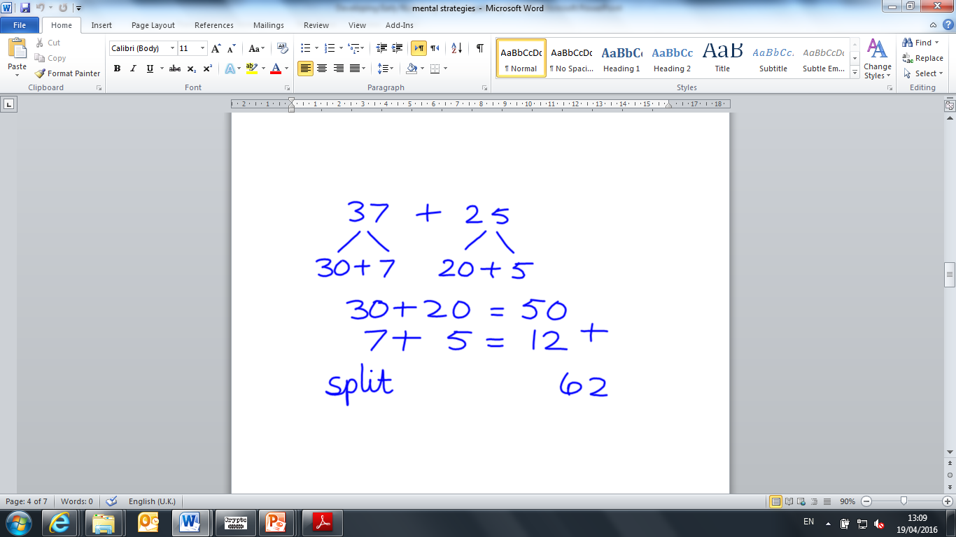
Bridging
Partition

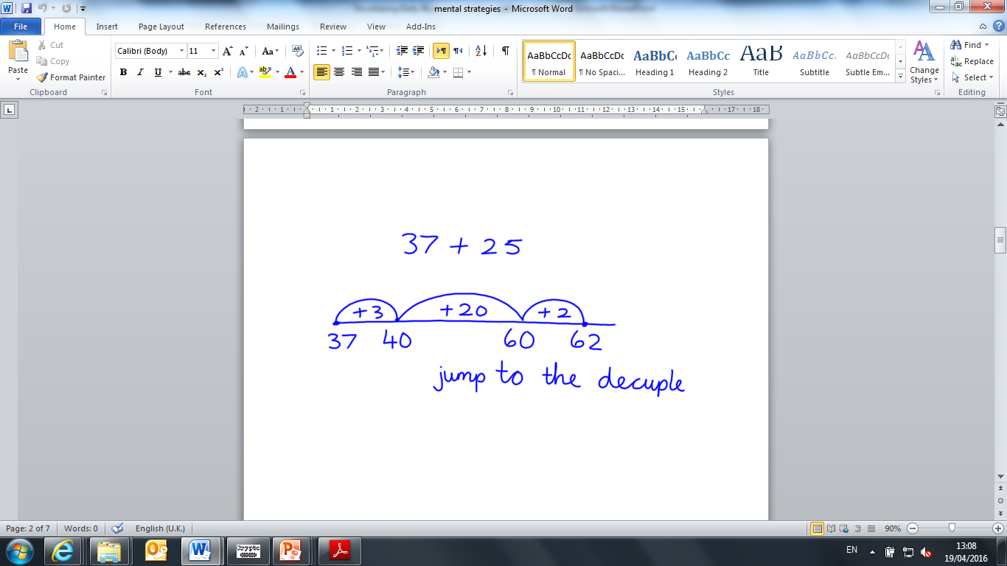
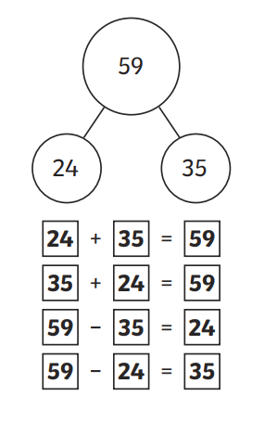

You can support this at home by:
- When reading stories at home, discuss the characters – Use adjectives to describe the characters. Discuss where the story is taking place.
- 10 minutes reading per night can have a great impact on your child’s ability to remember sight words and become a fluent reader.
- Encourage your child to read for enjoyment.
- Encourage your child to make up stories and write them in a notebook.
- Complete weekly spelling tasks on Showbie.
- Follow a set of instructions or a recipe at home.
Literacy
This term in Literacy we will be exploring:
- Procedural Writing
- Reading – before, during and after strategies.
- Reading for enjoyment
- Grammar and tools for writing
- Listening and talking activities
- Spelling words and Spelling patterns.
- Sight word recognition.

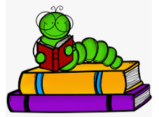

Other Curricular Areas
In IDL we are learning about where living things come from and how they grow and are nurtured. We will do this by looking at the life cycles of plants and animals. We will be spending time planting and growing in our garden and learning how to care for what we have planted. We will enjoy observing the life cycle of our class butterflies.
We will be learning simple food preparation and practical skills as well as good hygiene.
This term we will be exploring different types of music and instruments. We will be learning about rhythm and beat through body percussion lessons.
We will explore traditional tales through drama, learning how to express ourselves through movement, facial expression and gestures.

Health and Wellbeing
P3 have PE on a Monday and a Friday.
In P.E. we will be focussing on circuits, team games and sports day challenges.
Please ensure your child has their full P.E. kit, including footwear, on these days. Some of the sessions will be on the pitch. All jewellery must be removed for PE lessons. Staff are not allowed to remove earrings so if your child cannot take these out then please take them out before coming to school.
We use our daily emotions check-in to express our feelings throughout the day. We will continue to explore these through two PATHS lessons each week.

Top Tips!
- Please ensure that your child’s name is on all their property.
- Dress sensibly for outdoor learning as we will be going outside in almost all conditions.
- Check Showbie for weekly information and your child’s work.
- Follow us on X @RiverbankPri

