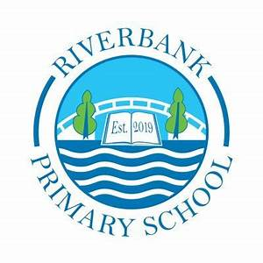
P5 Term 1 2025

Numeracy and Maths


In Term 3, we will be revising addition strategies and applying these to subtraction sums. We will also be learning about decimals, factors of multiples and fractions.
We will be working on our data handling skills and applying these skills to our topic, ‘Clyde in the Classroom’. We will investigate measurement and take some of this learning outdoors.
We will continue to develop the children’s mental maths skills through practicing multiplication and division facts alongside mental calculations of addition and subtraction sums.

You can support this at home by:
- Please see Showbie for the weekly home learning sheet.
- Counting forwards and backwards and practising multiplication.
- Practice using a ruler or estimating the size of an object
- Topmarks has some great multiplication, adding and subtracting games. https://www.topmarks.co.uk/maths-games/7-11-years/place-value


We look forward to seeing your home learning on Showbie.
If you need a paper copy, please contact the school office.

You can support this at home by:
- Please see Showbie for the weekly home learning sheet
- Working on weekly spellings on Showbie – practice spellings in preparation for Friday spelling tests to check progress.
- Reading for pleasure at home, utilising our reading strategies and discussing what takes place in their books.
Literacy
This term in Literacy we will be:
- Explanation writing
- Reading strategies
- Spelling words
- Grammar and tools for writing
- Listening and talking activities

Other Curricular Areas
In IDL, we are going to be exploring Clyde in the Classroom, which will be our focus for the whole term. This will include researching about the River Clyde, taking responsibility for looking after our fish, and learning about the importance of taking care of our natural environment.
In addition to this the children will engage in some mixed media art that will support their learning around this topic and allow them to apply their learning in a wider context..
In science with Miss Lovick we will be investigating forces and will be carrying out experiments to learn about these.

Health and Wellbeing
P5 have PE on a Wednesday and a Friday (Outdoor)
In P.E. we will be focusing on Scottish Country dancing, gymnastics and Matball. We will be working in groups, individually and teams to encourage our friends through our activities.
Please ensure your child has their full P.E. kit, including footwear, on these days. Some of the sessions will be on the pitch. All jewellery must be removed for PE lessons. Staff are not allowed to remove earrings so if your child cannot take these out then please take them out before coming to school.
We use our daily emotions check-in to express our feelings throughout the day. We will continue to explore these through two PATHS lessons each week.

Top Tips!
- Please ensure that your child’s name is on all their property.
- Dress sensibly for outdoor learning as we will be going outside in almost all conditions.
- Check Showbie for weekly information and your child’s work.
- Follow us on X @RiverbankPri

