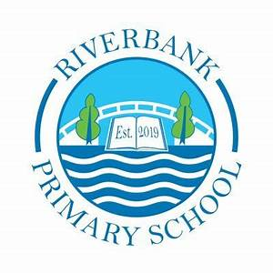
P1/2 Term 4 2025-26

Numeracy and Maths

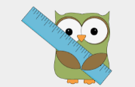
You can support this at home by:
- Counting objects at home and when out and about, for example counting cars on the road, toys in the toy box, etc.
- Looking for numbers when in our environment, for example numbers on a bus, numbers on a TV remote, etc.
- Topmarks.co.uk has some great number recognition and counting games.
- Practise using the language of measurement; tall, taller, tallest, short, shorter shortest, light, lightest, heavy, heaviest. Measure objects around the house!

During Numeracy this term, with P1 we will we will continue to work on our addition and subtraction strategies within 30. We will be using concrete materials to support our learning - counters, cubes, tens frames and number lines.
For P2, we will continue to develop our addition and subtraction skills for instant recall. We will also introduce the concept of sharing equally and begin division calculations.
During Mathematics, we will be learning about measurement; length, weight, capacity and area. We will use non-non-non-standard units (i.e. shoes, handspan) and begin to use rulers and metre sticks.

We look forward to seeing your home learning on Showbie.
If you need a paper copy, please contact the school office.



You can support this at home by:
- Please see Showbie for the weekly letter sounds and common words.
- Read stories at home and discuss it together – Who is your favourite character? What was your favourite part of the story? Did the story have a happy ending? Why did this happen? What do you think about…?
- Practise writing sentences together to develop confidence and skills. When reading or watching a film, discuss what the character looks like, how they behave and what their personality is like.
- Practise writing independently at home…have-a-go! Be confident!

Literacy
This term in Literacy we will be:
- learning new weekly letter sounds, blending sounds together to read/write

- learning to recognise and write weekly common words
- reading books and comprehension
- writing – sentence structure, character description, nonfiction.

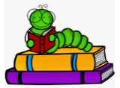

Other Curricular Areas
For IDL at the beginning of the term, we will explore Earth Day and the reasons why and how we can celebrate it. We will learn about Dinosaurs, different types, herbivores, carnivores where and when did they live? We will become fossil hunters! We will develop our art skills through this topic. We will also find out about and explore ‘People Who Help Us in our Community’.
We have caterpillars in a tub in the class and will be able to watch them grow, develop a cocoon and become butterflies! This will help our learning about life cycles with butterflies in the classroom.
In Science/Technologies, we will be learning about different types of materials, forces, magnetism, staying safe with electricity.
For Music we have a specialist this term who will visit fortnightly. We will enjoy singing and playing musical instruments along to music of different styles.
In French, we will be learning colours and consolidating greetings, numbers, days of week and some personal information.

Health and Wellbeing
P1/2 have PE on a Tuesday (indoor with Mrs Fisher) and a Friday (outdoor with Miss Stewart).
In P.E. we will be practising activities for our Sports Day.
Please ensure your child has their full P.E. kit, including footwear, on these days. Friday sessions will be on the pitch. All jewellery must be removed for PE lessons. Staff are not allowed to remove earrings so if your child cannot take these out then please take them out before coming to school.
We use our daily emotions check-in to express our feelings throughout the day. We will continue to explore these through two PATHS lessons each week. We will be choosing a PATHS Pupil of the Day who will receive compliments daily from their classmates. We will be discussing and learning about feelings, friendship, caring and sharing.
Every Wednesday afternoon we will be in our Community Garden! On those days when it is sunny and hot, it would be great if your child brought a cap and sunscreen lotion to school. We will be planting lettuce and carrot seeds, learning how to re-plant flowers, make a nature bracelet and nature crown, make a bird feeder and a bug hotel…and having fun exploring play in the garden.

Top Tips!
- Please ensure that your child’s name is on all their property.
- Dress sensibly for outdoor learning as we will be going outside in almost all conditions.
- Check Showbie for weekly information and your child’s work.
- Follow us on X @RiverbankPri

