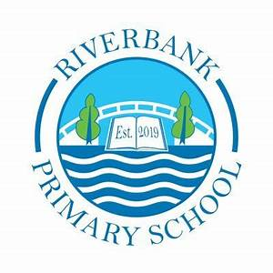

P 5b Term 4 2025 Overview

Numeracy & Maths

This term in numeracy, we are learning to round to the nearest 10, 100 and 1000 as well as rounding numbers with one decimal place to the nearest whole number. We will also be looking at fractions, decimals and percentages. Some key vocabulary we will be using:

- pat, equal parts, one whole, half and quarter, eighth, third, sixth, fifth, tenth.

- Decimal fraction, decimal point and decimal

place.

- expenditure, budget, cost

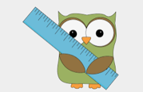

You can support this at home by :

* Asking your child to recite time tables as quickly as they can. It would be good for them to use their tables to solve simple division problems as this will help their work with fractions.
* Accessing Sumdog for focussed skills practice.
* Access the range of games on the websites Top Marks and Mathsframe.

You can support this at home by:

* Reading daily. Newspaper, magazine, comic, fiction or non-fiction book.
* Encouraging writing at home.
* Play a would you rather game with your child, providing two options (e.g. dinner choice – chicken or fish). Ask your child to choose one and use persuasive language to explain their choice.

Literacy

This term in Literacy we will be exploring:

* Class novel – Planet Omar Accidental Trouble Magnet.
* Persuasive writing
* Handwriting

Other Curricular Areas

IDL

This term we are learning about natural disasters. This is a topic which the children have shown great interest in previously whilst reading non-fiction books in class. The children will be learning about various types of natural disasters, how they occur and the impact and devastation they have on peoples lives. We will explore this through social studies, science and expressive arts.

Expressive Arts

P5b will be participating in a school summer performance – more information on this will follow soon. The children will be exploring music and drama to help prepare for the show and upcoming performance.

Health and Wellbeing

**P5b** have PE on a **Wednesday** and a **Thursday**. Wednesday is an outdoor session.

In P.E. we will be focussing on Sports day and striking and fielding.

Please ensure your child has their full P.E. kit on these days. Some of the sessions might be on the pitch. All jewellery must be removed for PE lessons. Staff are not allowed to remove earrings so if your child cannot take these out then please take them out before coming to school. We have lots of newly pierced ears this term. During the 6 week period that they can’t be removed, your child will be provided with alternative Health & Wellbeing tasks.

We use our daily emotions check-in to express our feelings throughout the day. We will continue to explore these through two PATHS lessons each week.