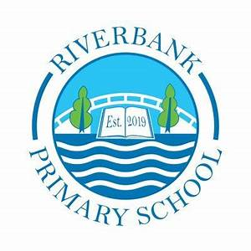
P6b Term 4 2025 Overview

Numeracy and Maths

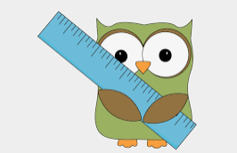
In Term 4, we are looking at measurement. This includes length, area, perimeter, mass and volume. We will be using our outdoor space to measure and compare different objects.
Some key phrases we will be using are:
- measurement
- difference
- units

You can support this at home by:
- Access Sumdog through the app or online using the QR code. Your child had a login from their teacher and there are many activities appropriate to your child’s level.
- Estimate and measure items at home.
- Help measure ingredients or liquids.
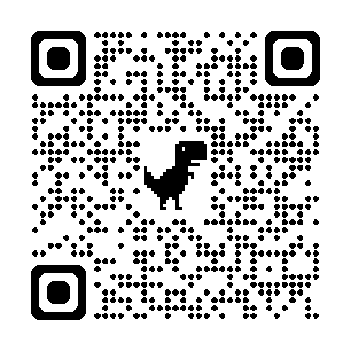

Number Strategies

Counting on
Comparing numbers
Rounding



Literacy
This term in Literacy we will be exploring:
- Persuasive writing
- Discussion Writing
- Reading fiction texts
- Punctuation and tools for writing
- Partner and group presentations

You can support this at home by:
- Reading daily. Newspaper, magazine, comic, fiction or non-fiction book. After reading can they summarise what they have read and give a review.
- Practise talking and listening skills. You could time each other to see who can talk the longest about a subject.
- Watch Newsround or educational programmes such as those about animals and talk about what they have learned and what they might want to know about.

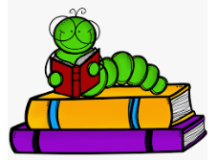

Other Curricular Areas
In IDL, we are going to be exploring our class novel Fox Girl and White Gazelle. This will include researching and learning about the people, places and values that feature in our country and area. We will be incorporating Art, RME and Social Subject into this topic.
In Science, we will be exploring the dissolving of substances and the water cycle. We will incorporate outdoor learning into this.
In French children will be learning vocabulary to support daily tasks.

Health and Wellbeing
P6b have PE on a Tuesday and a Wednesday. We will try to take sessions outdoors if we can.
In P.E. we will be focussing on Striking/Fielding and Sports day Athletics prep.
Please ensure your child has their full P.E. kit, including footwear, on these days. All jewellery must be removed for PE lessons. Staff are not allowed to remove earrings so if your child cannot take these out then please take them out before coming to school.
We use our daily emotions check-in to express our feelings throughout the day. We will continue to explore these through two PATHS lessons each week. Our PATHS lessons this term will focus on being responsible and commemorating others.
In our RSHP (Relationships, Sexual Health and Parenthood) lessons we are revisiting My body: Functions and looking at Consent and Being a Parent and/or Carer.

Top Tips!
Please ensure that your child’s name is on all their property.
Dress sensibly for outdoor learning as we will be going outside in almost all conditions.
Check Showbie for weekly information and your child’s work.
Follow us on X @RiverbankPri

